Load Test Report

### Live assets

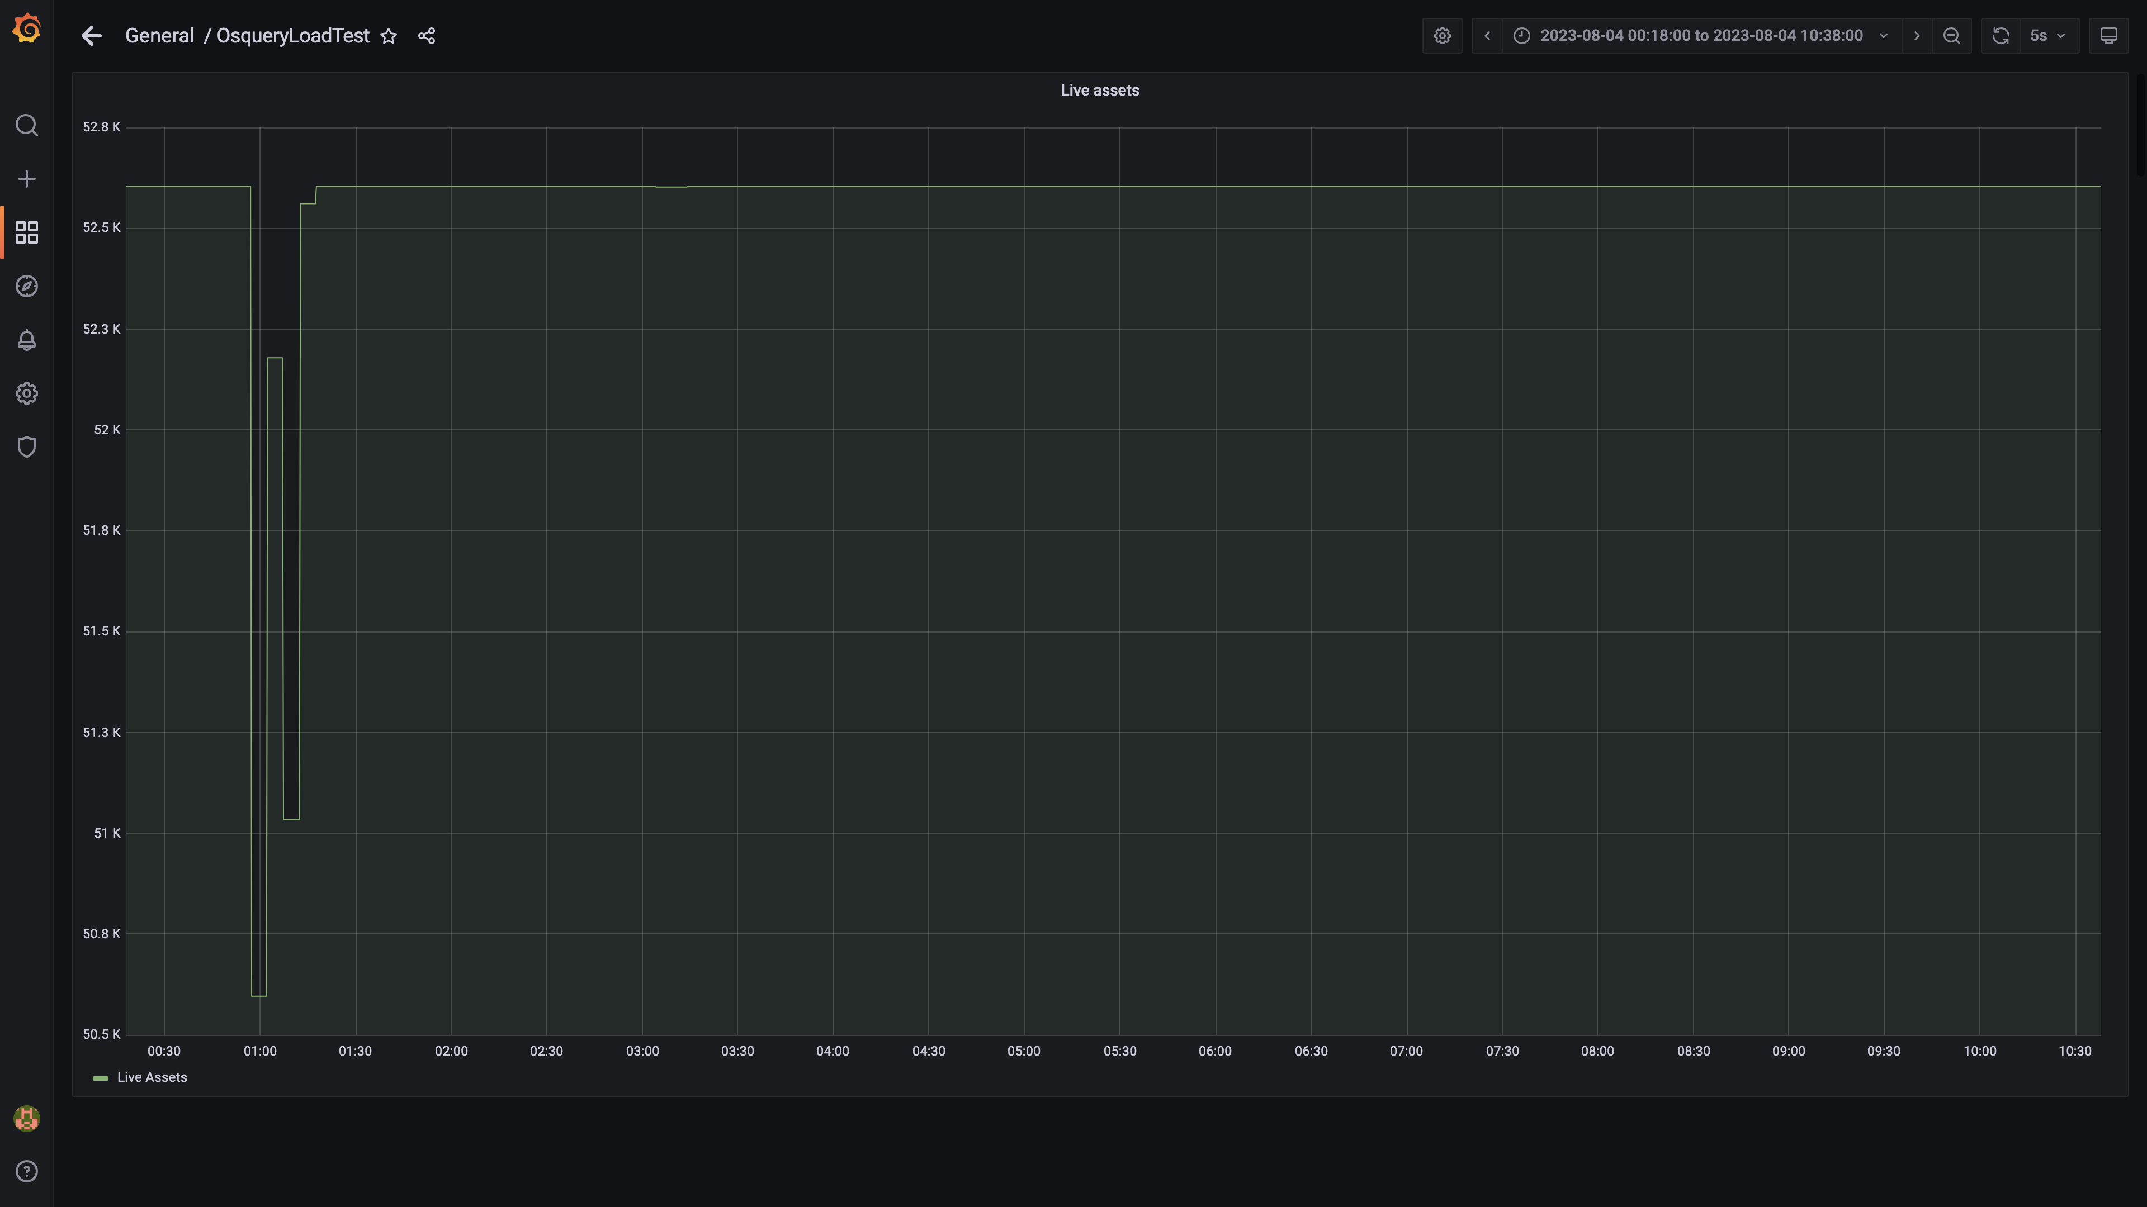

### Kafka lag for all groups

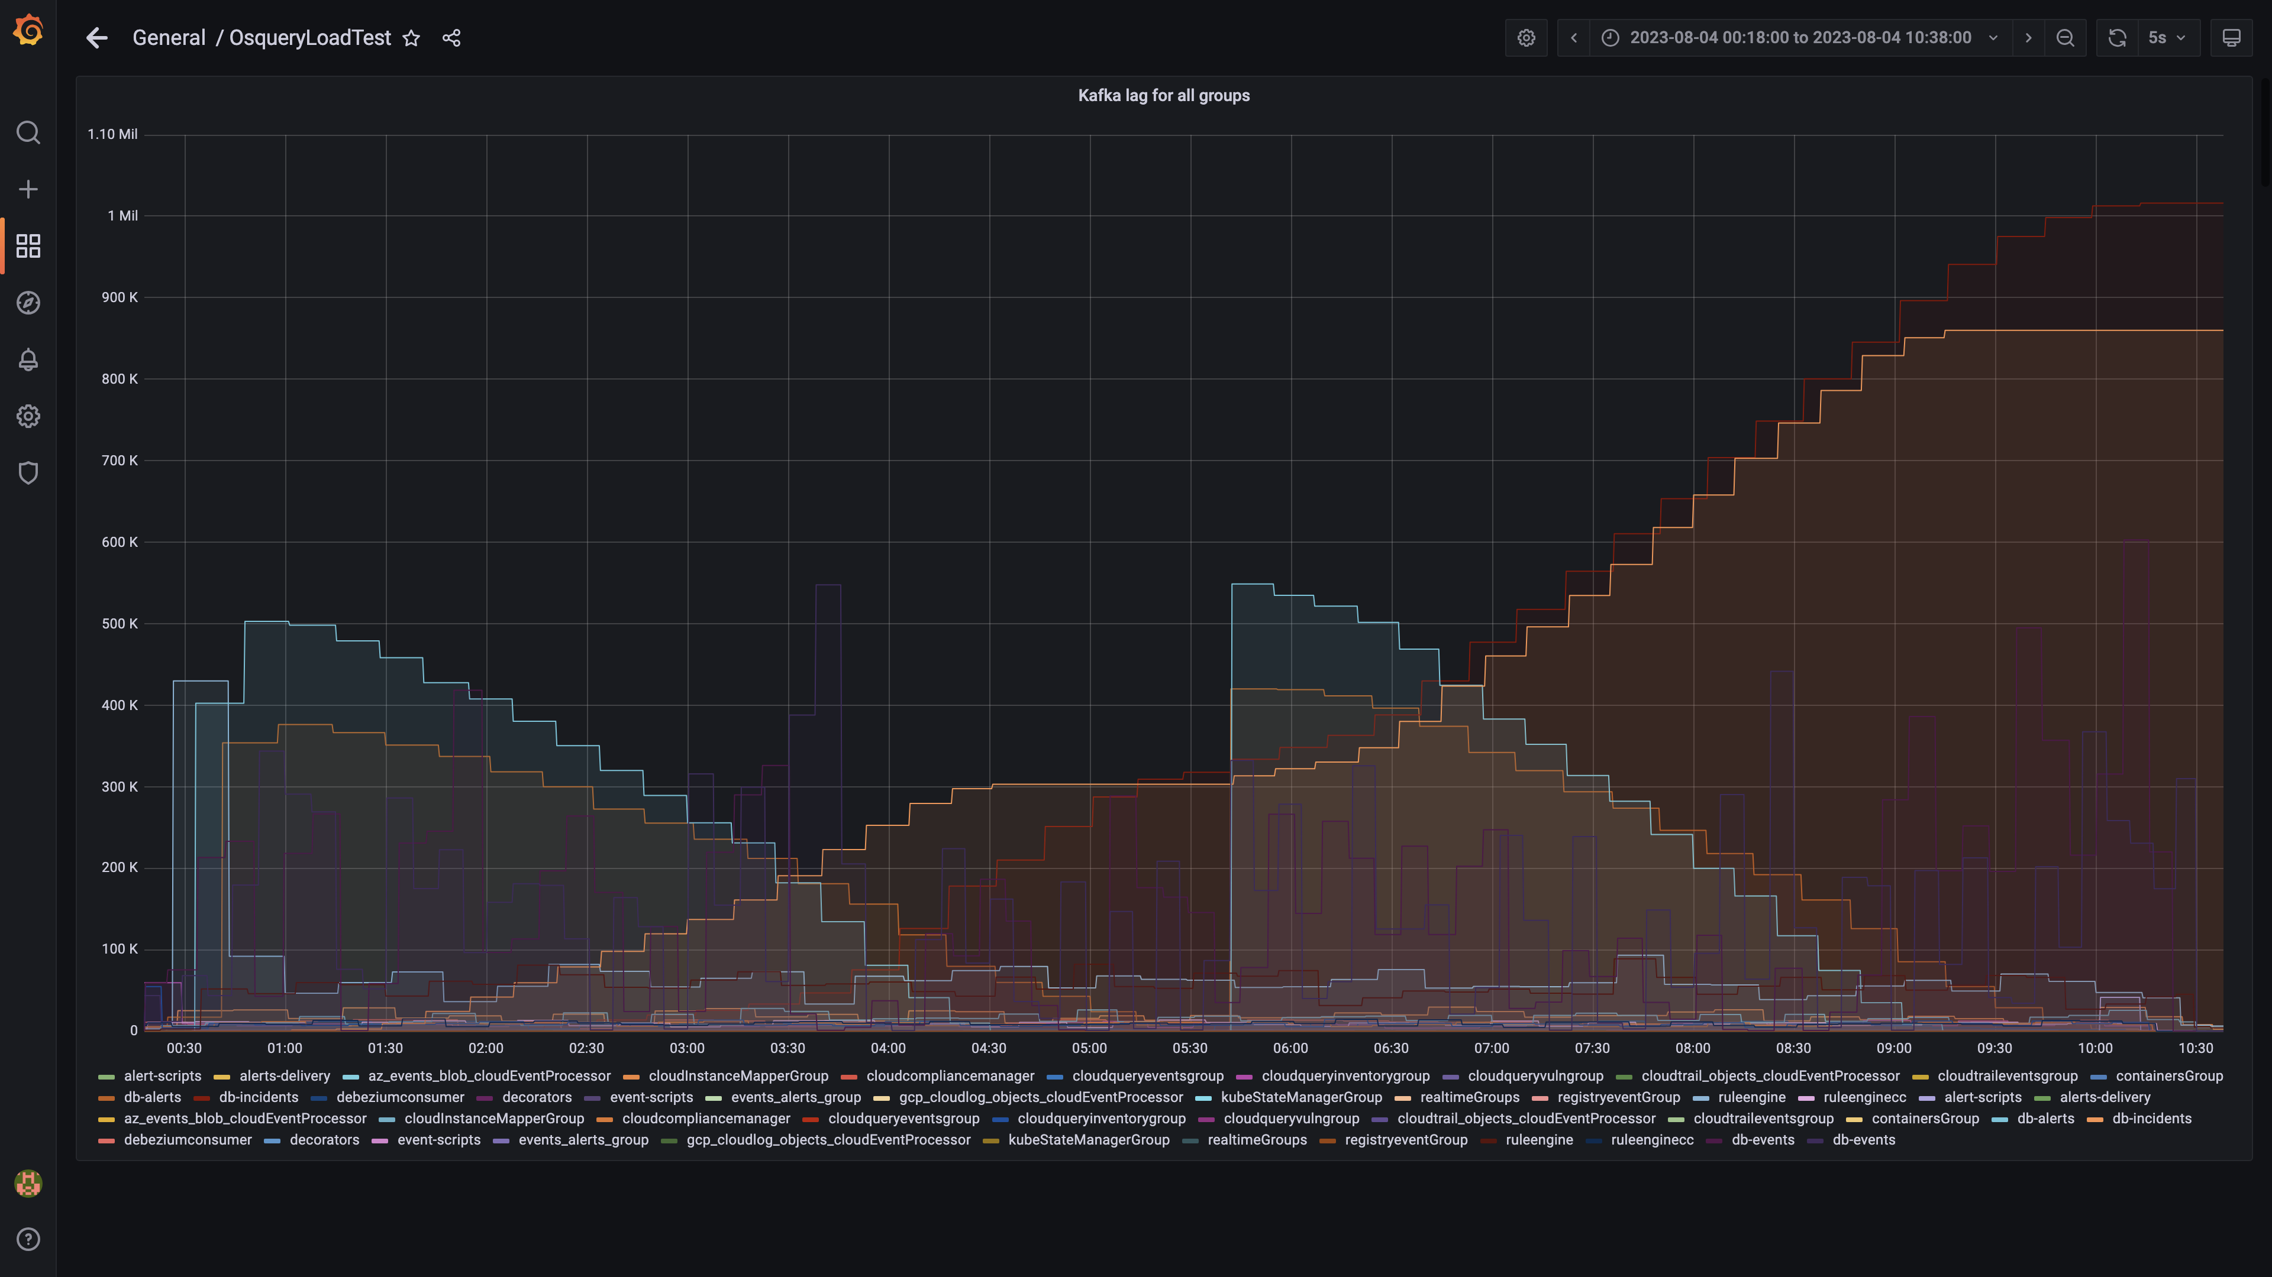

### Process node ram used percent

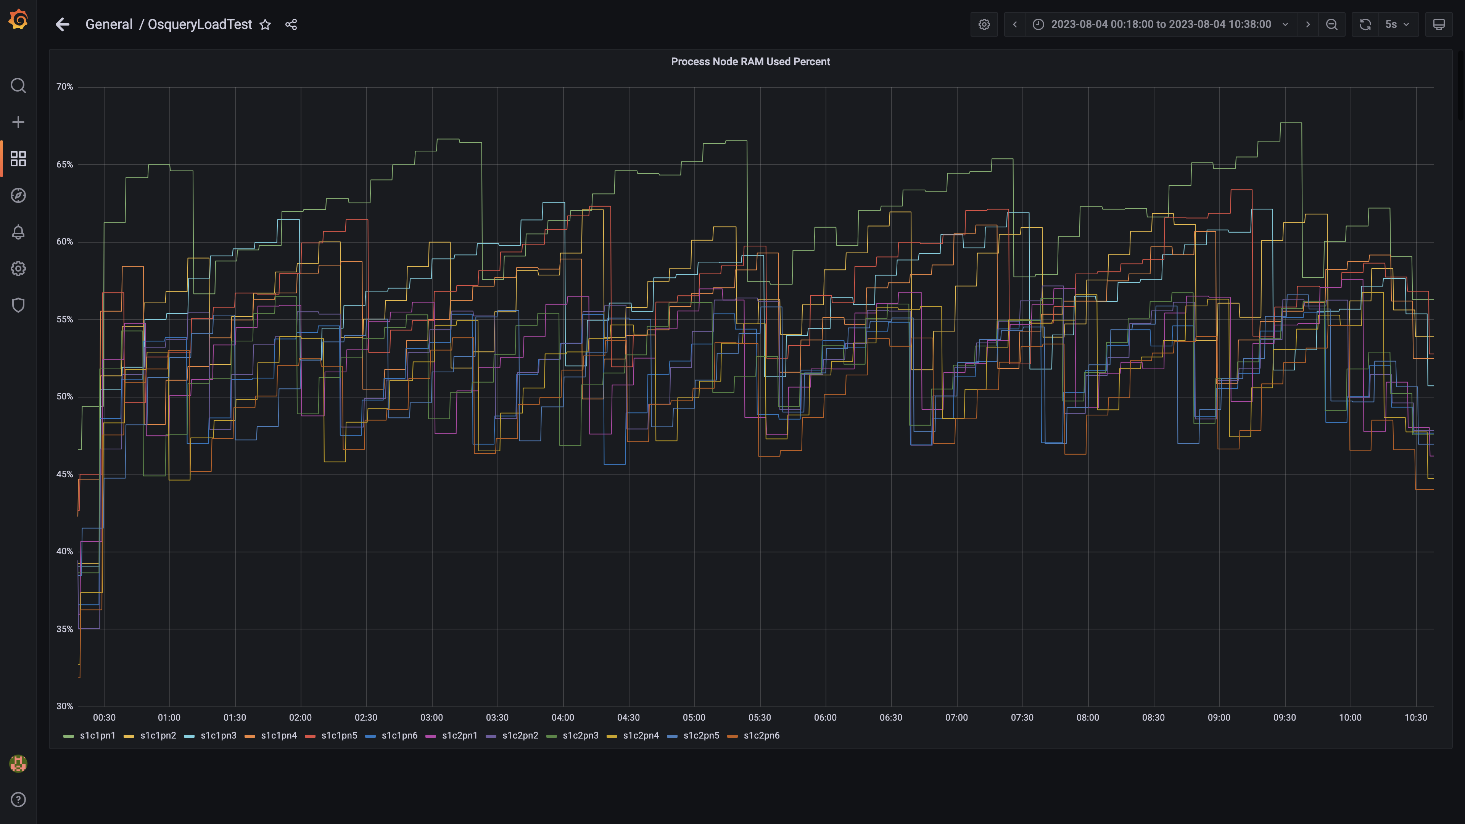

### Data node ram used percent

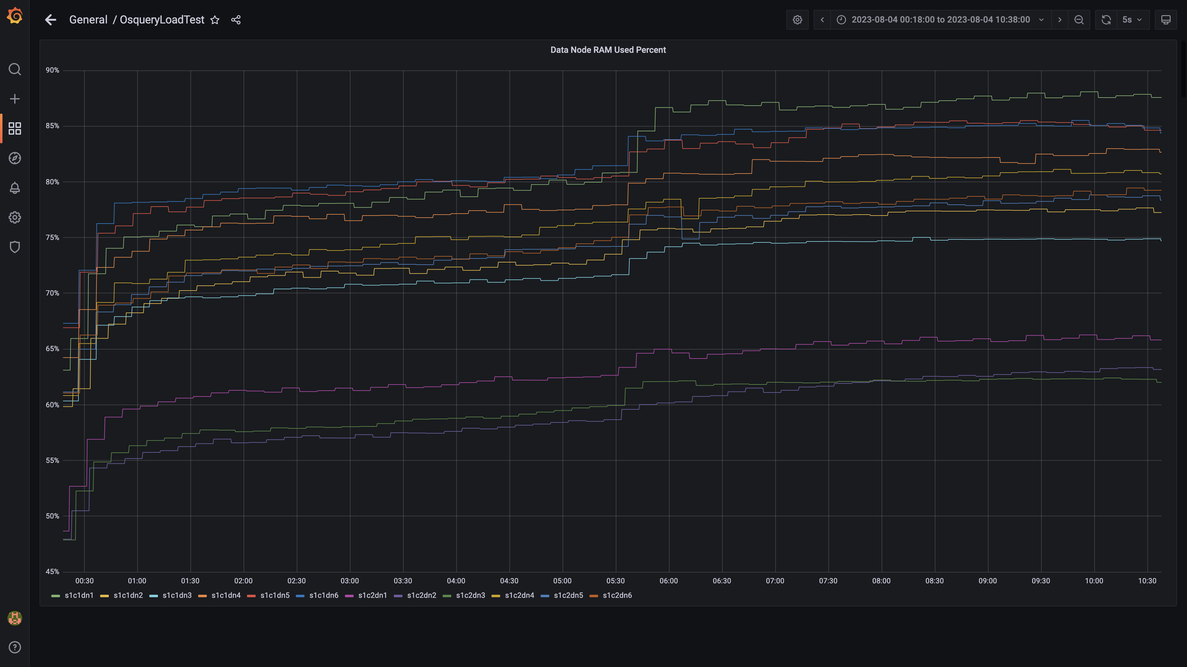

### Postgres node ram used percentage

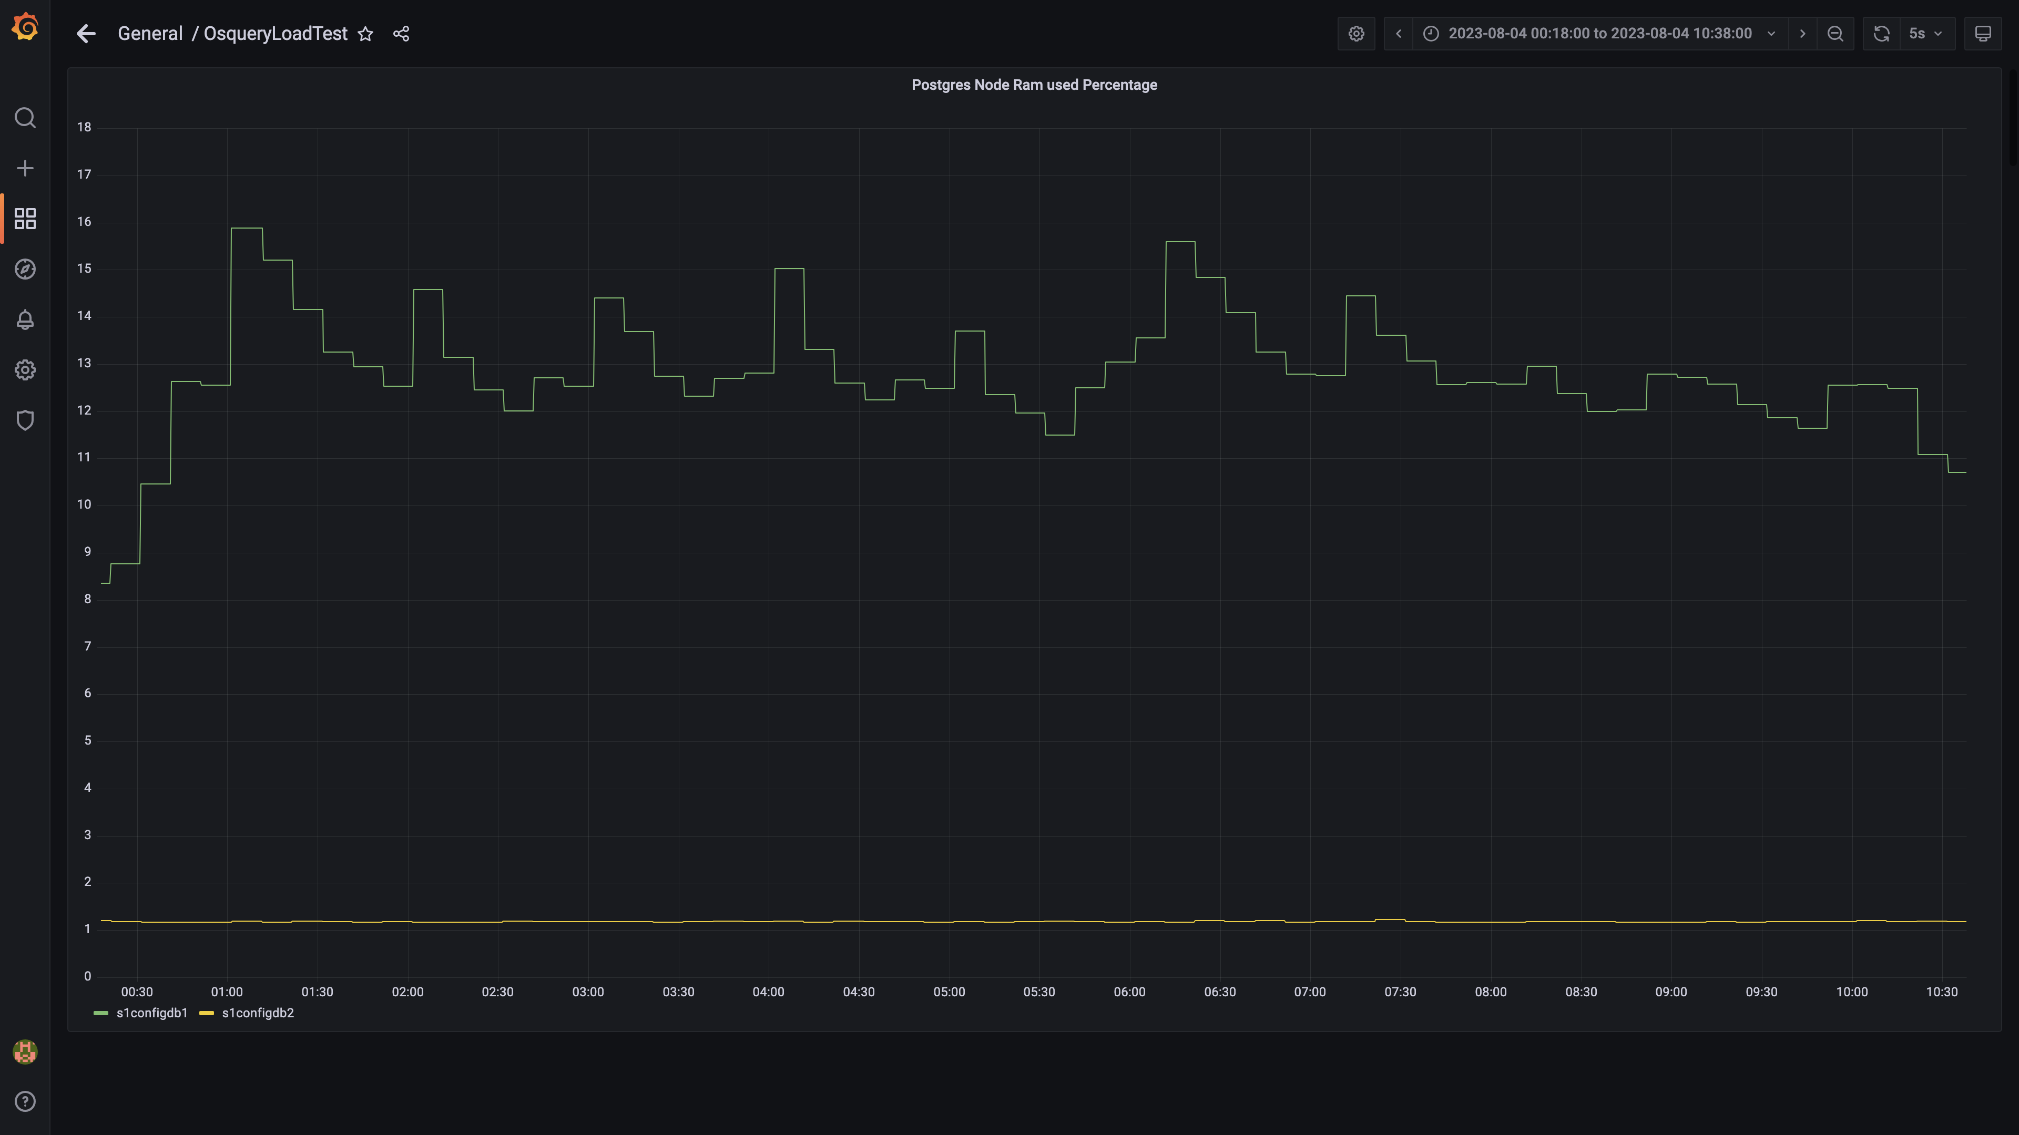

### Memory consumed by eventsdbingestion

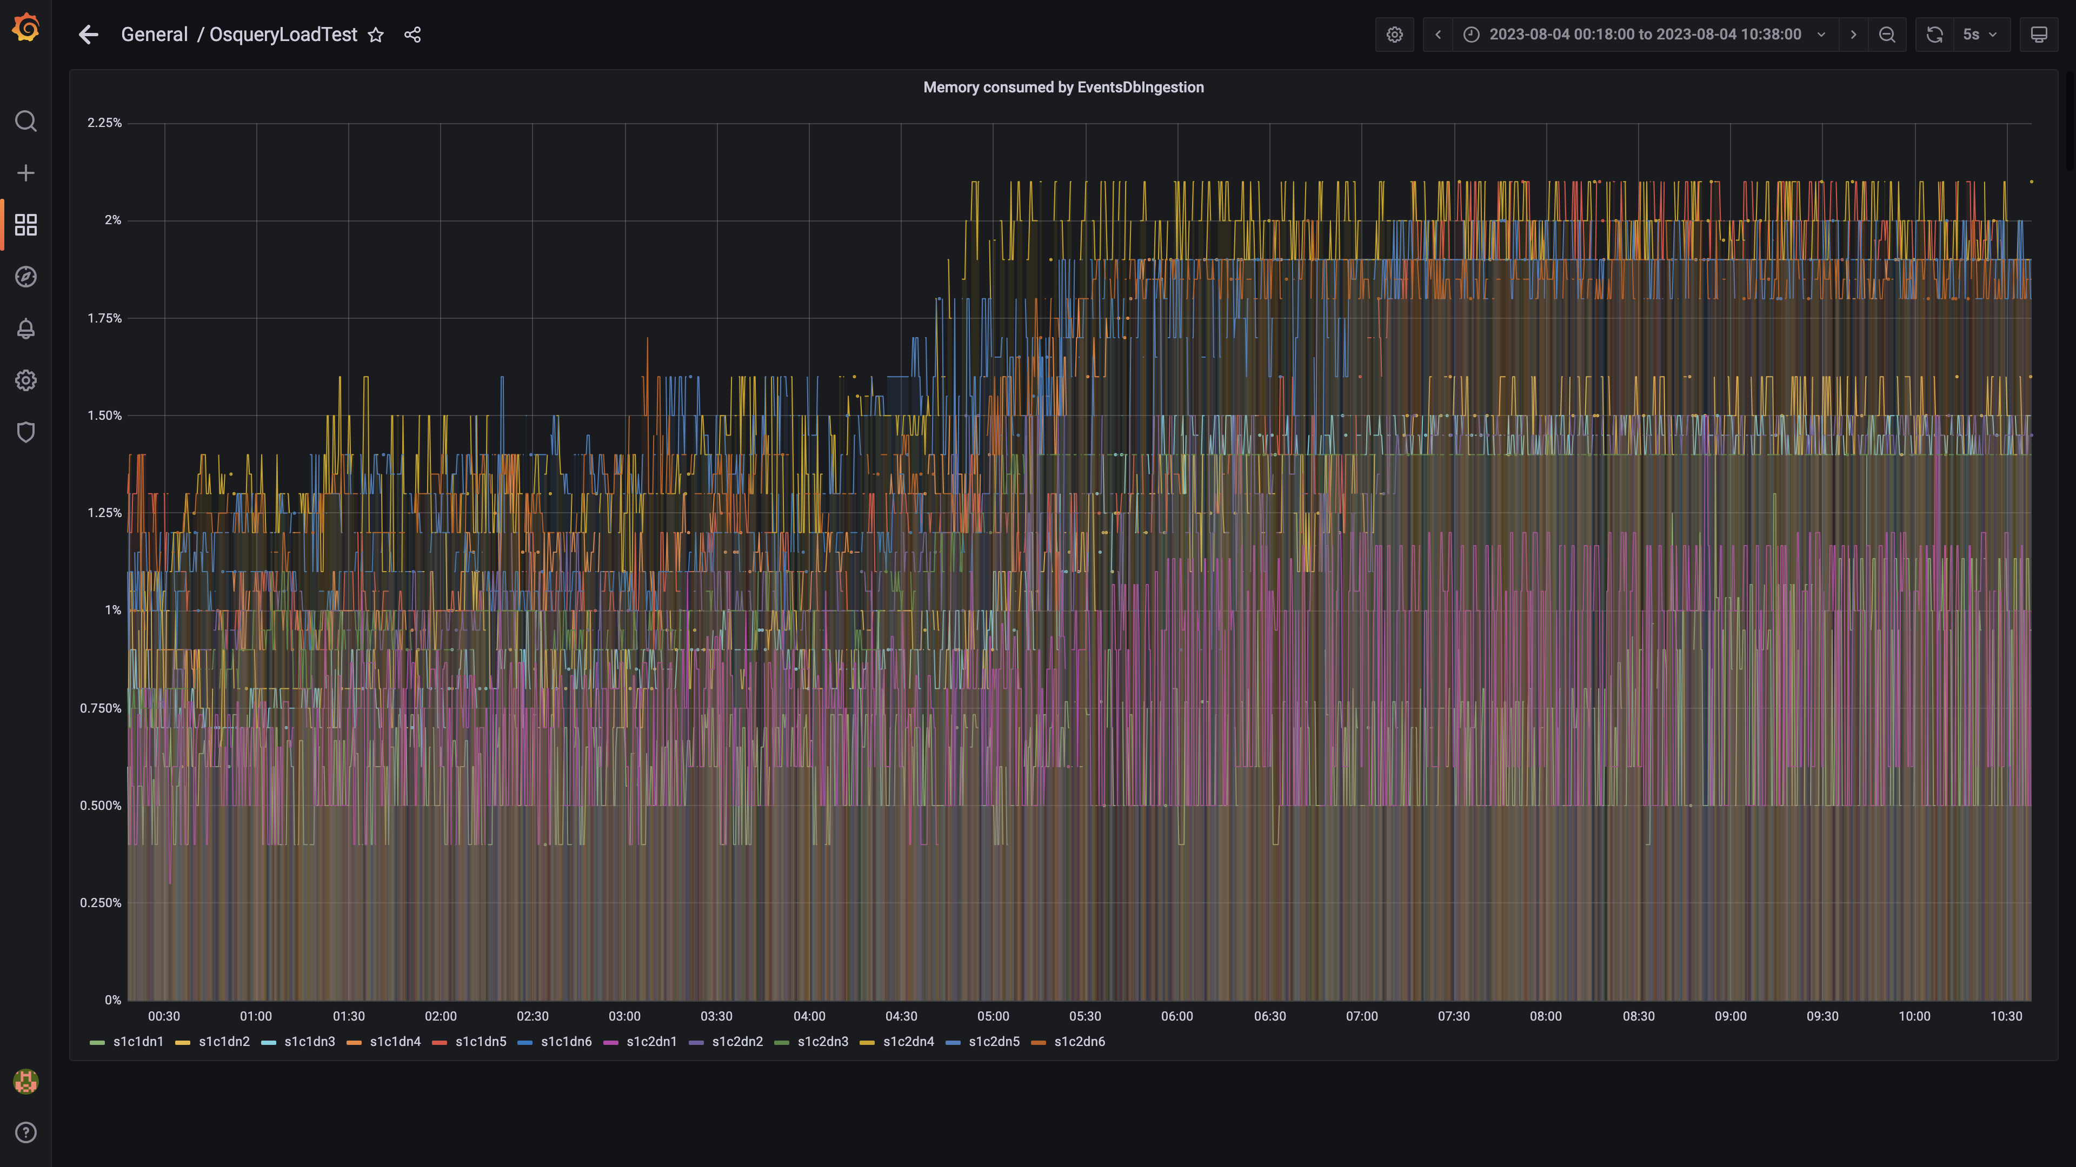

### Kafka disk used percentage

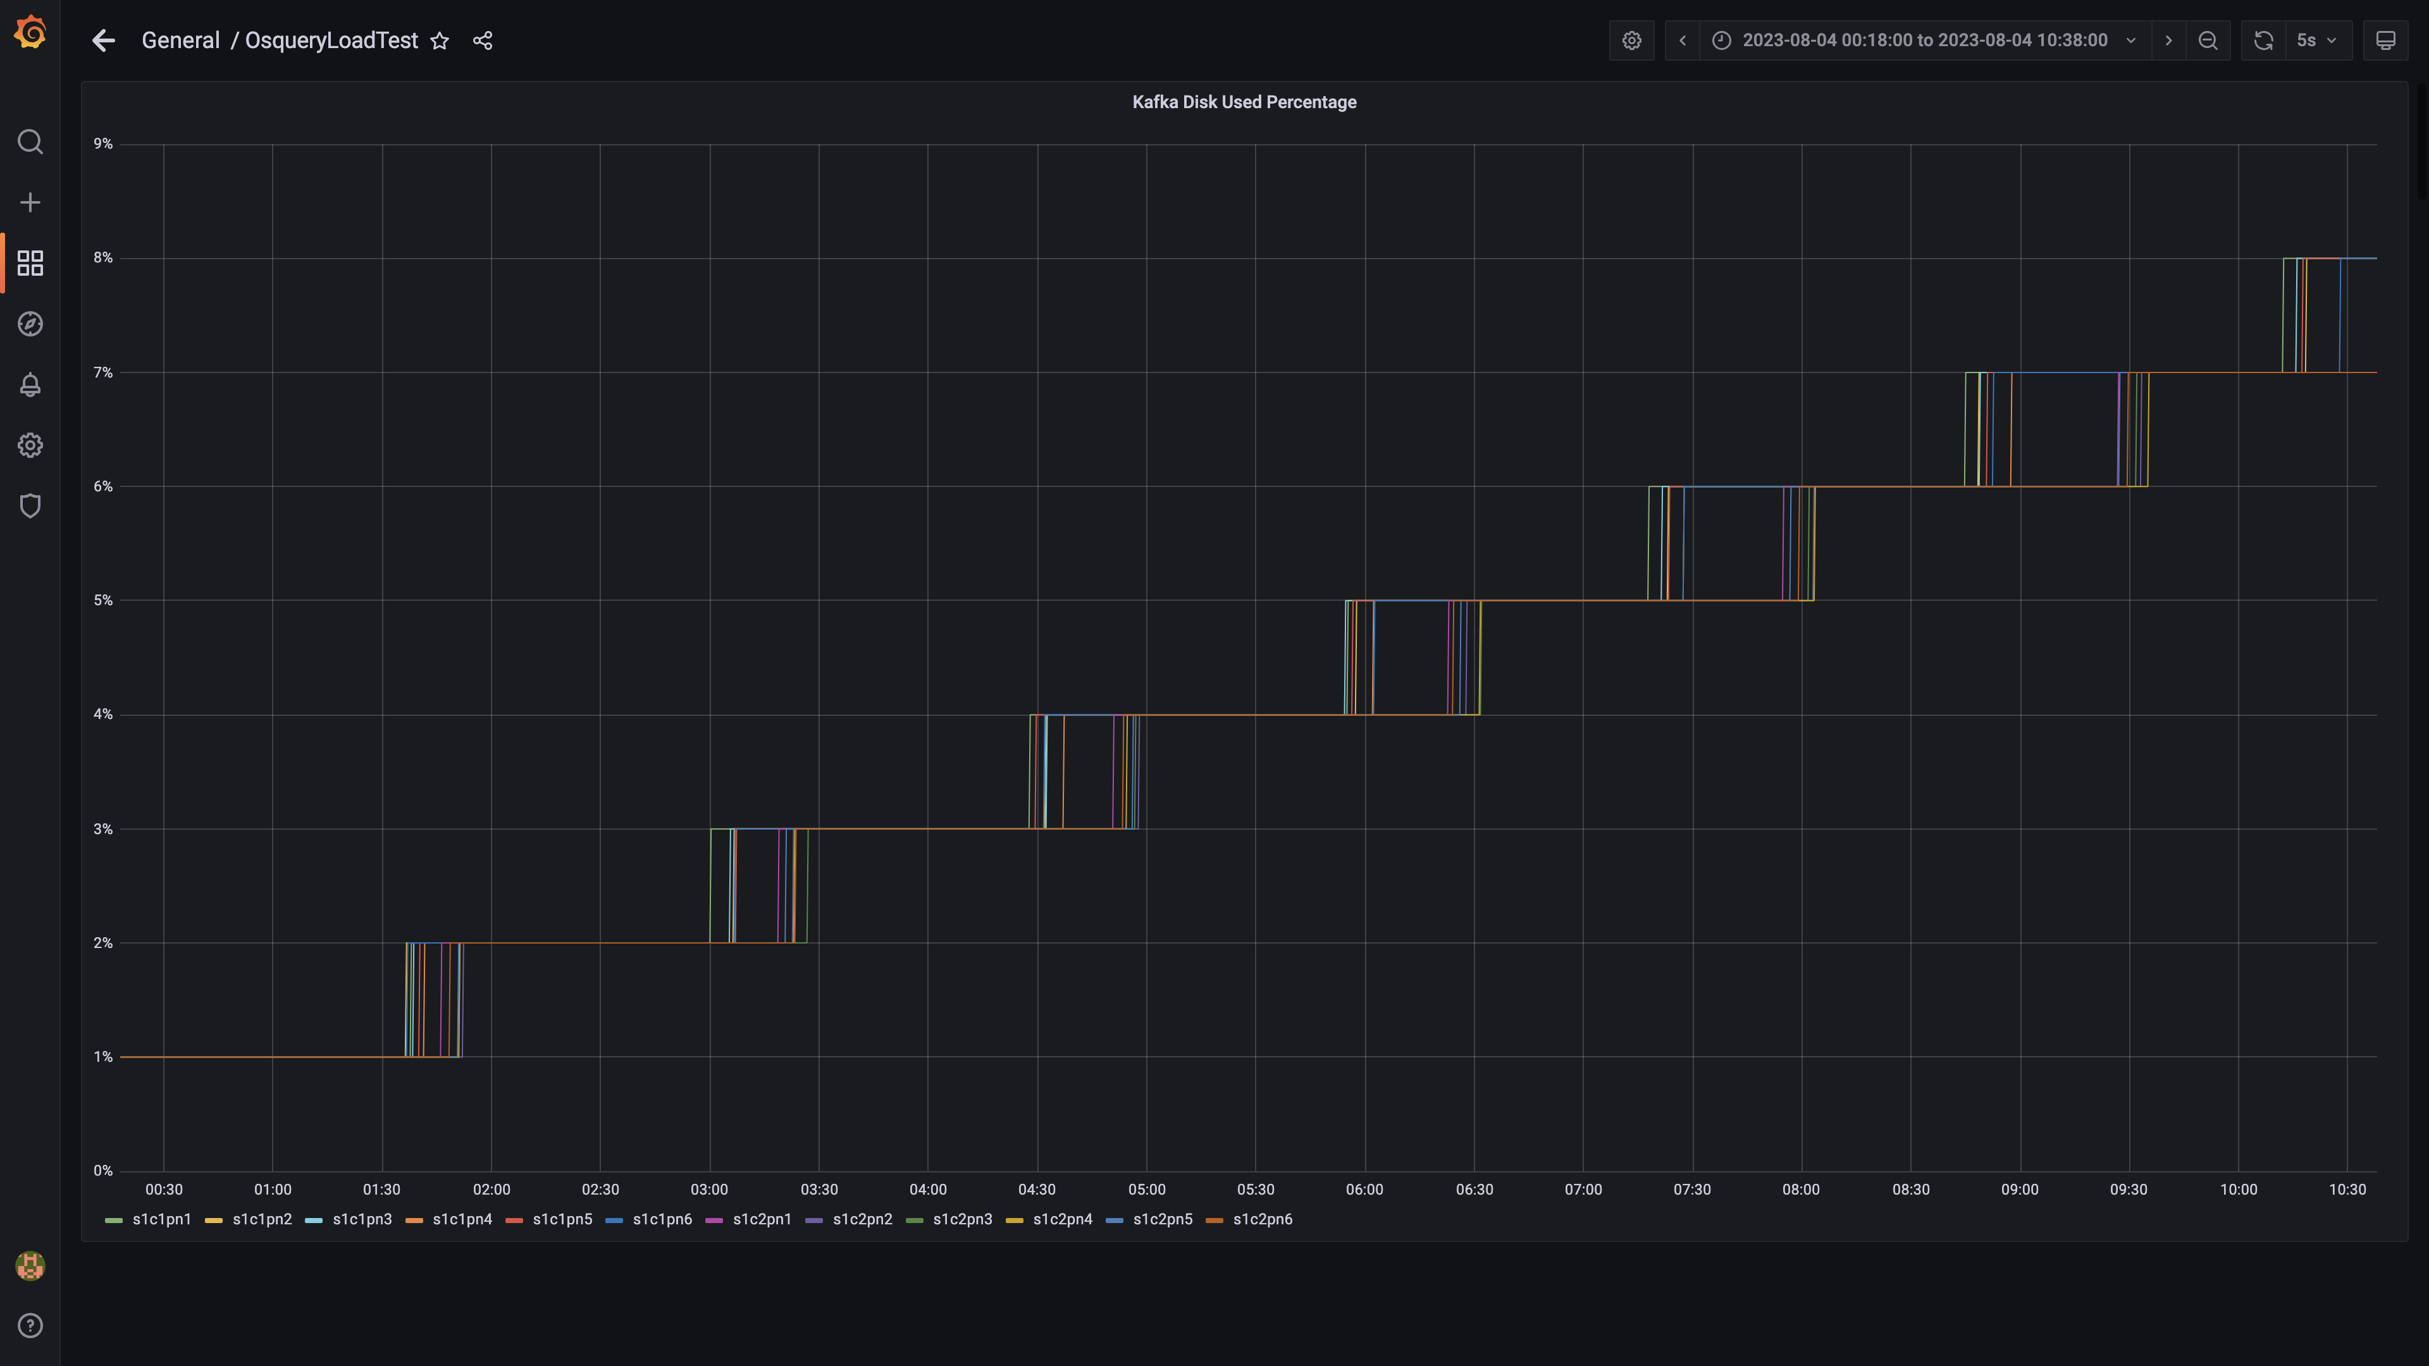

### Memory consumed by orc-compaction

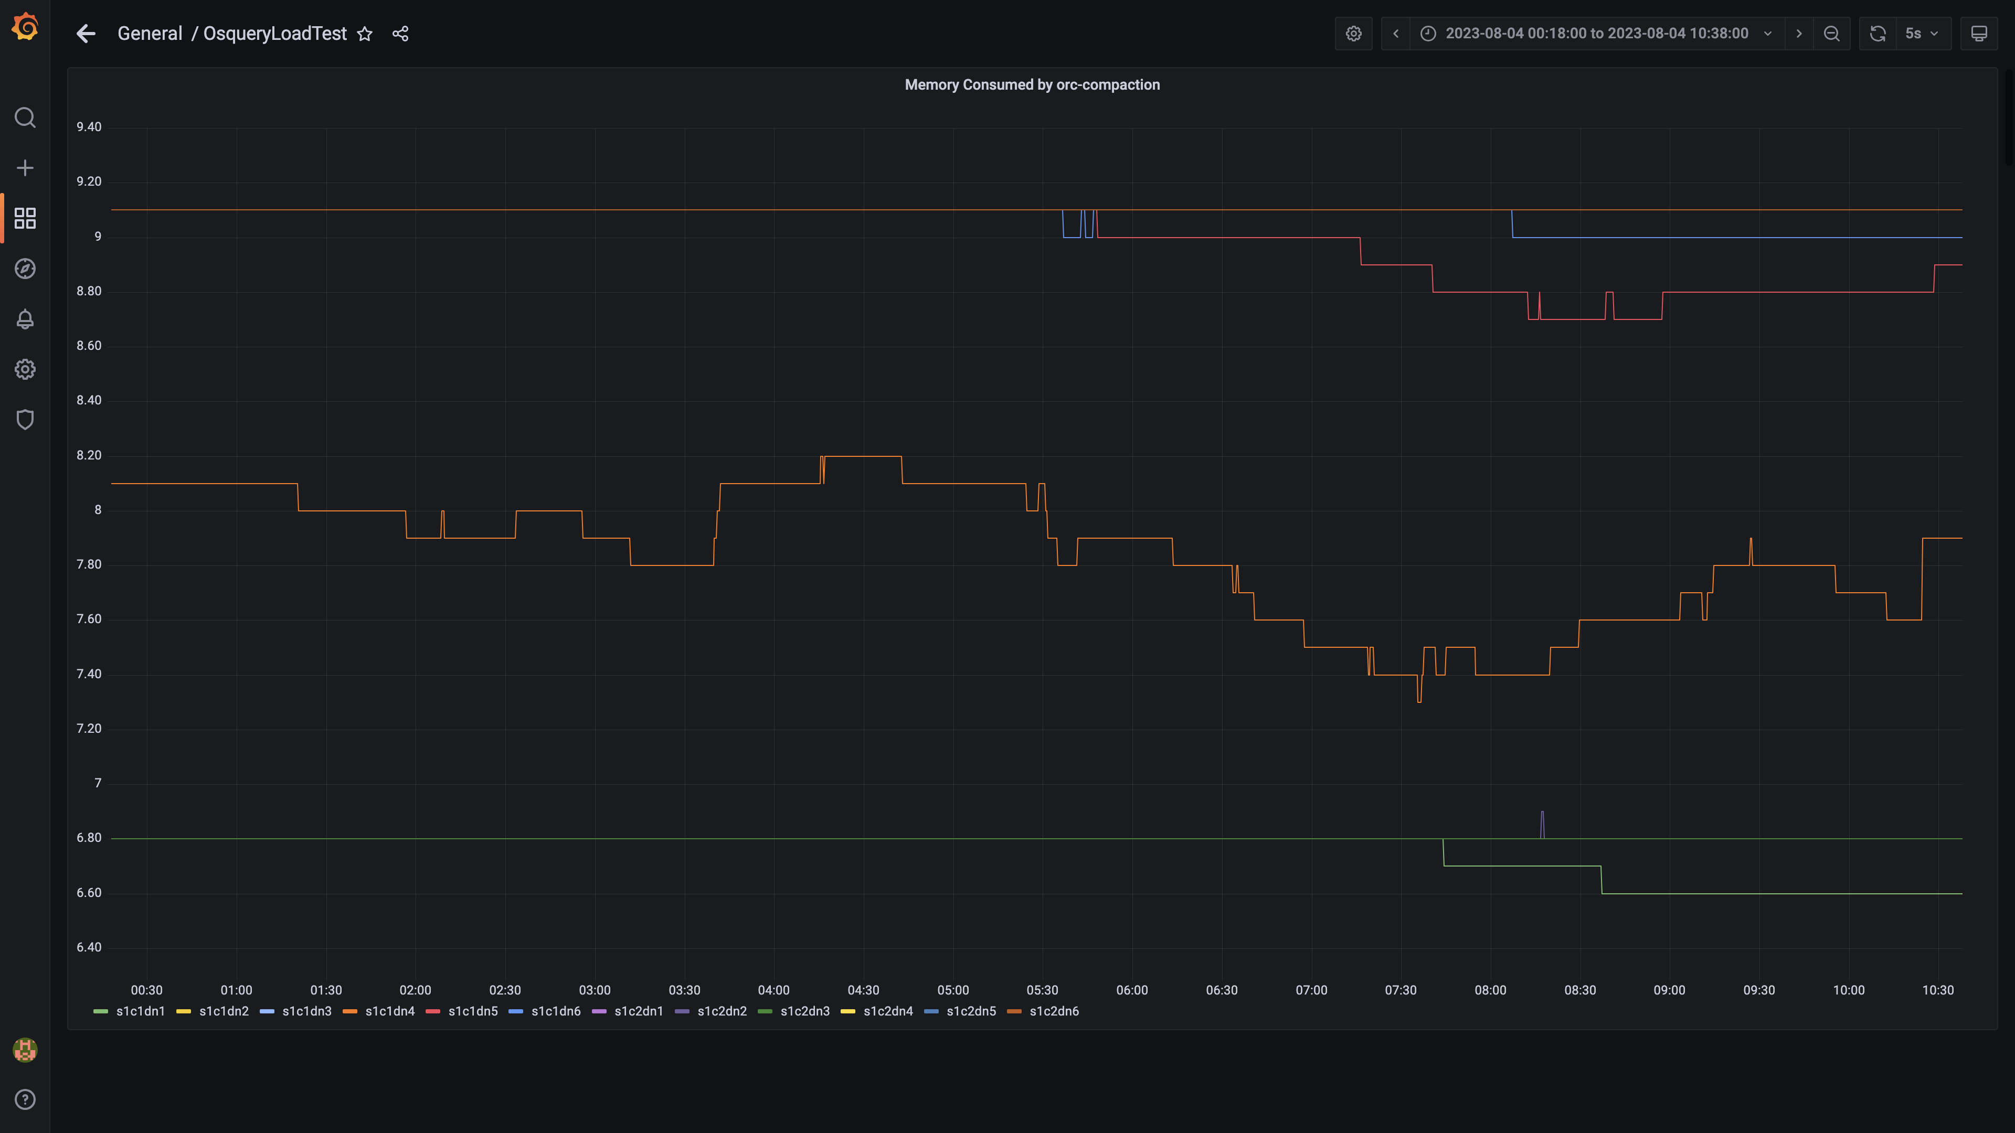

### Compliance summary consumer memory consumption

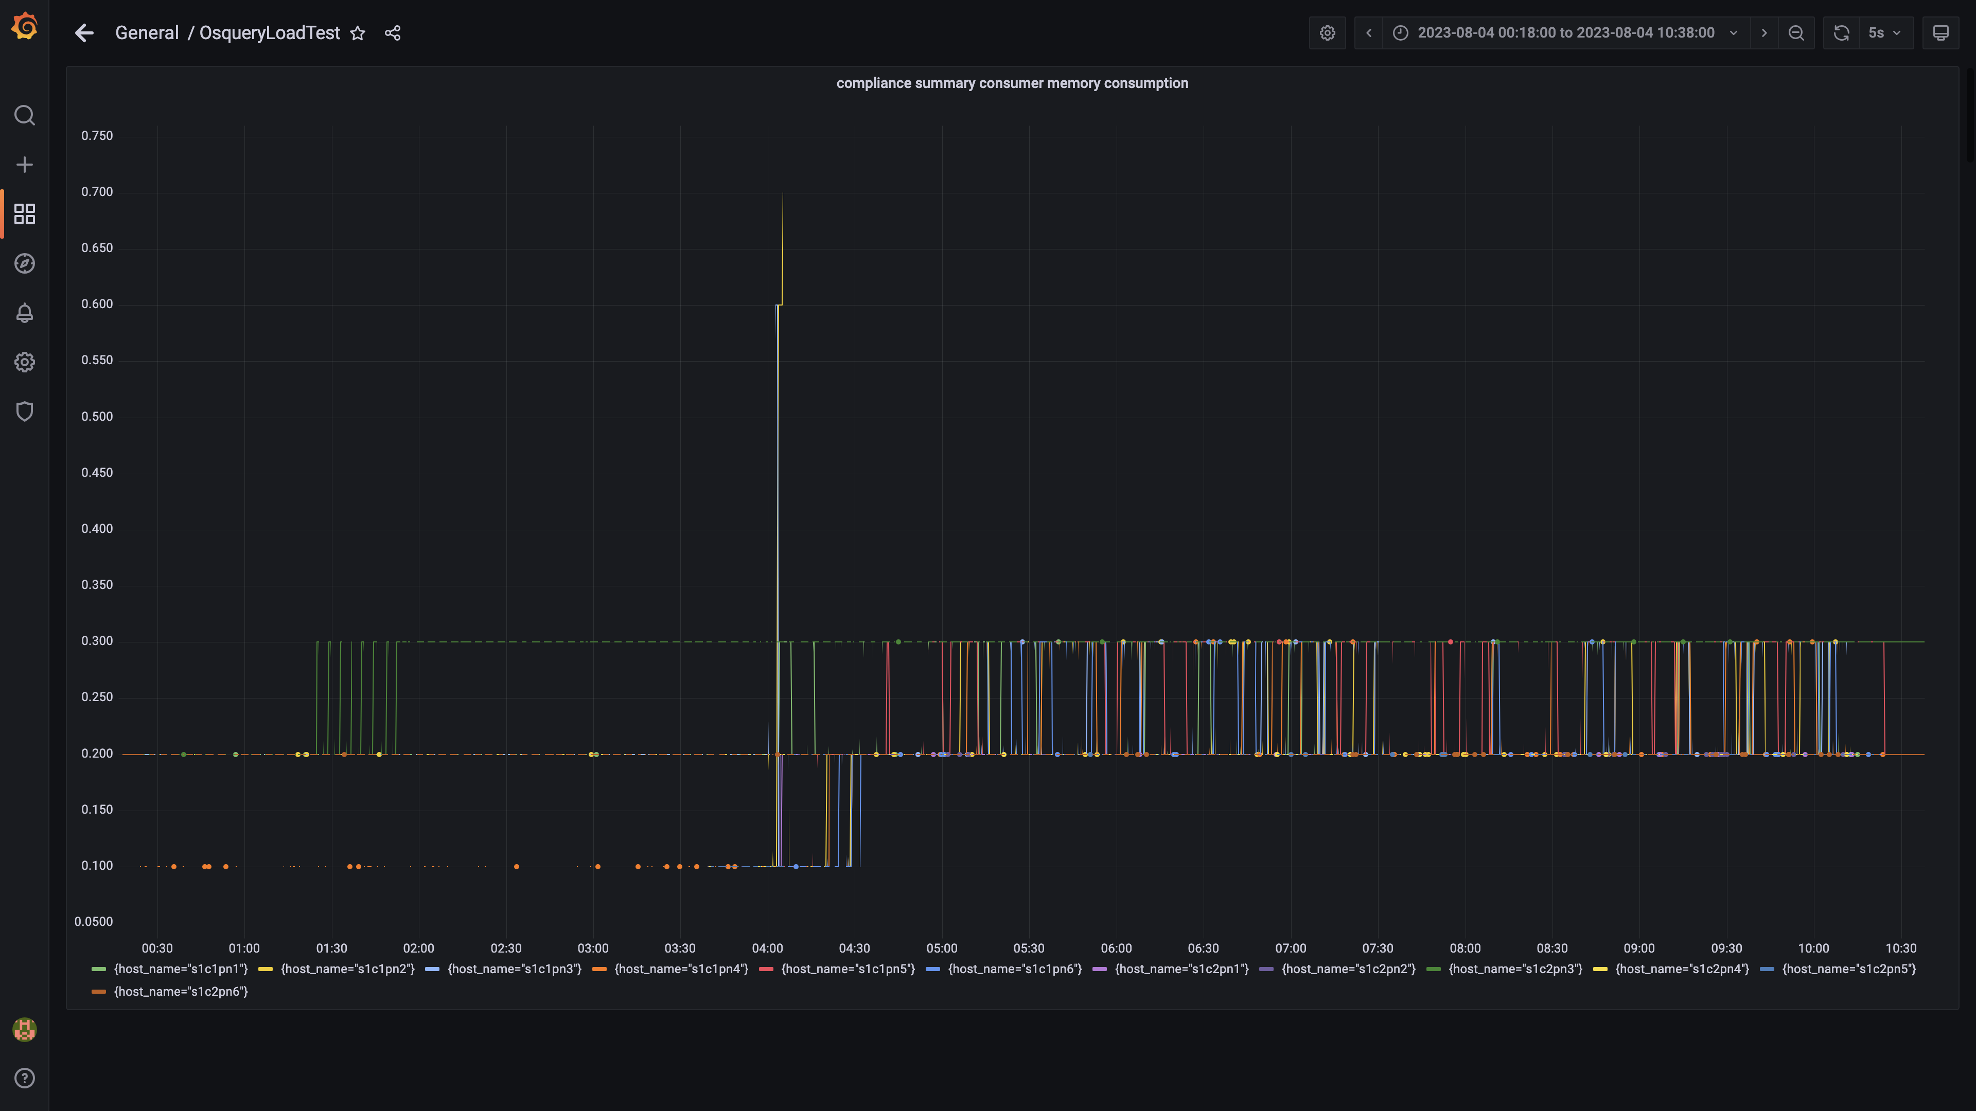

### Memory consumed by logger

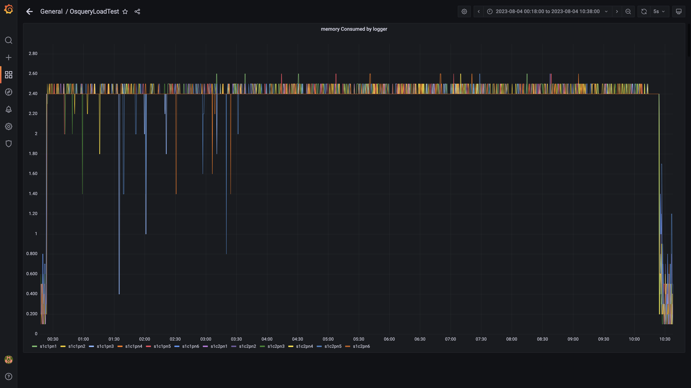

### Kafka memory used percentage

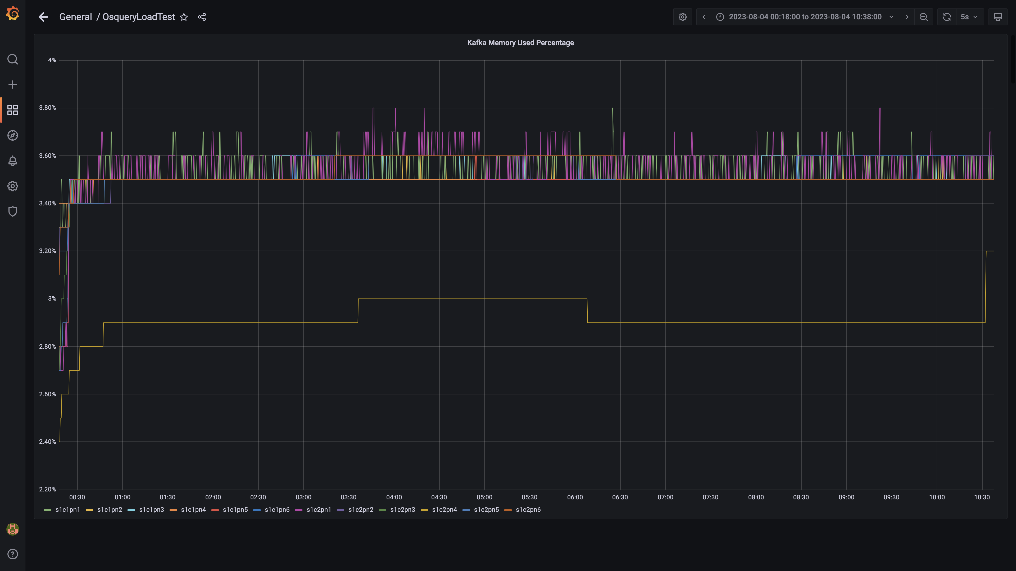

### Memory consumed by trino

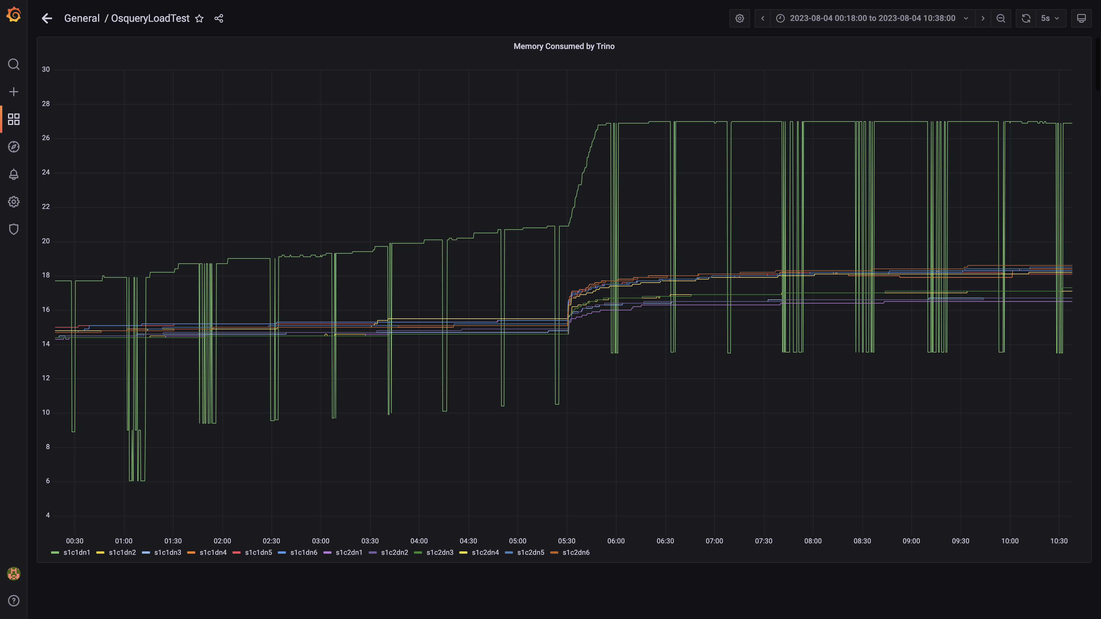

### Memory consumed by osqueryingestion

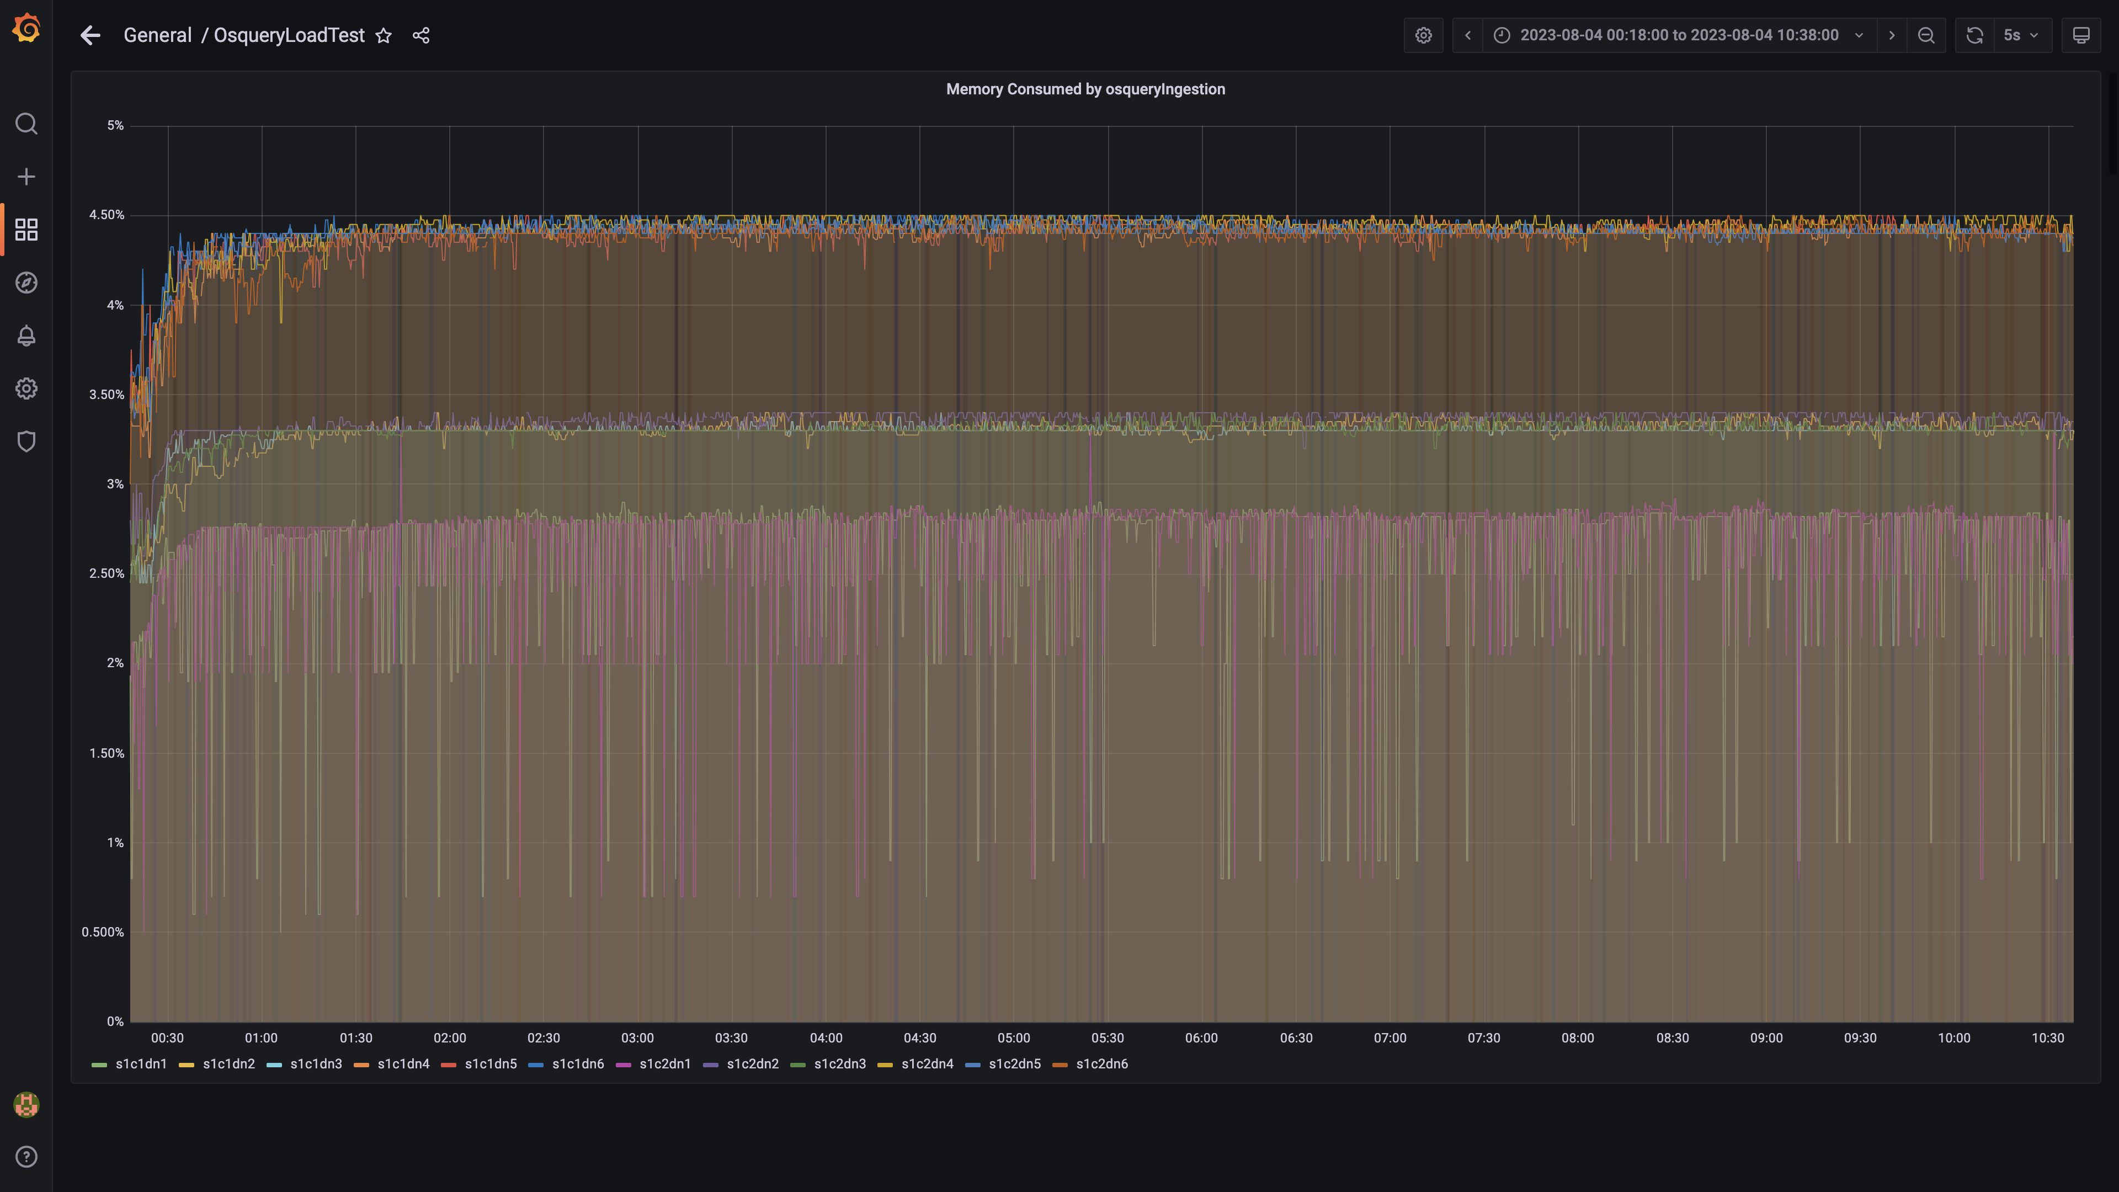

### Memory consumed by spark-worker

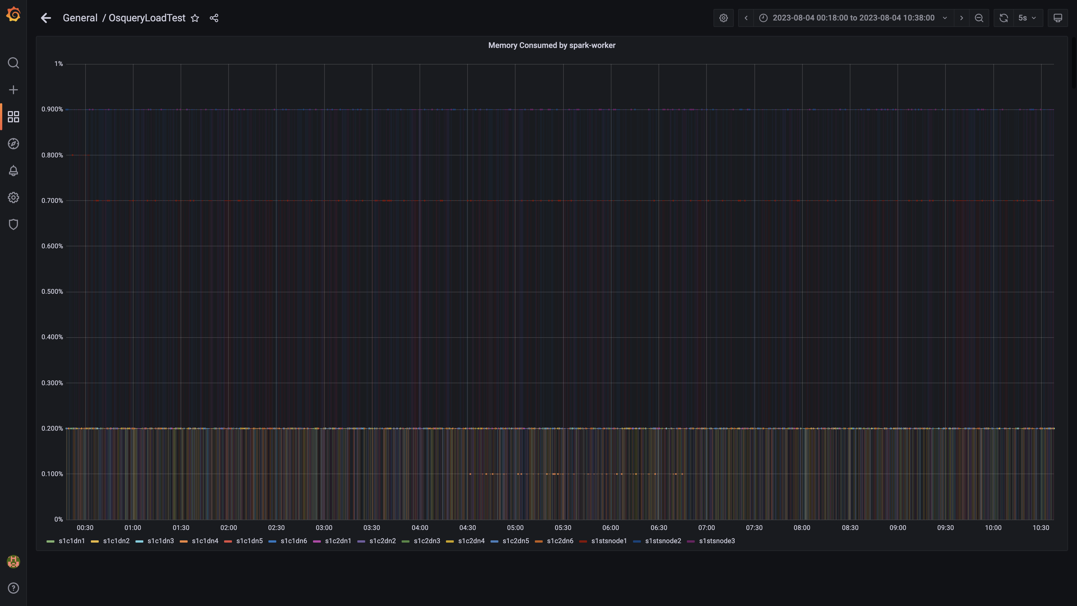

### Memory consumed by ruleengine

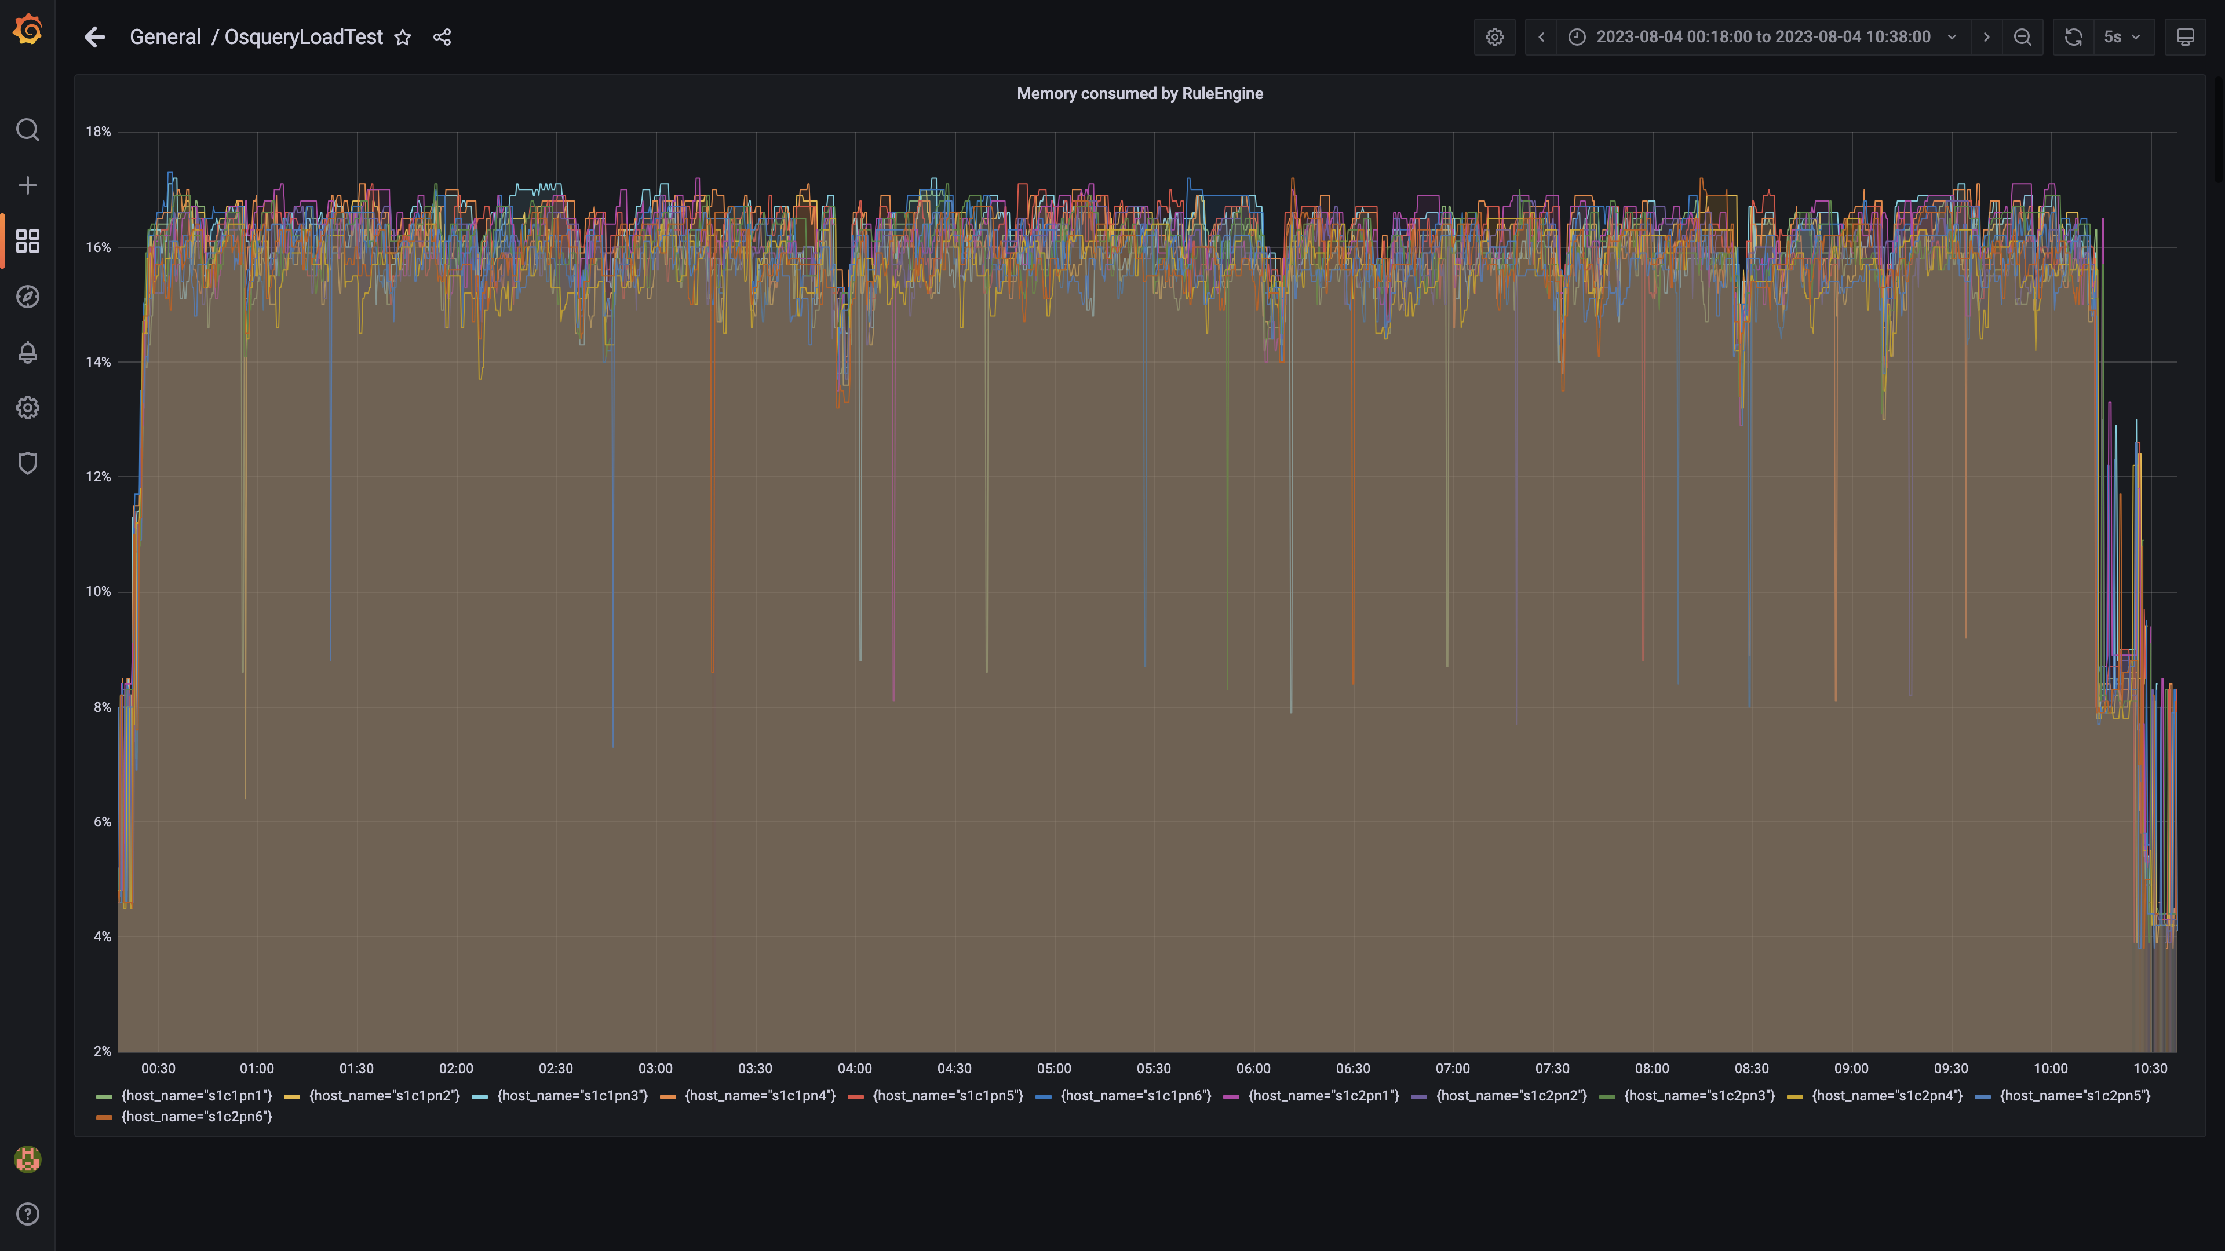

### Memory consumed by configdb

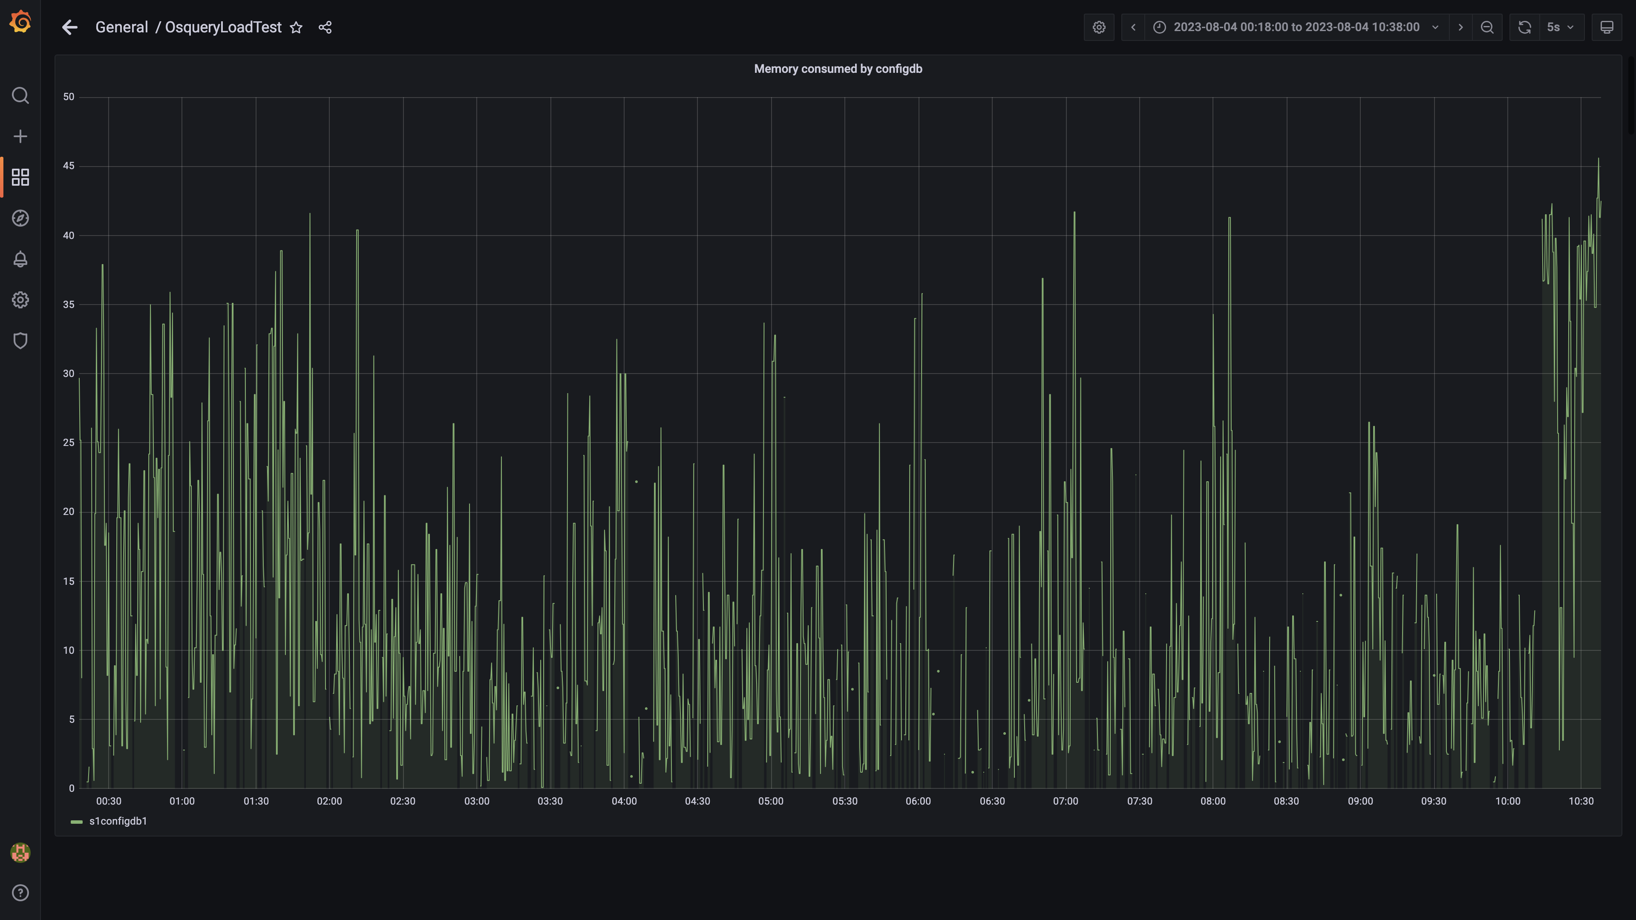

### Memory consumed by data archival

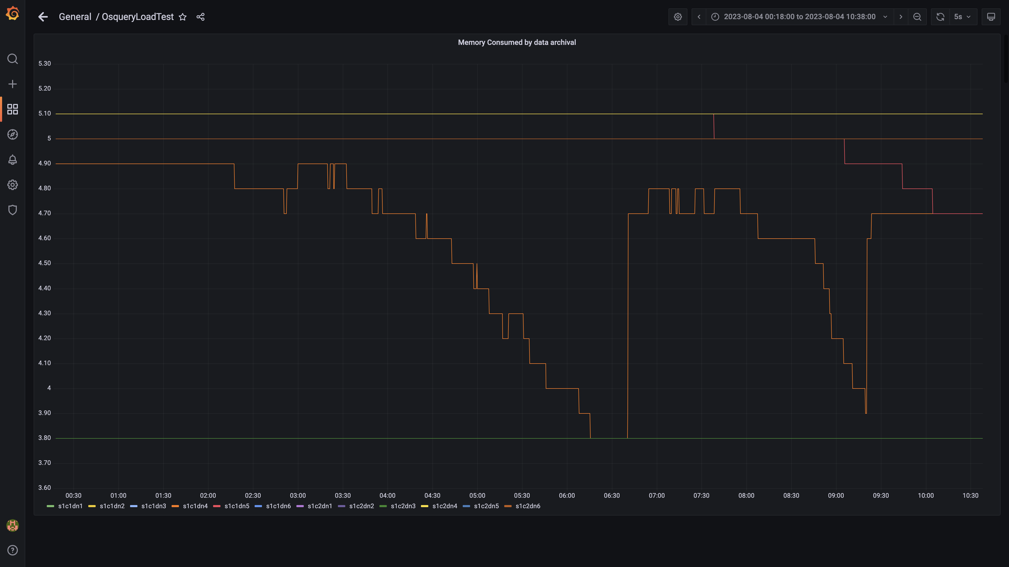

### Debezium memory usage

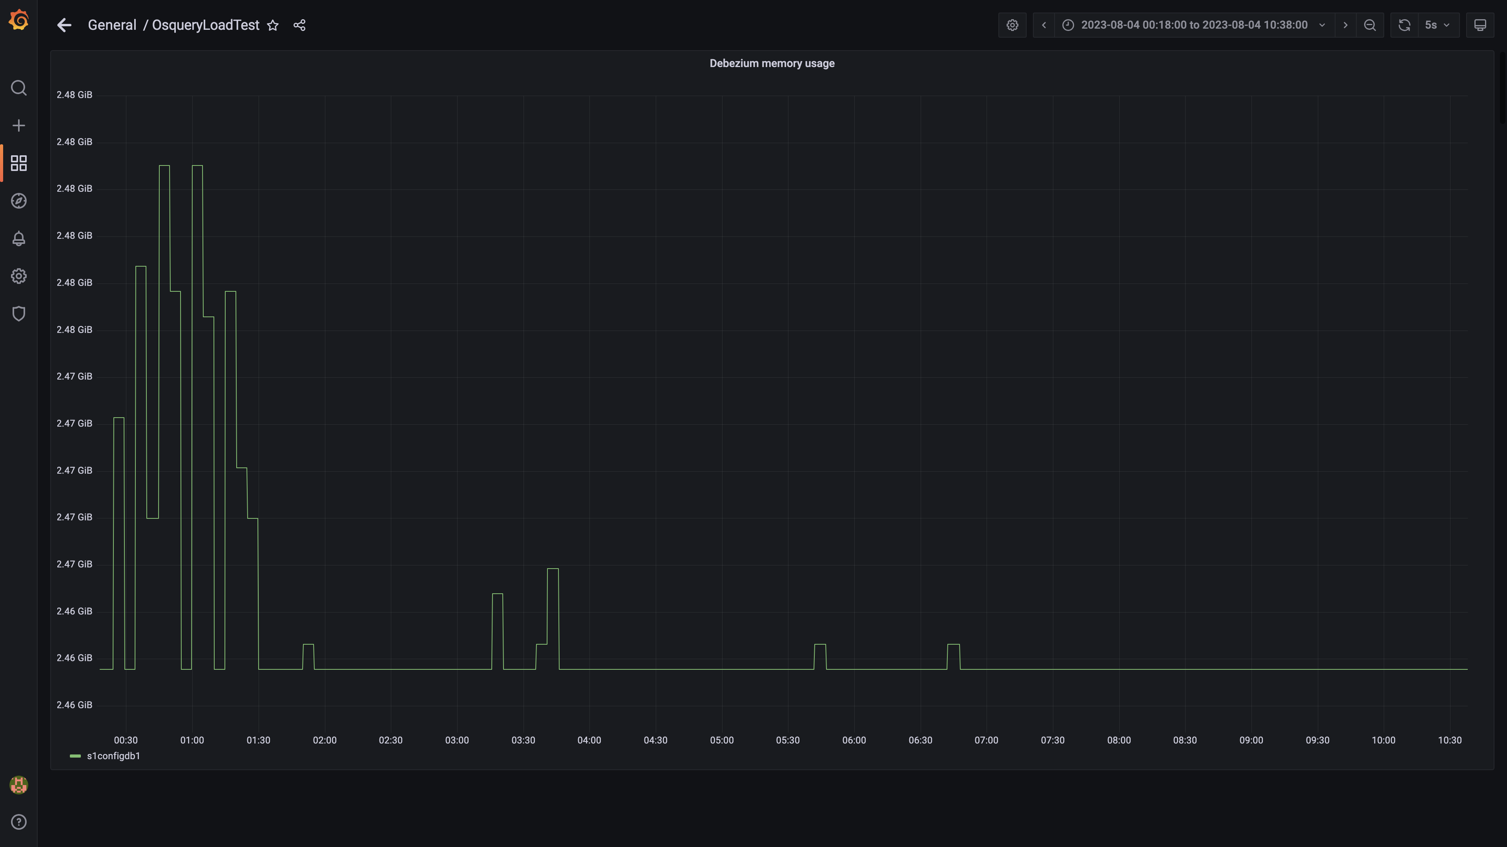

### Memory consumed by redis server

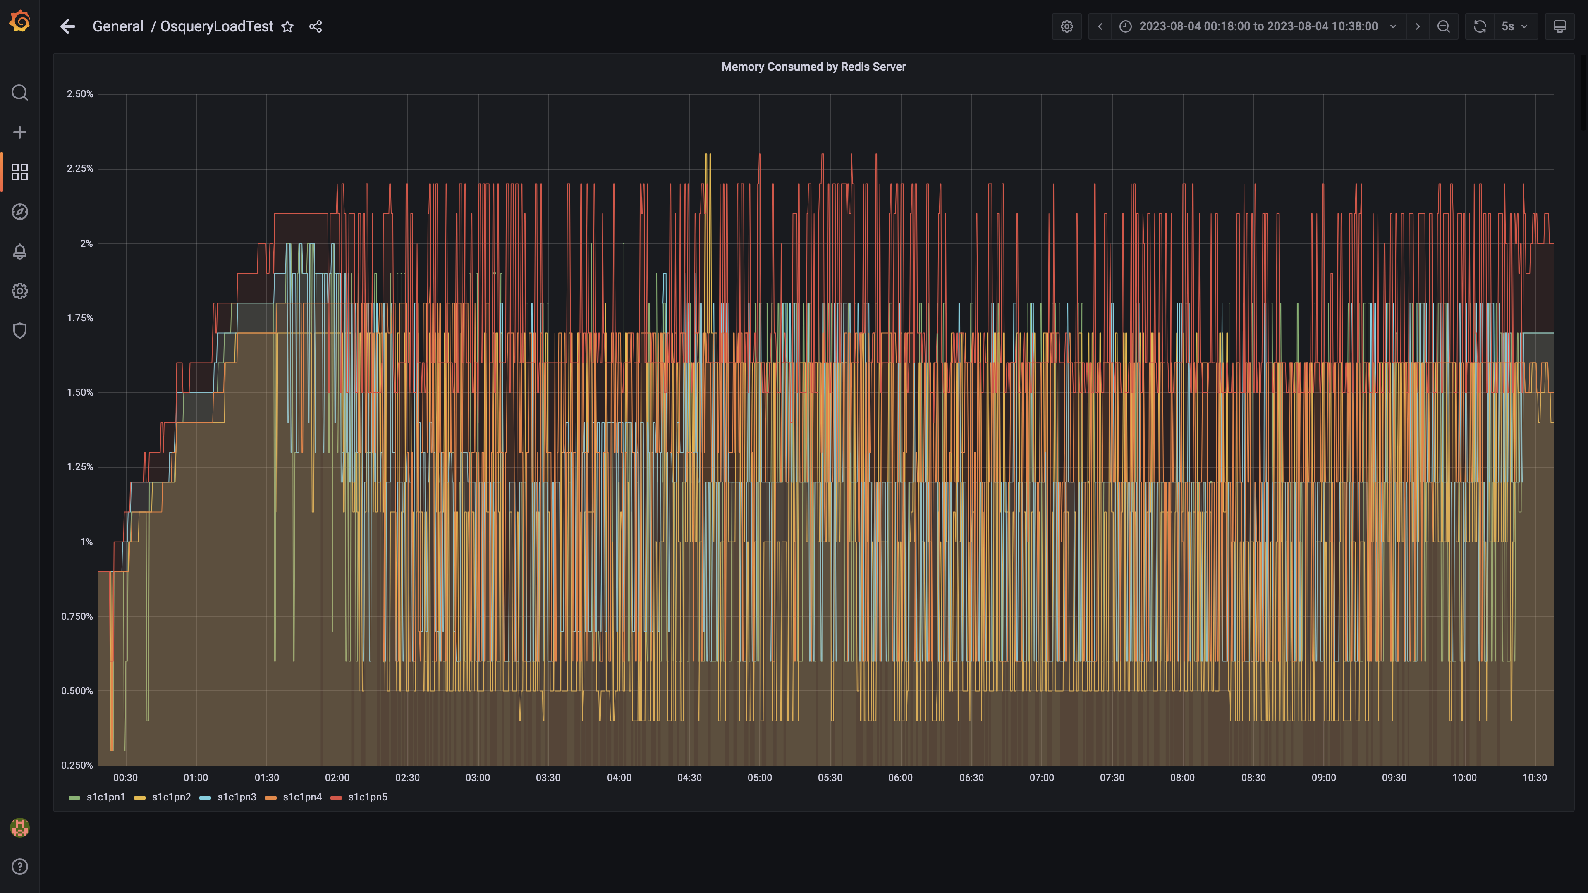

### Memory consumed by tls

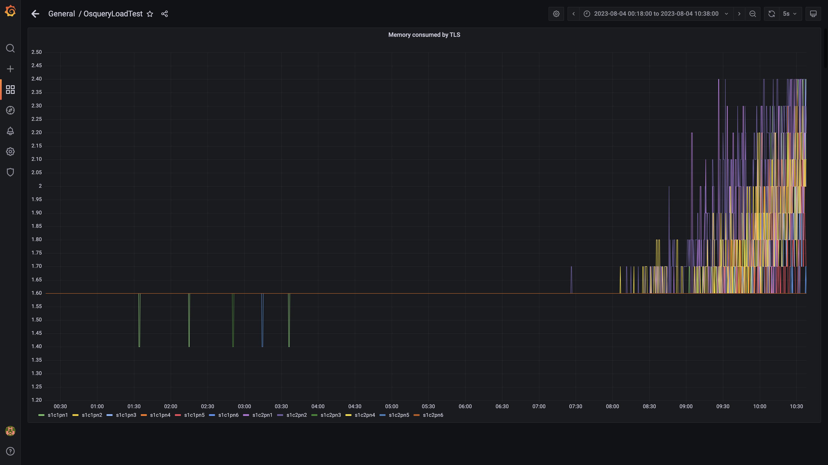

### Airflow memory usage

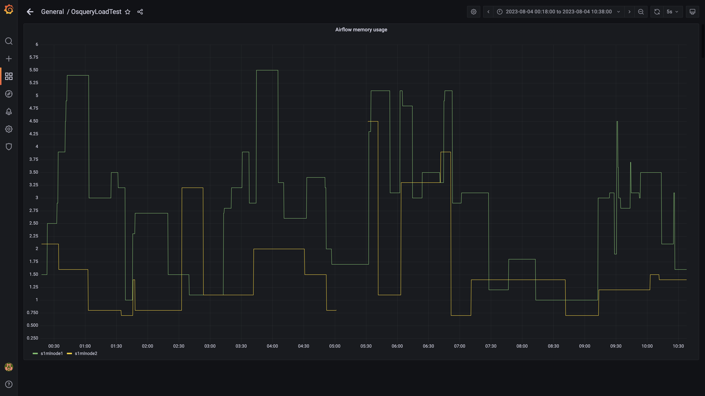

### Postgres node cpu busy percent

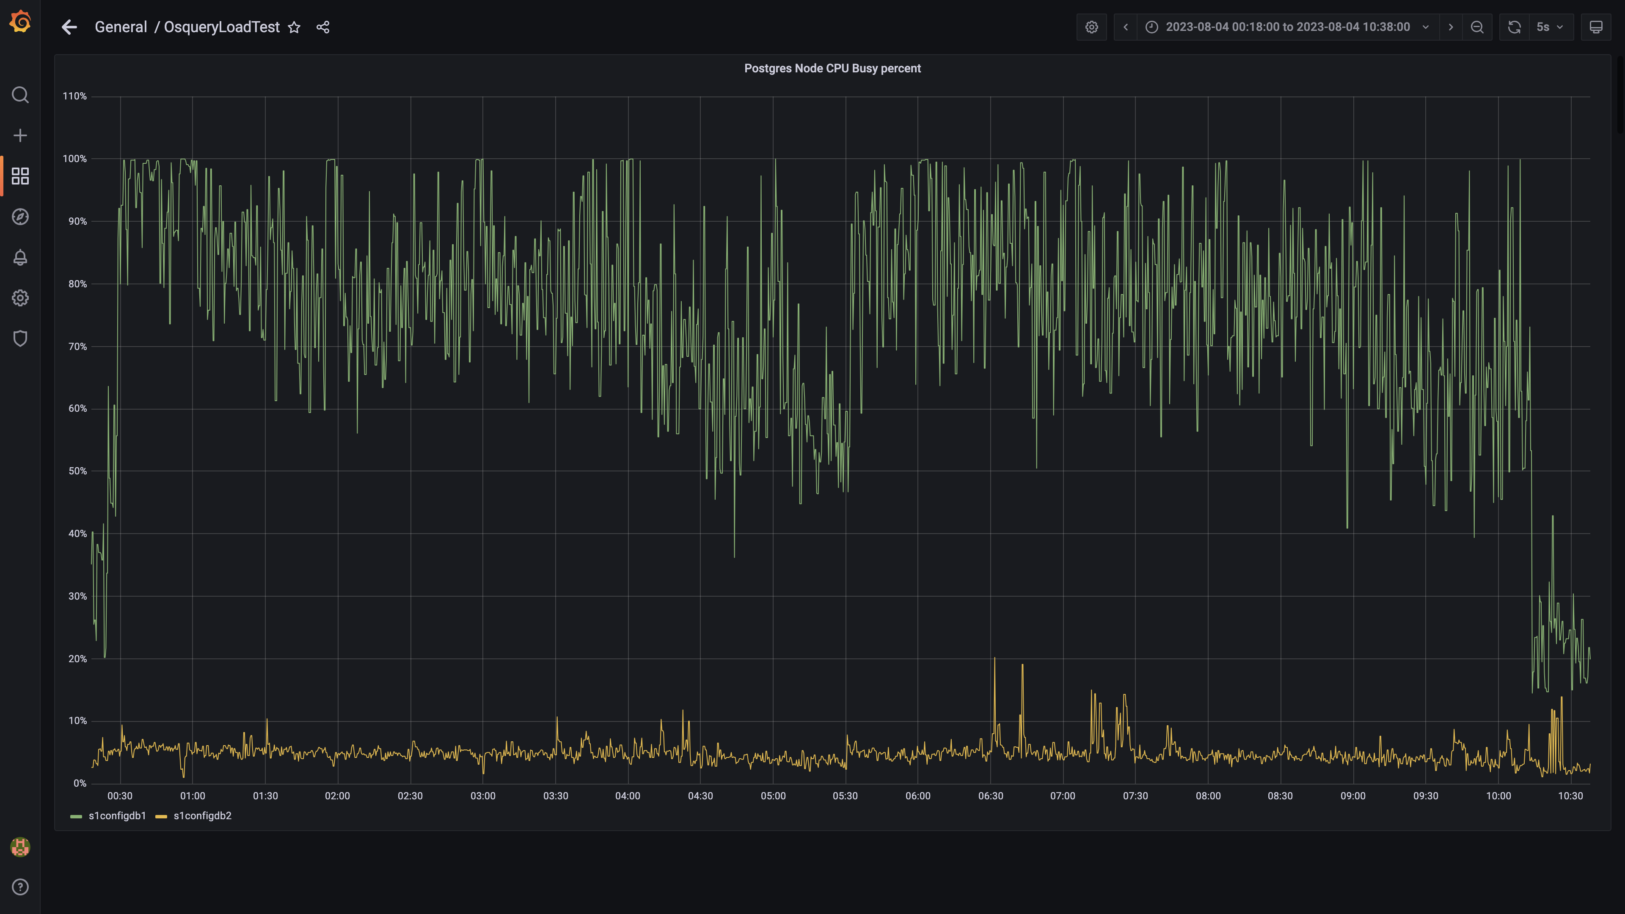

### Process node cpu busy percent

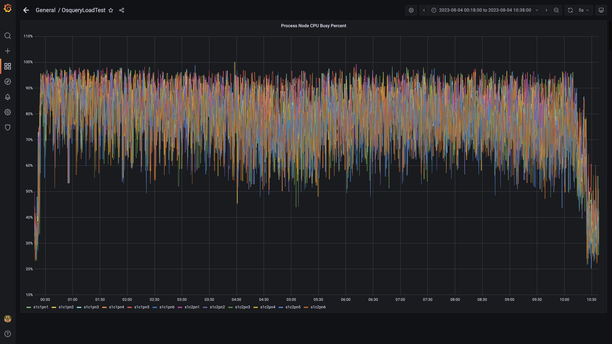

### Data node cpu busy percent

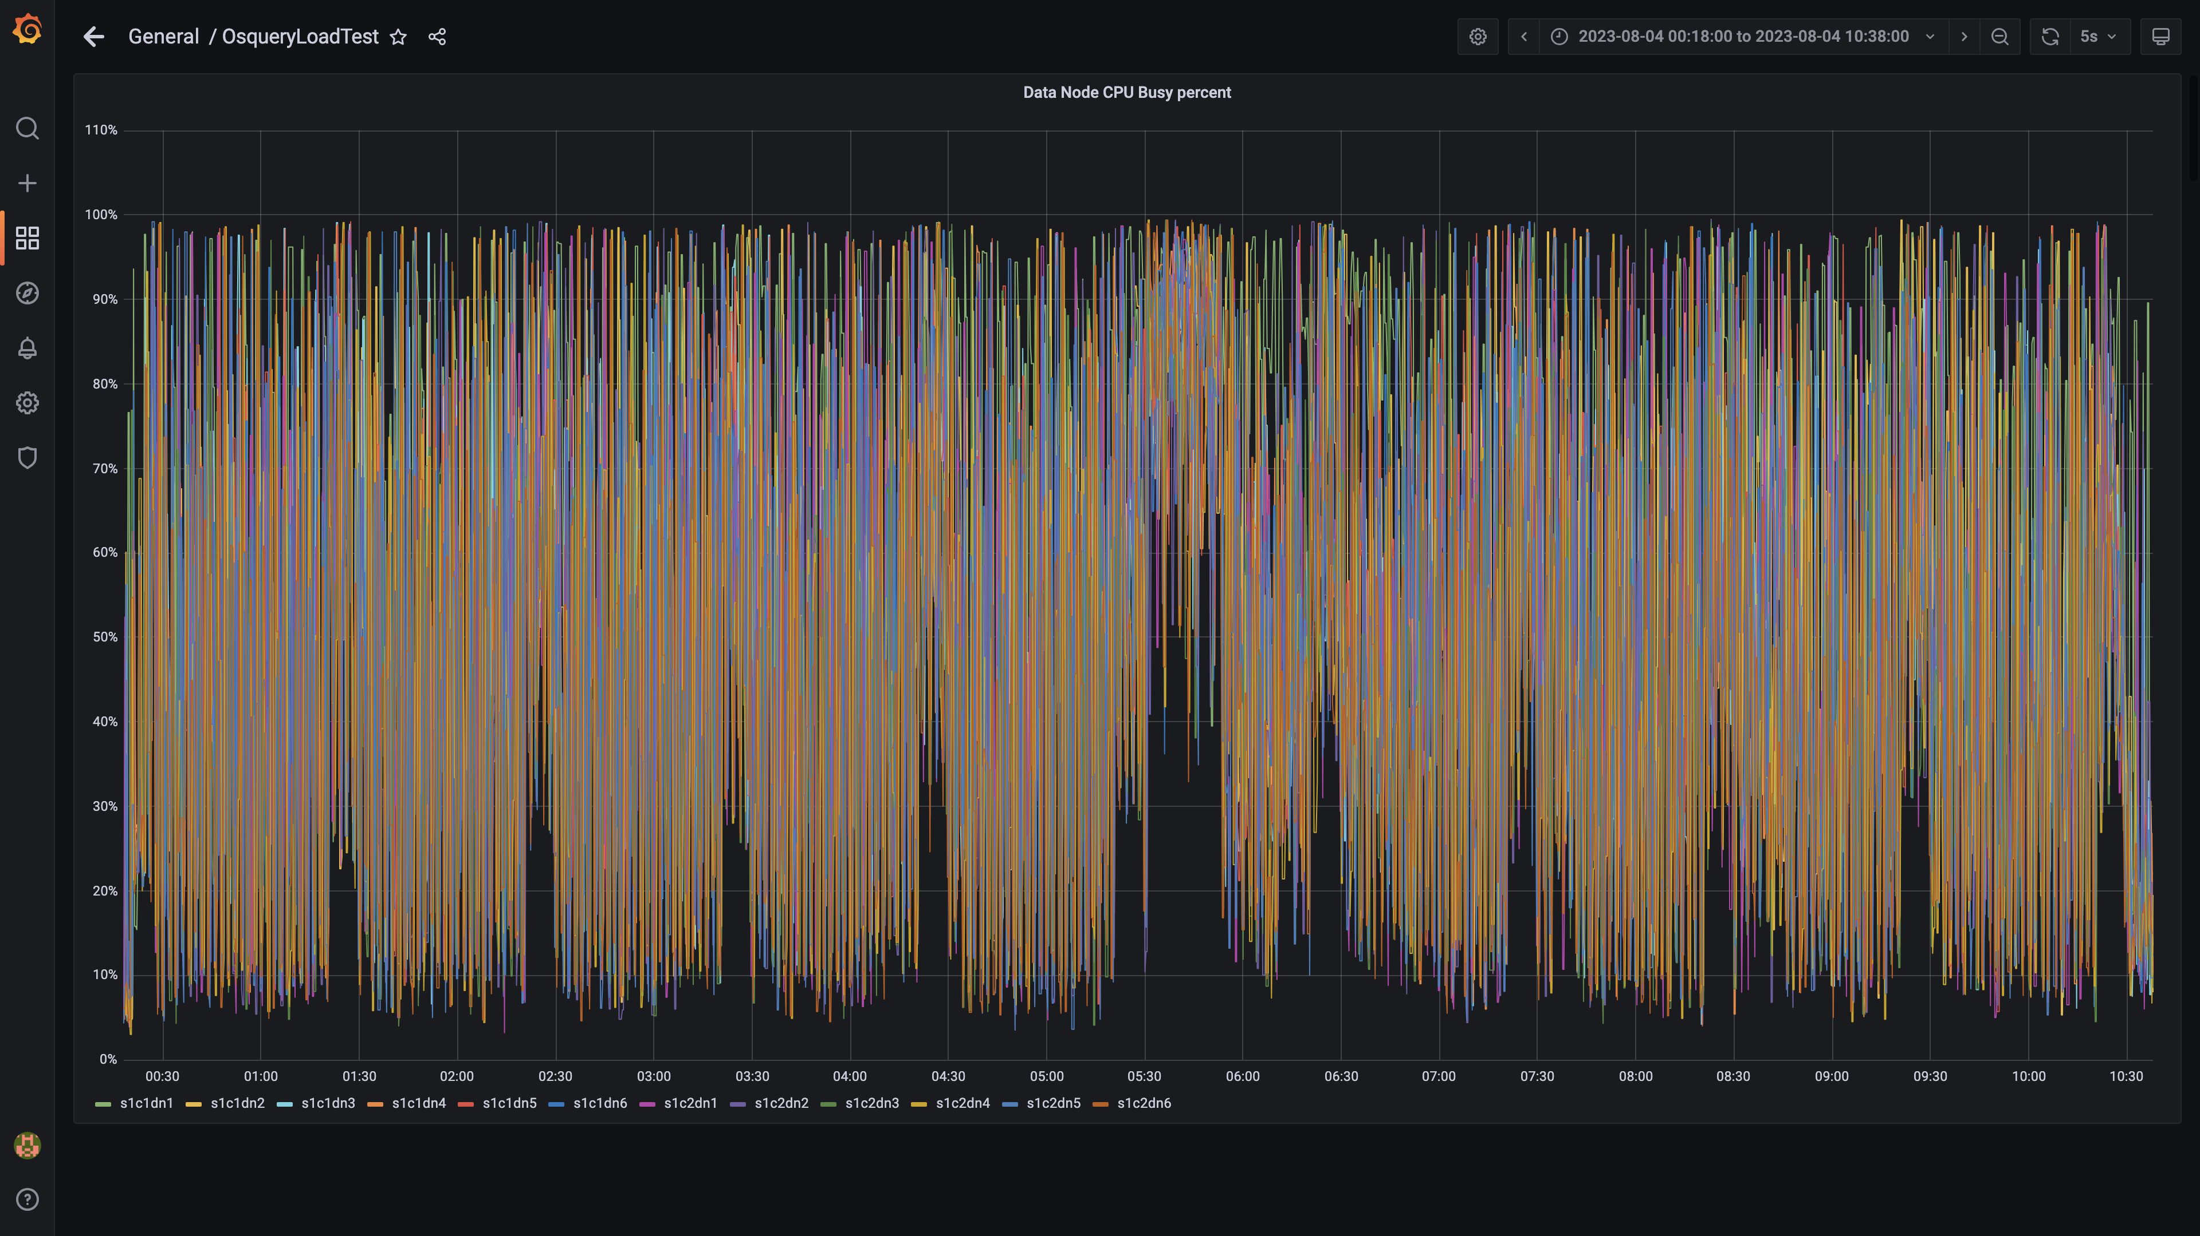

### Postgres-configdb cpu used percentage

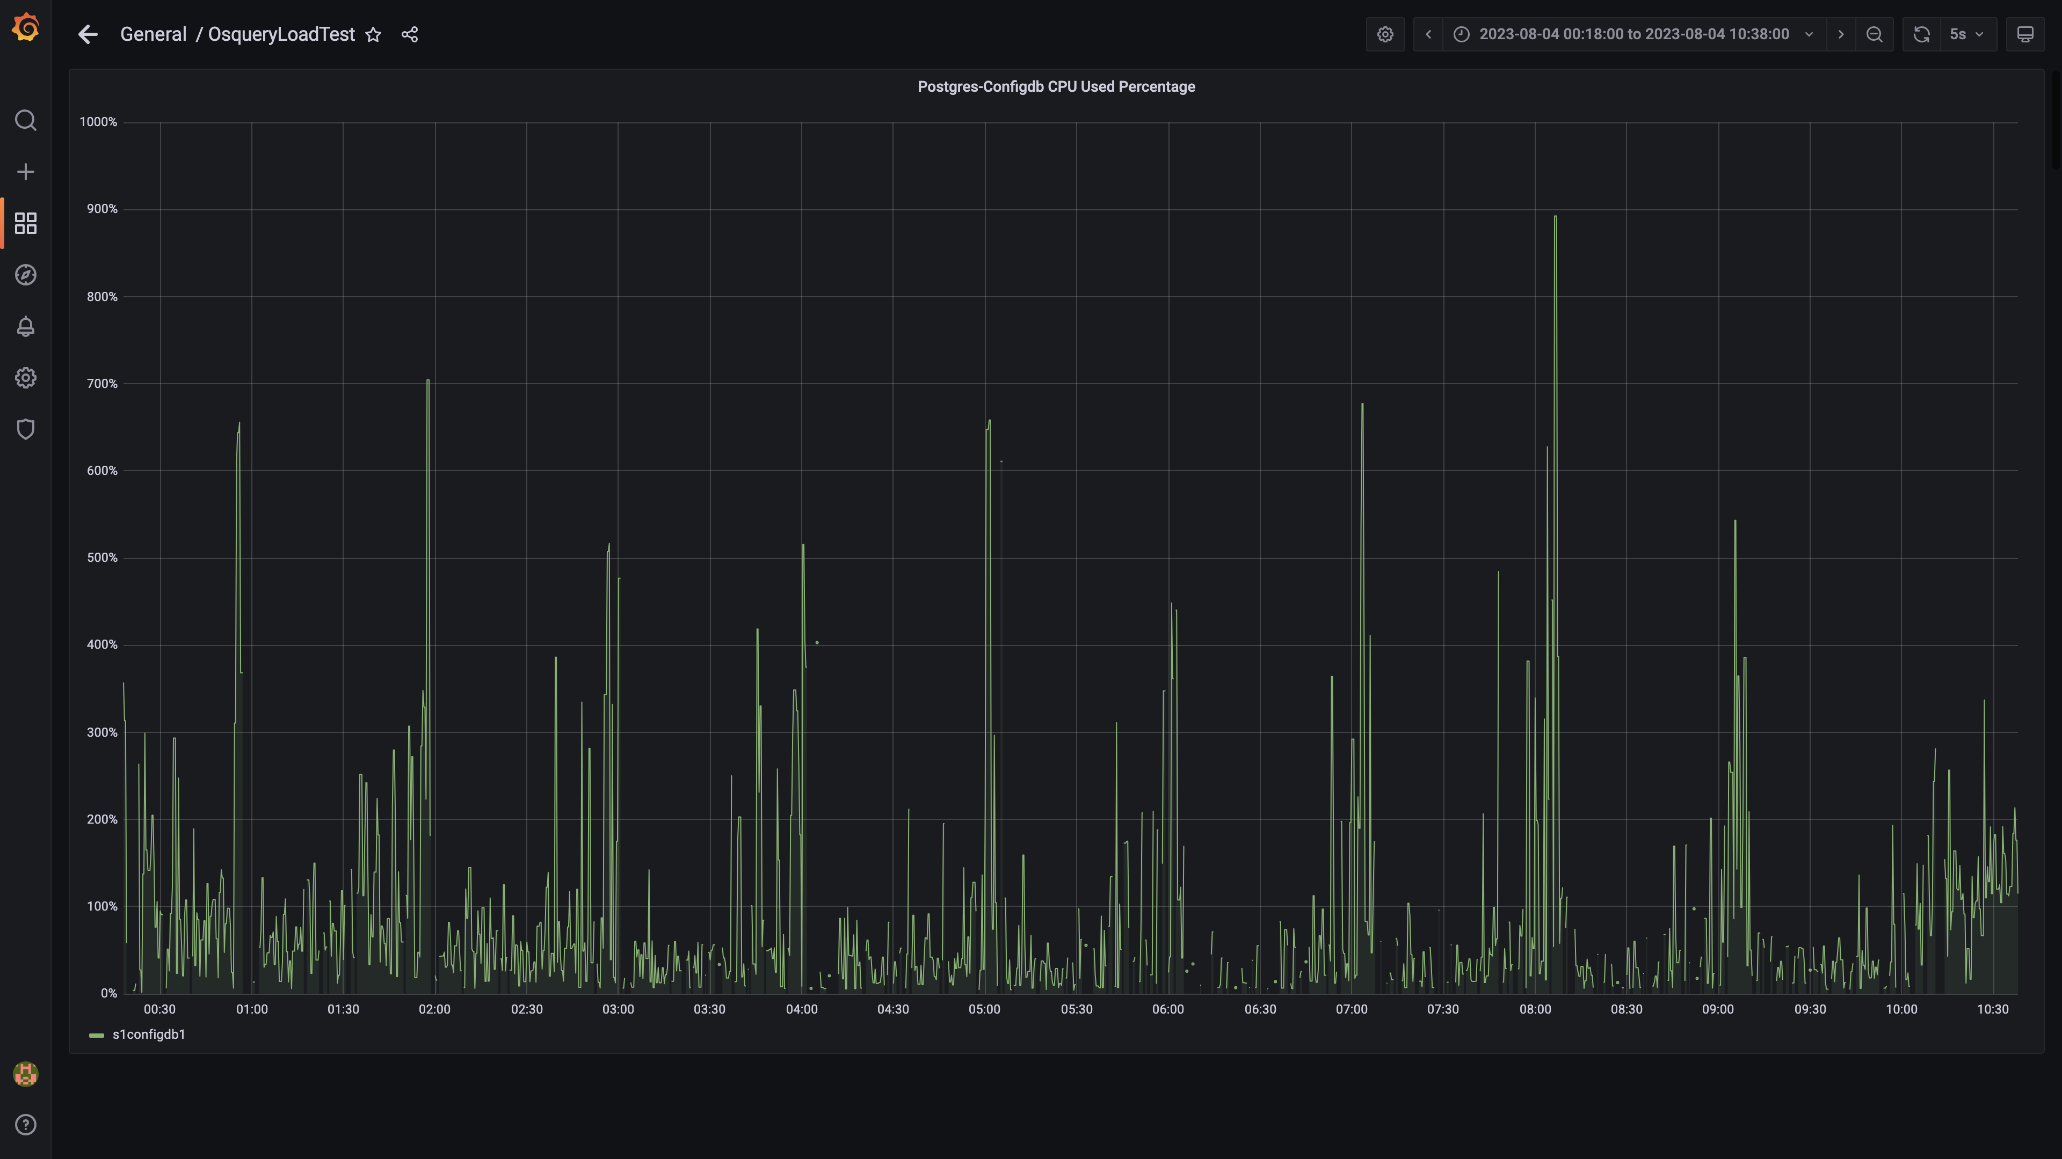

### Pgbouncer cpu used percentage

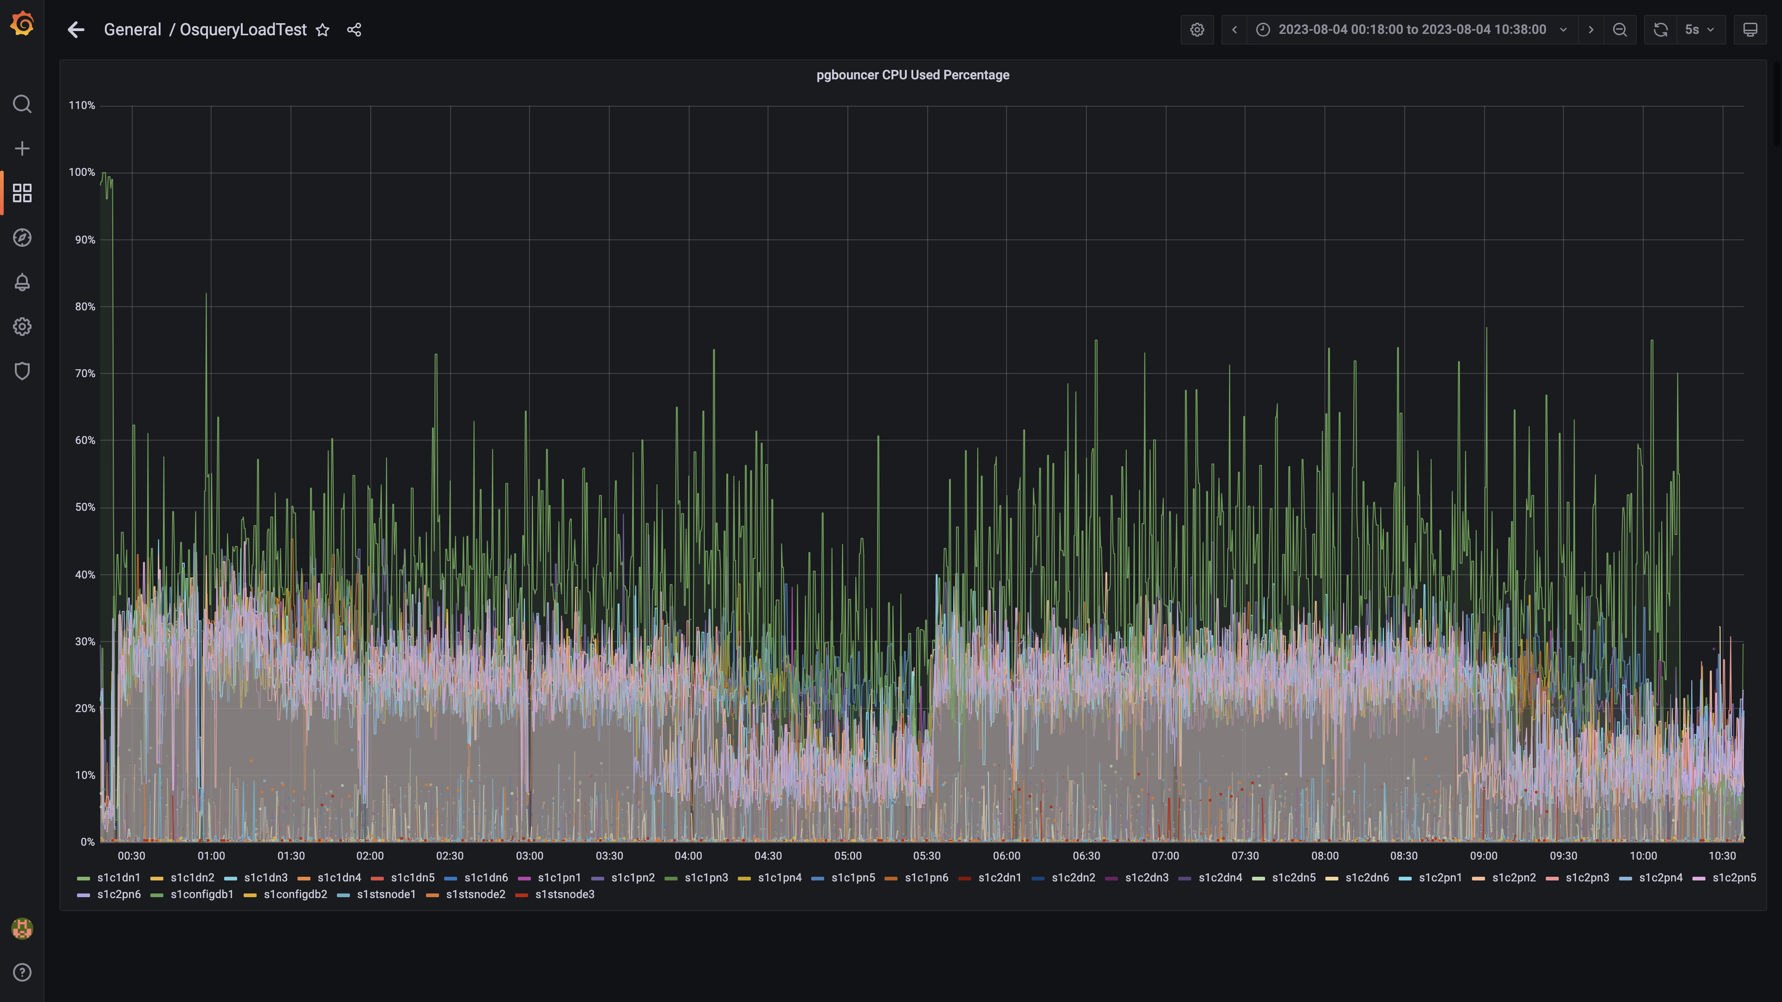

### Cpu consumed by eventsdbingestion

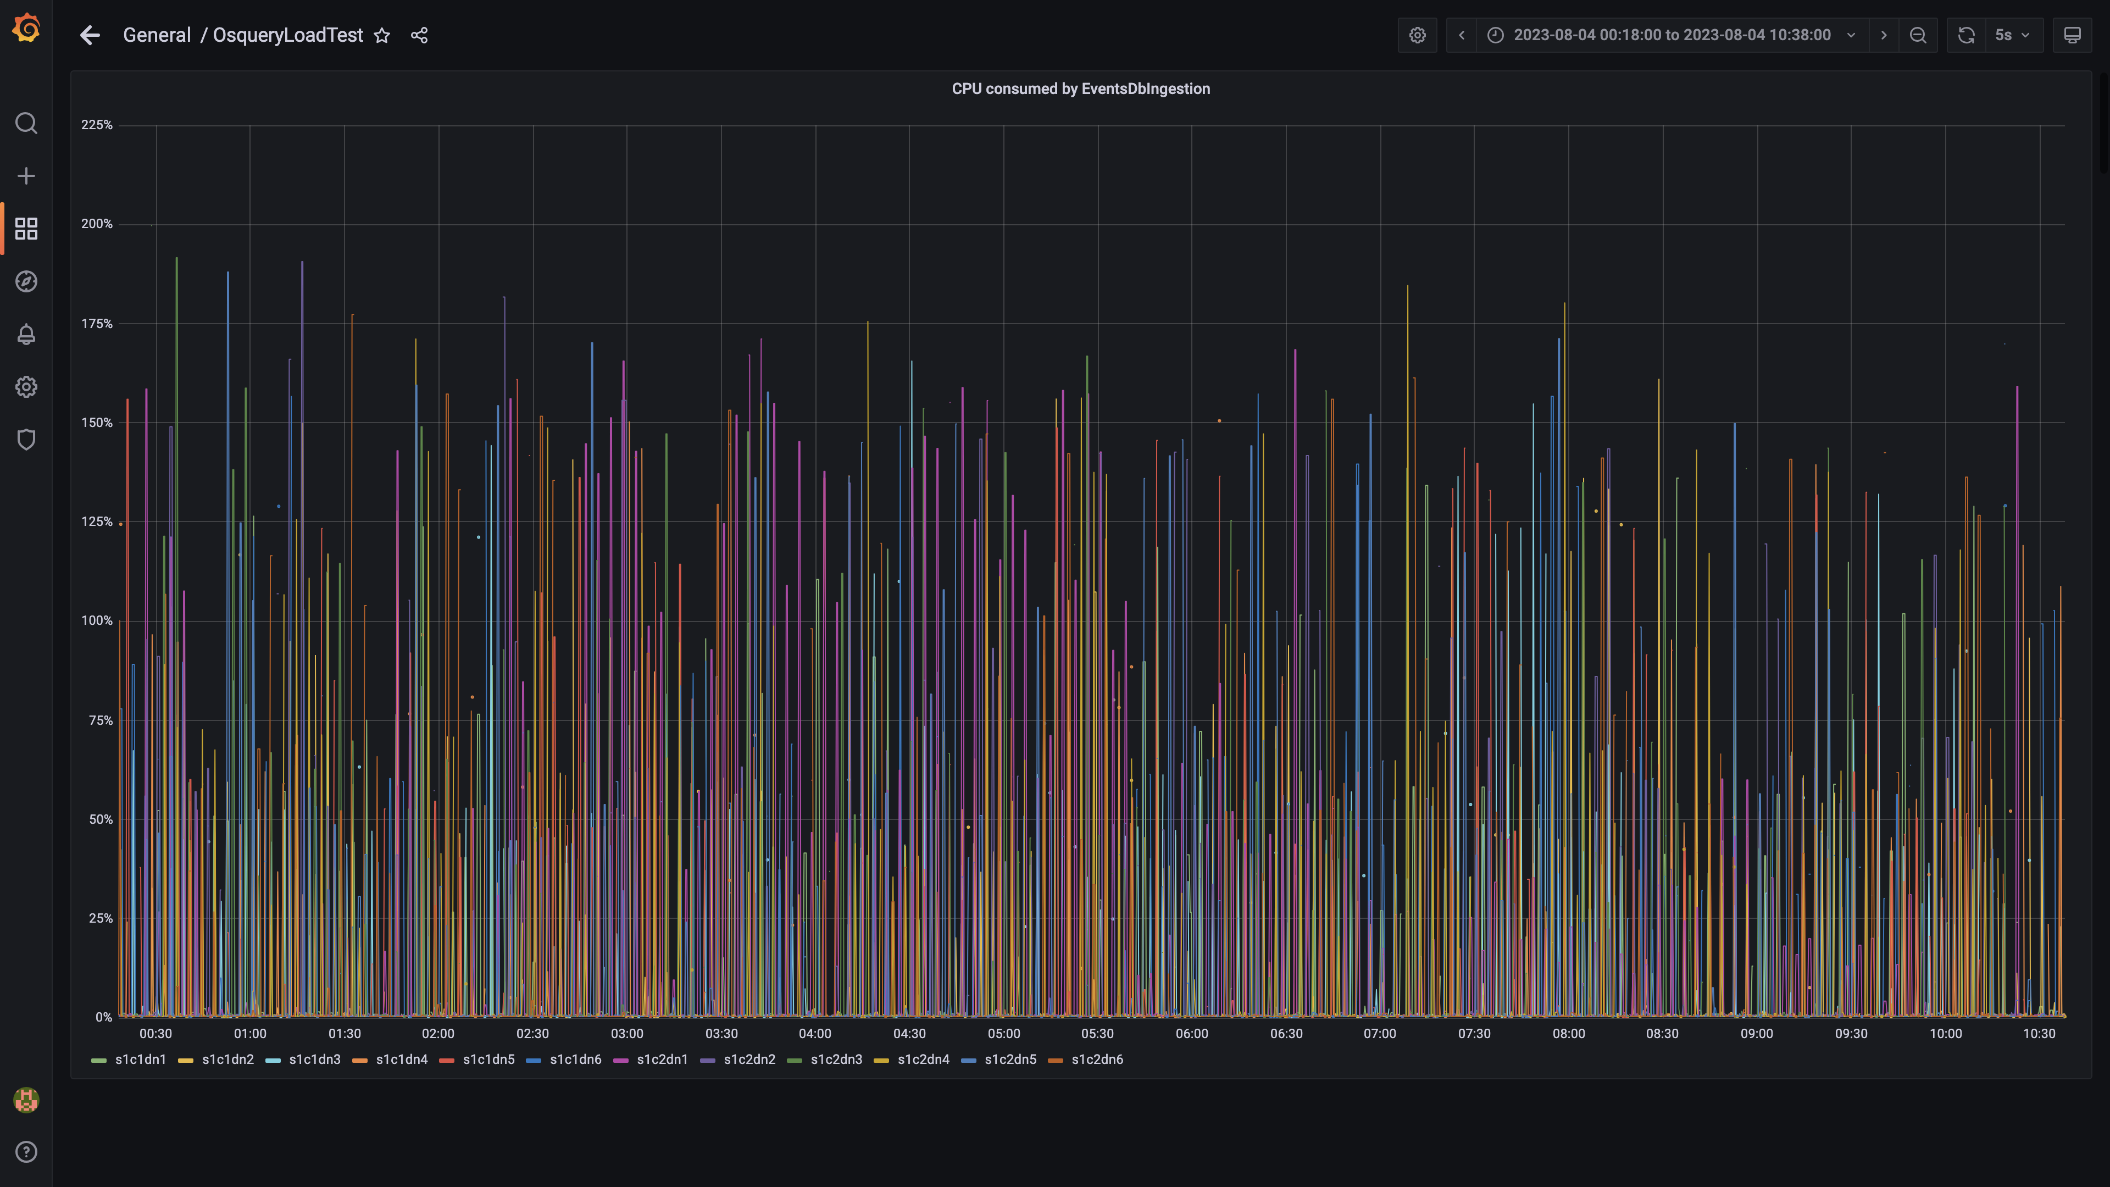

### Cpu consumed by pushgateway

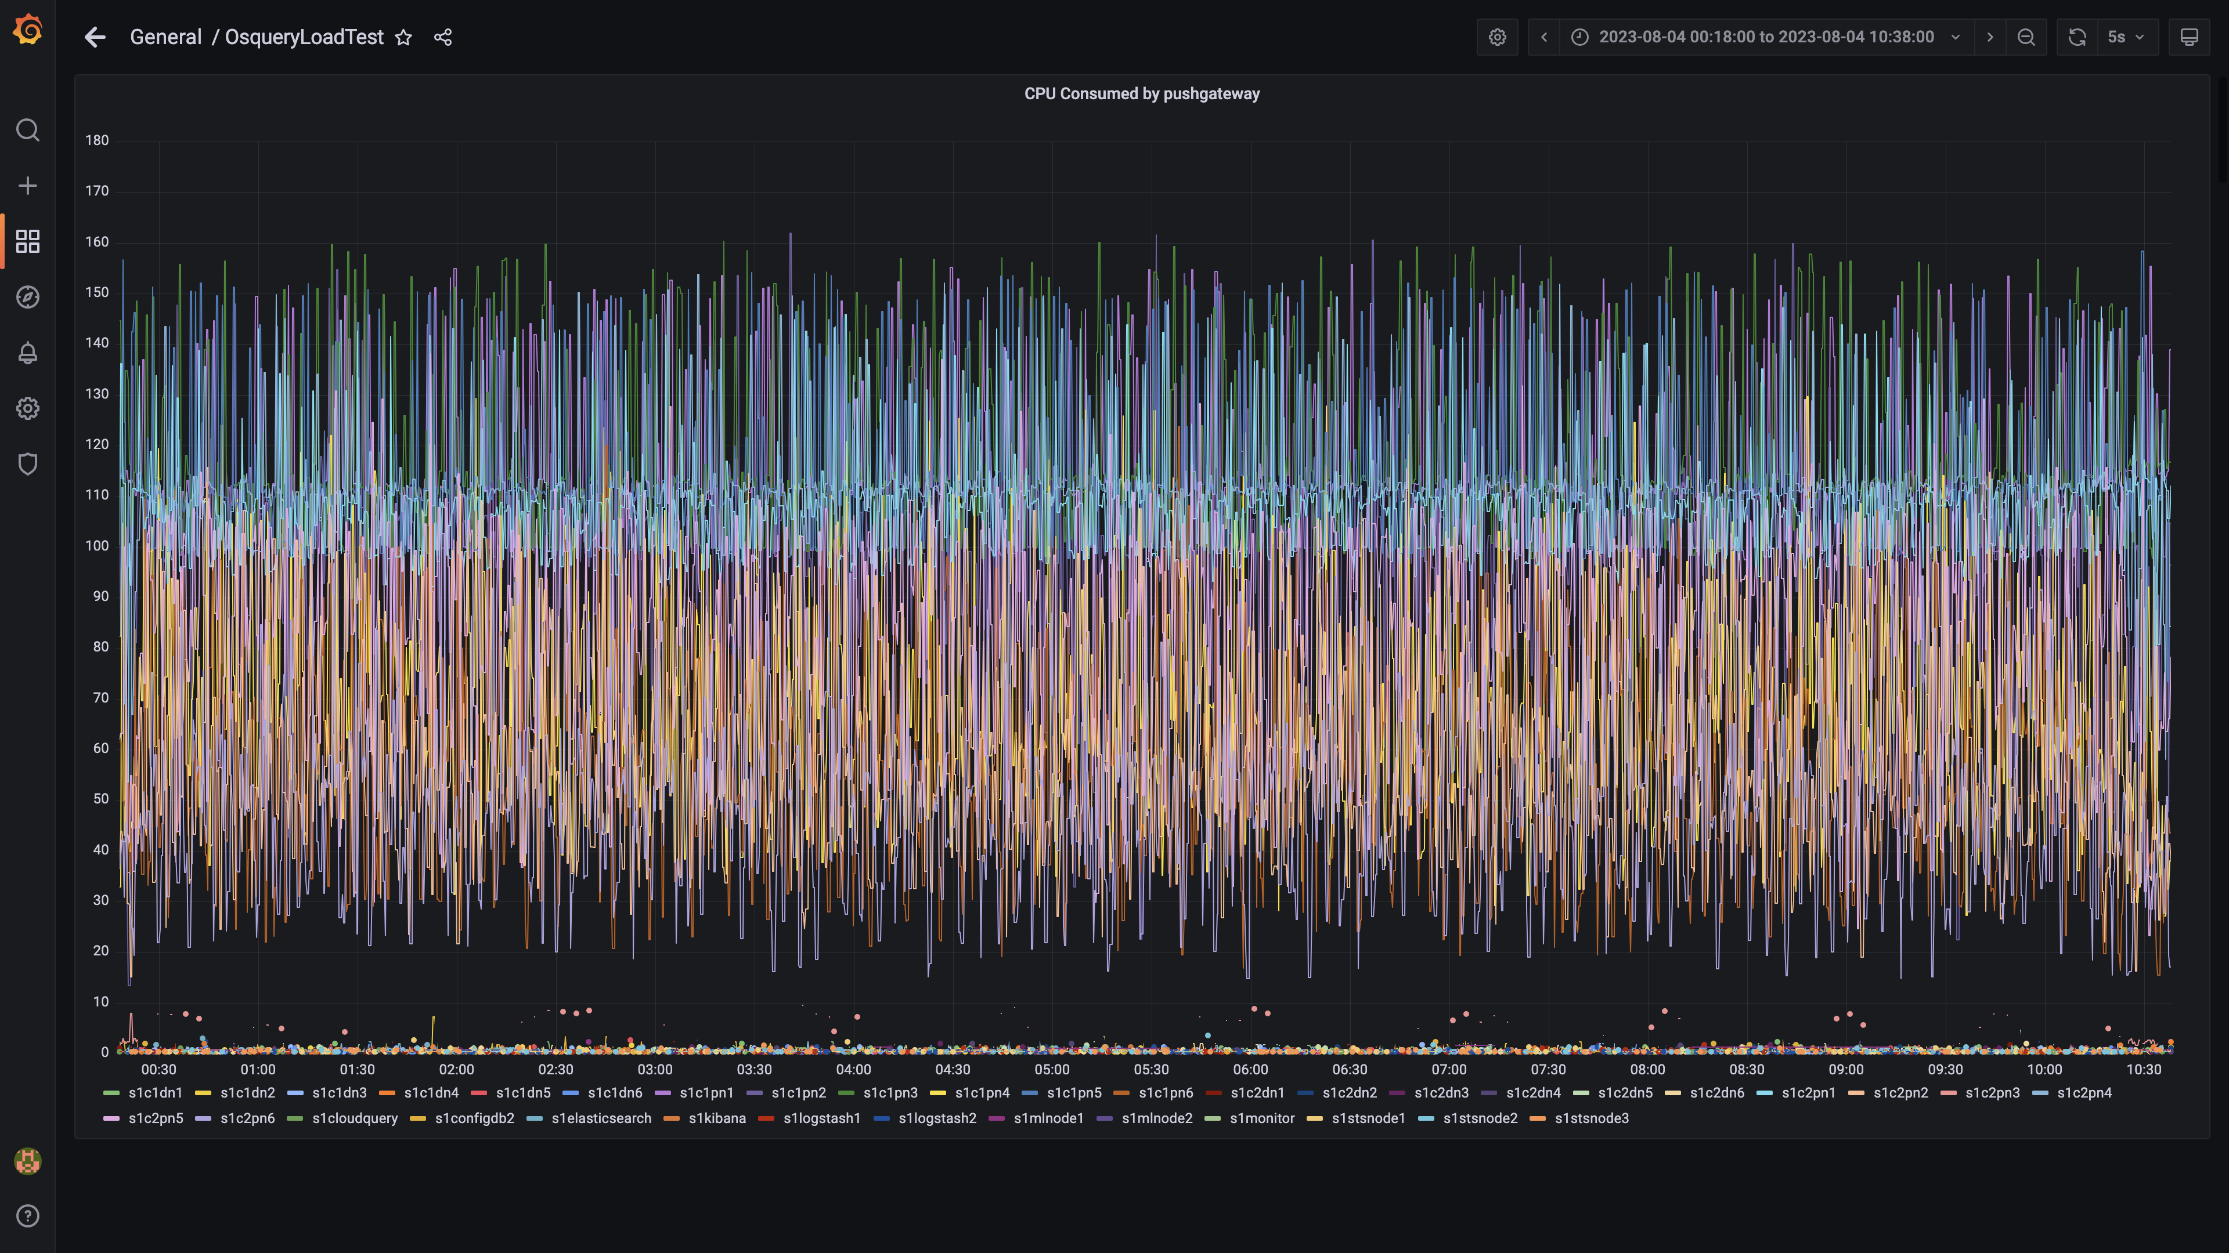

### Cpu consumed by ruleengine

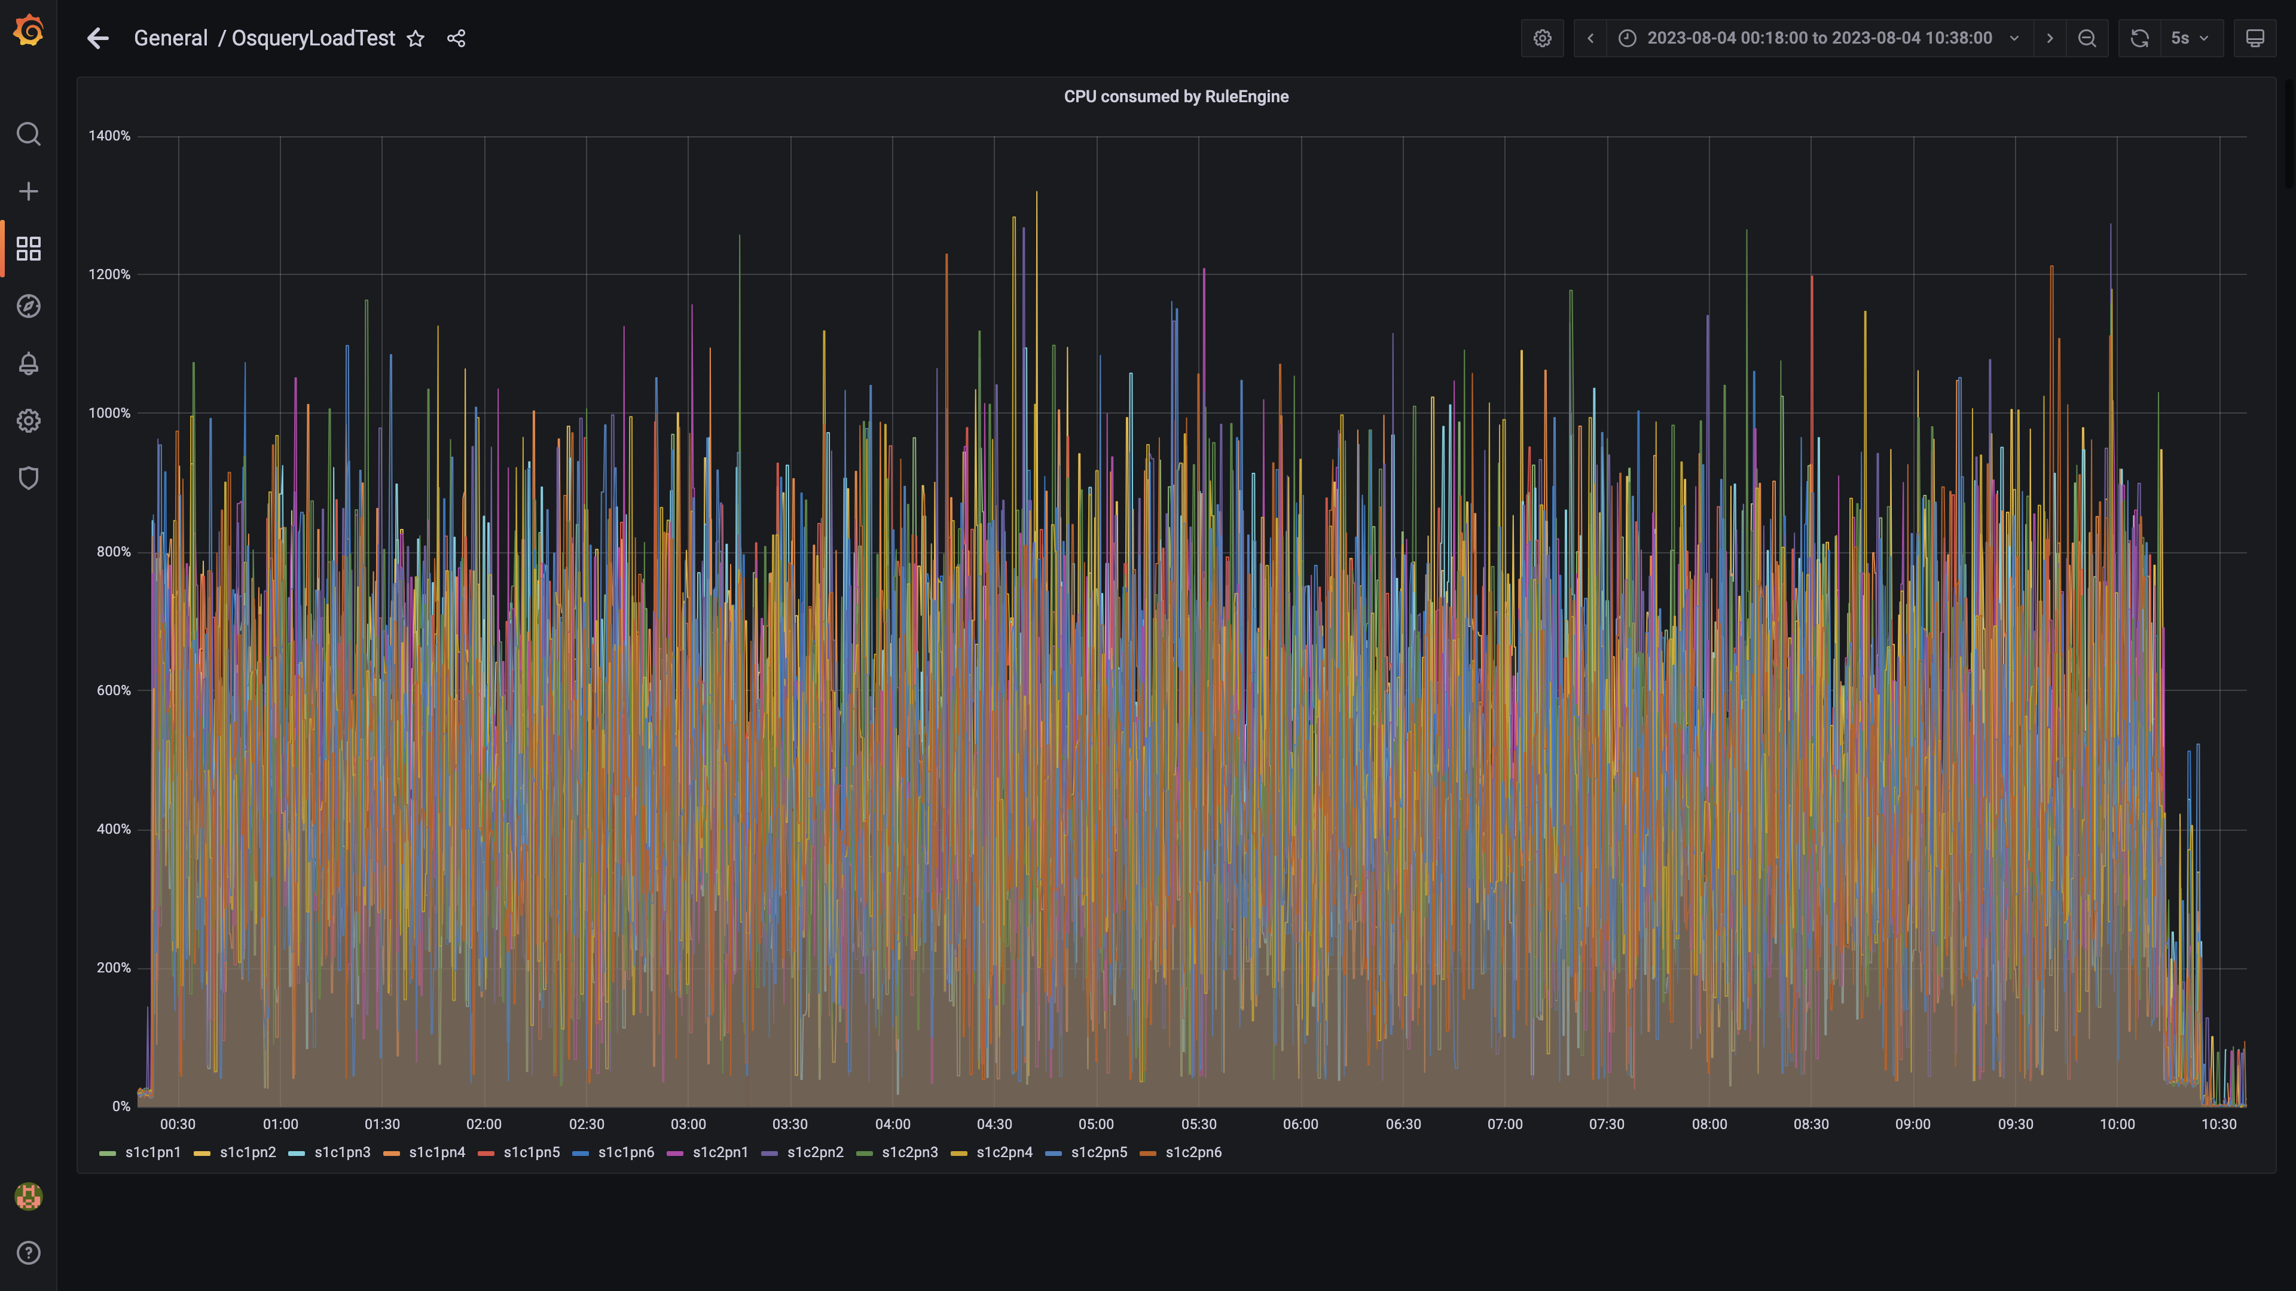

### Kafka cpu used percentage

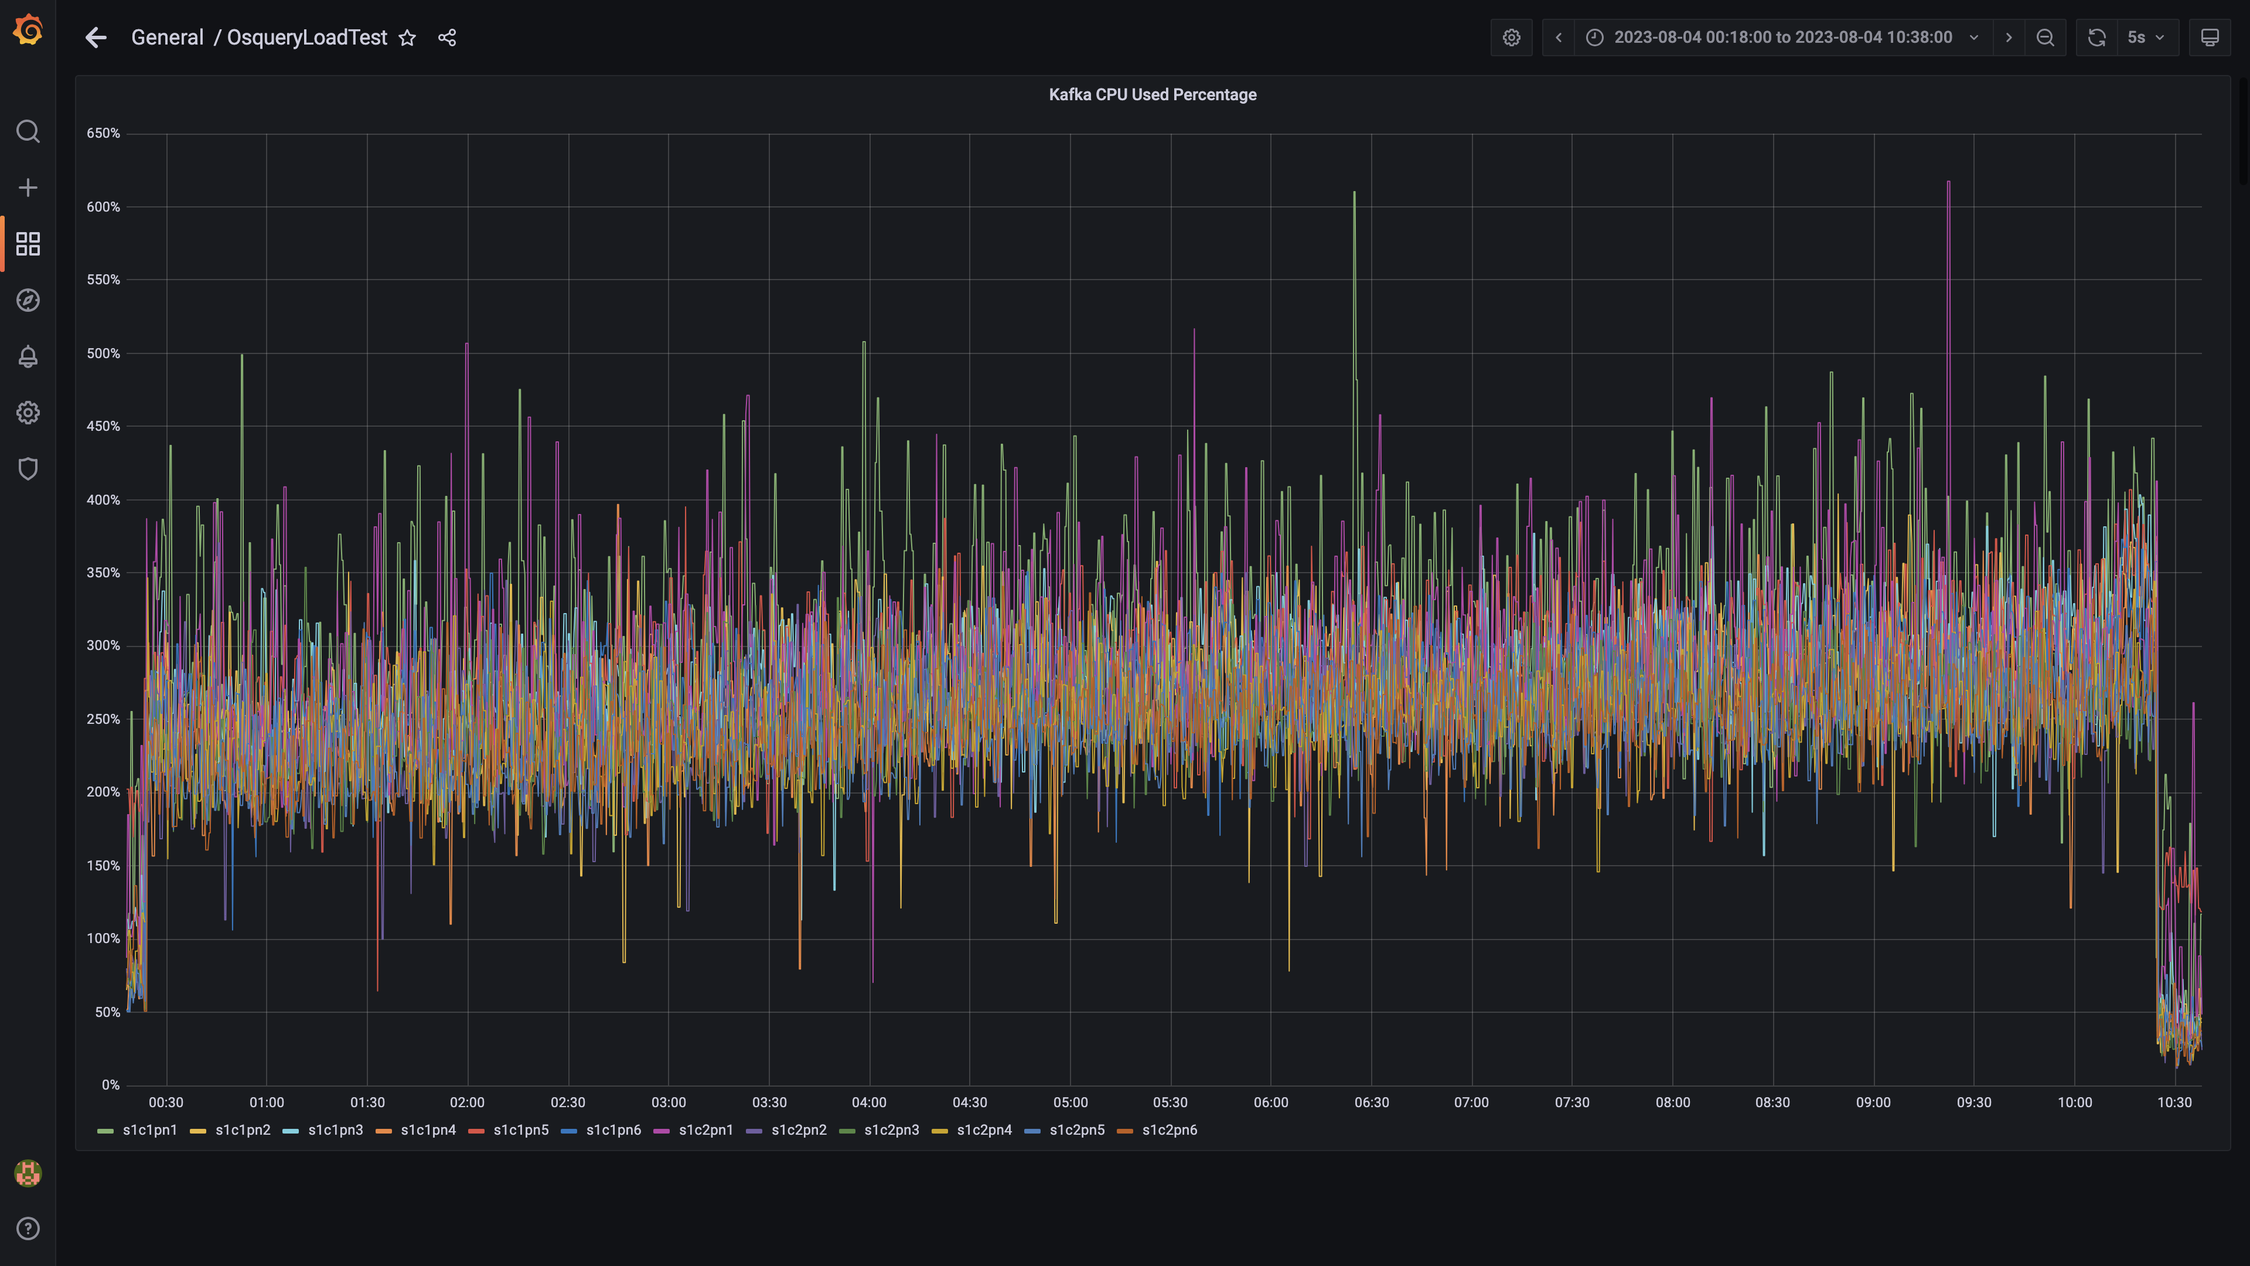

### Cpu used by data-archival

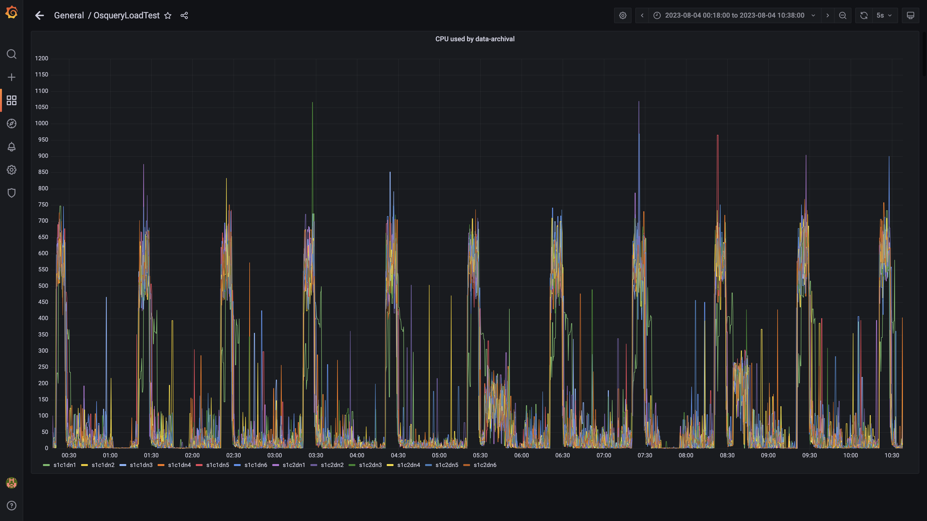

### Cpu consumed by osqueryingestion

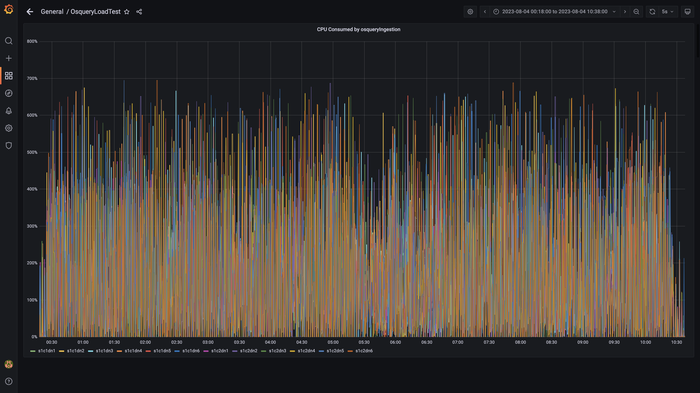

### Cpu consumed by redis server

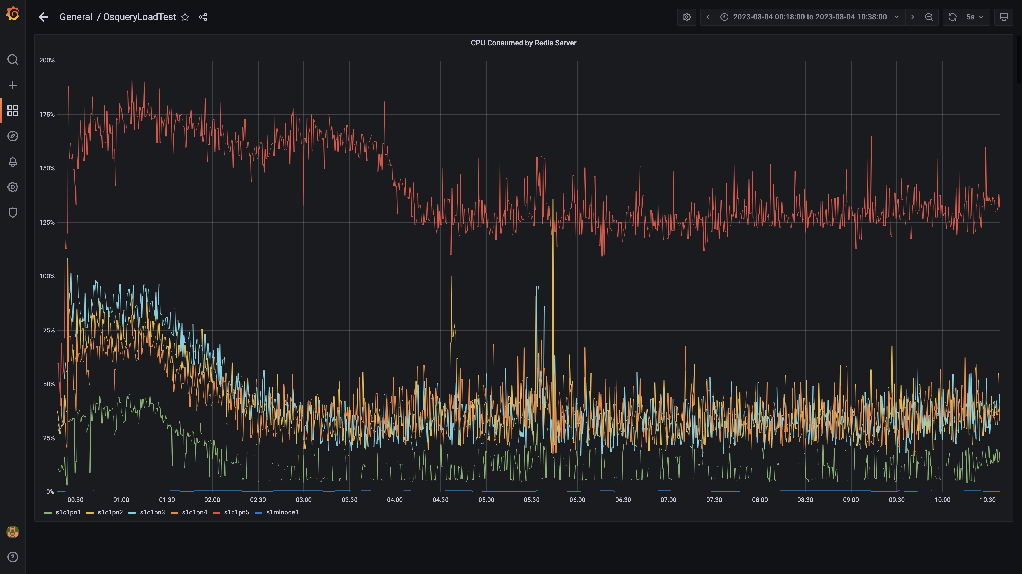

### Cpu consumed by orc-compaction

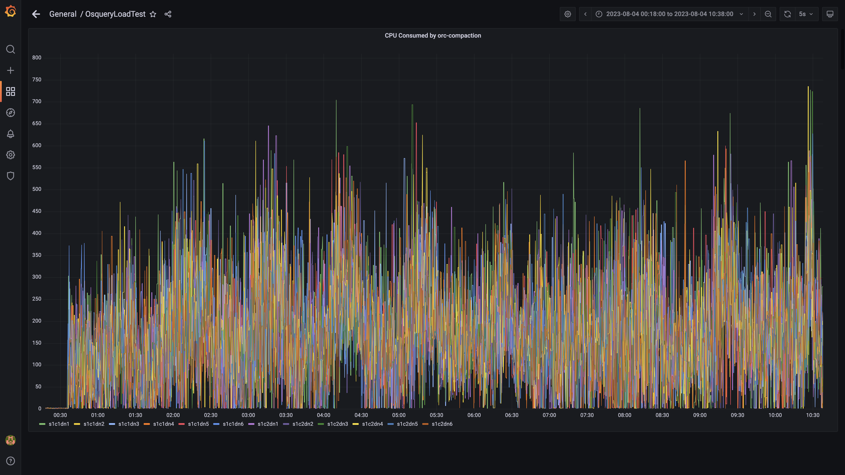

### Cpu consumed by spark-worker

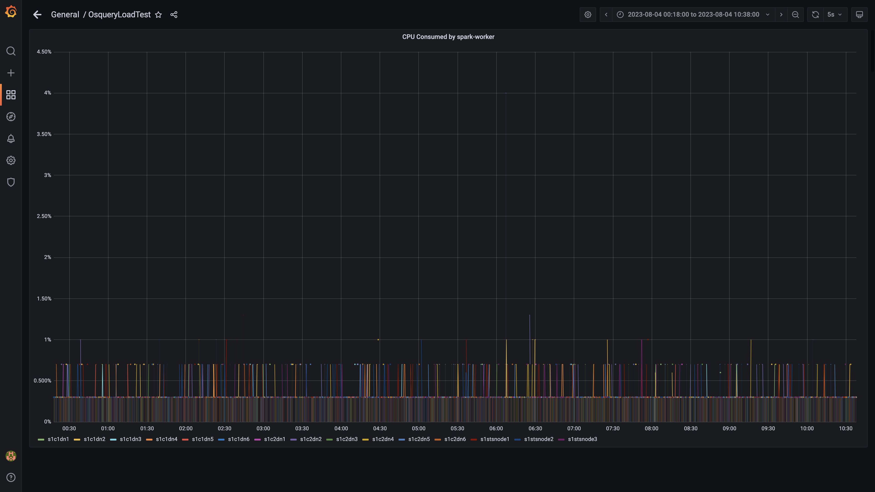

### Cpu consumed by logger

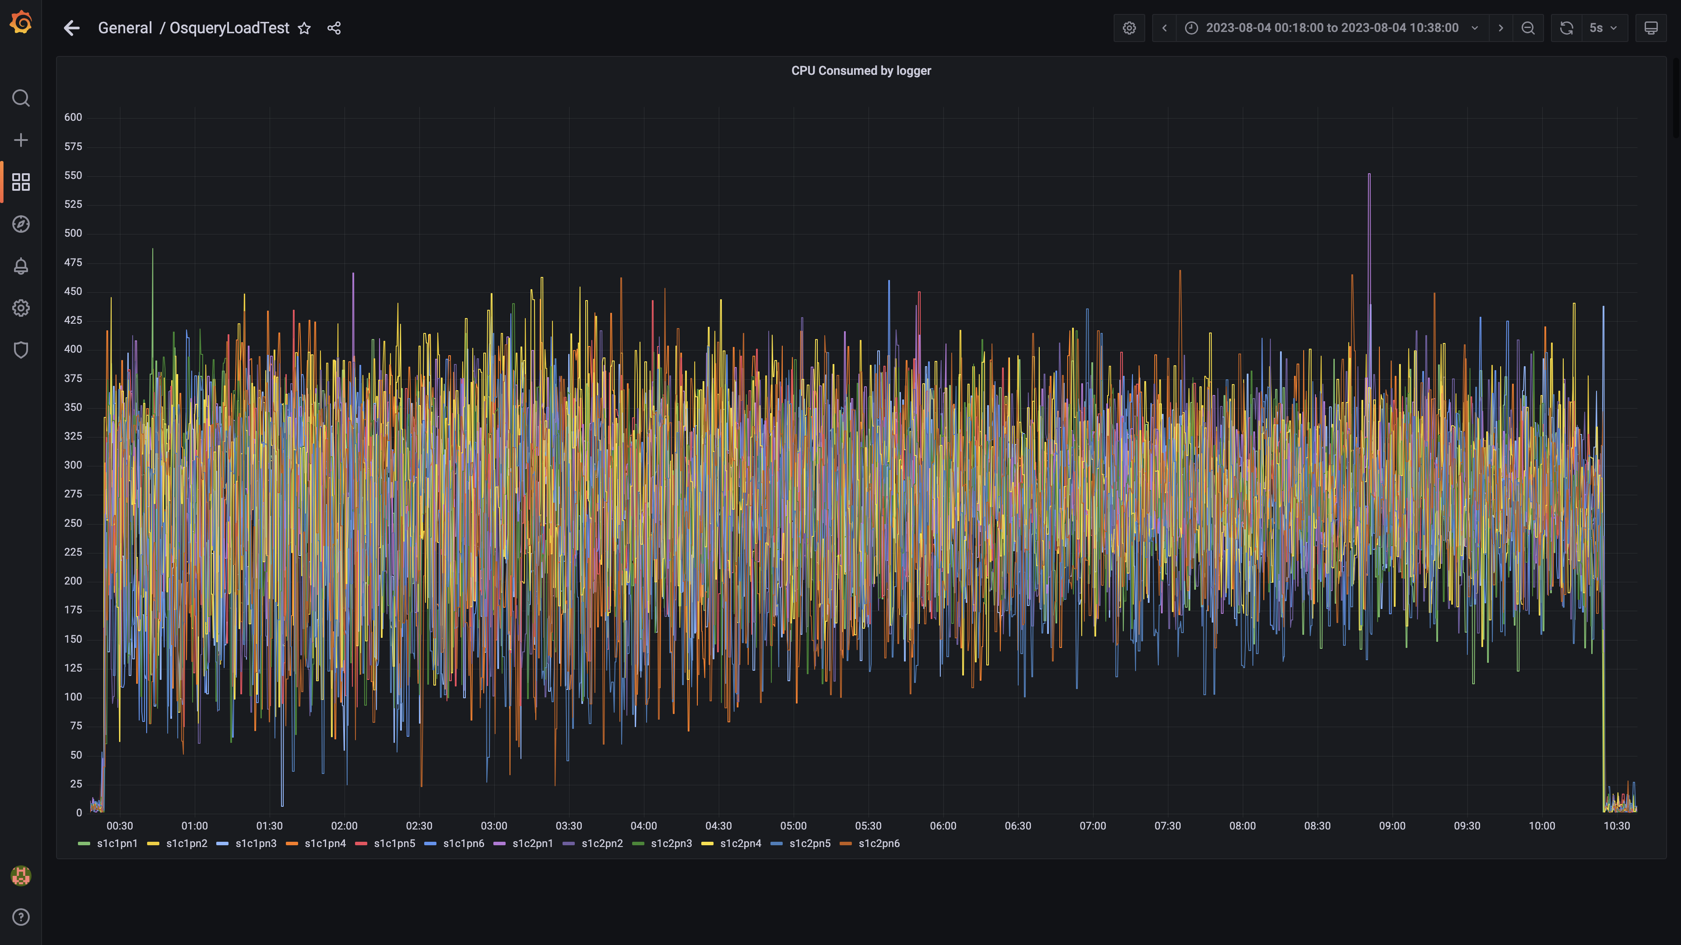

### Compliance summary consumer cpu consumption

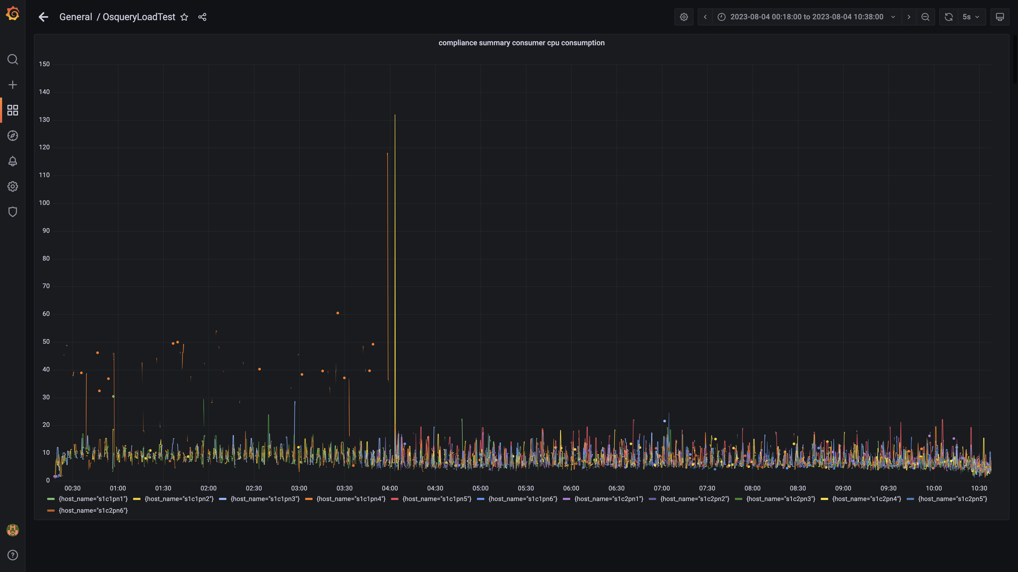

### Cpu consumed by trino

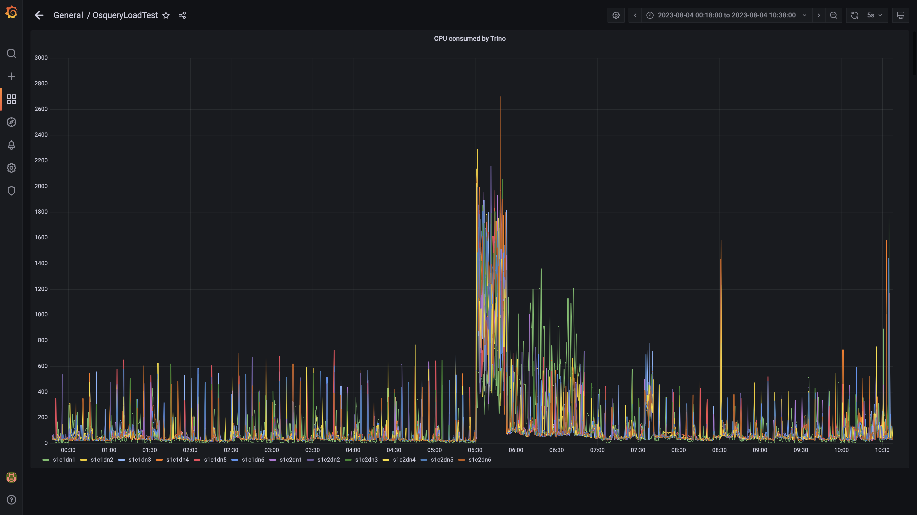

### Debezium cpu usage

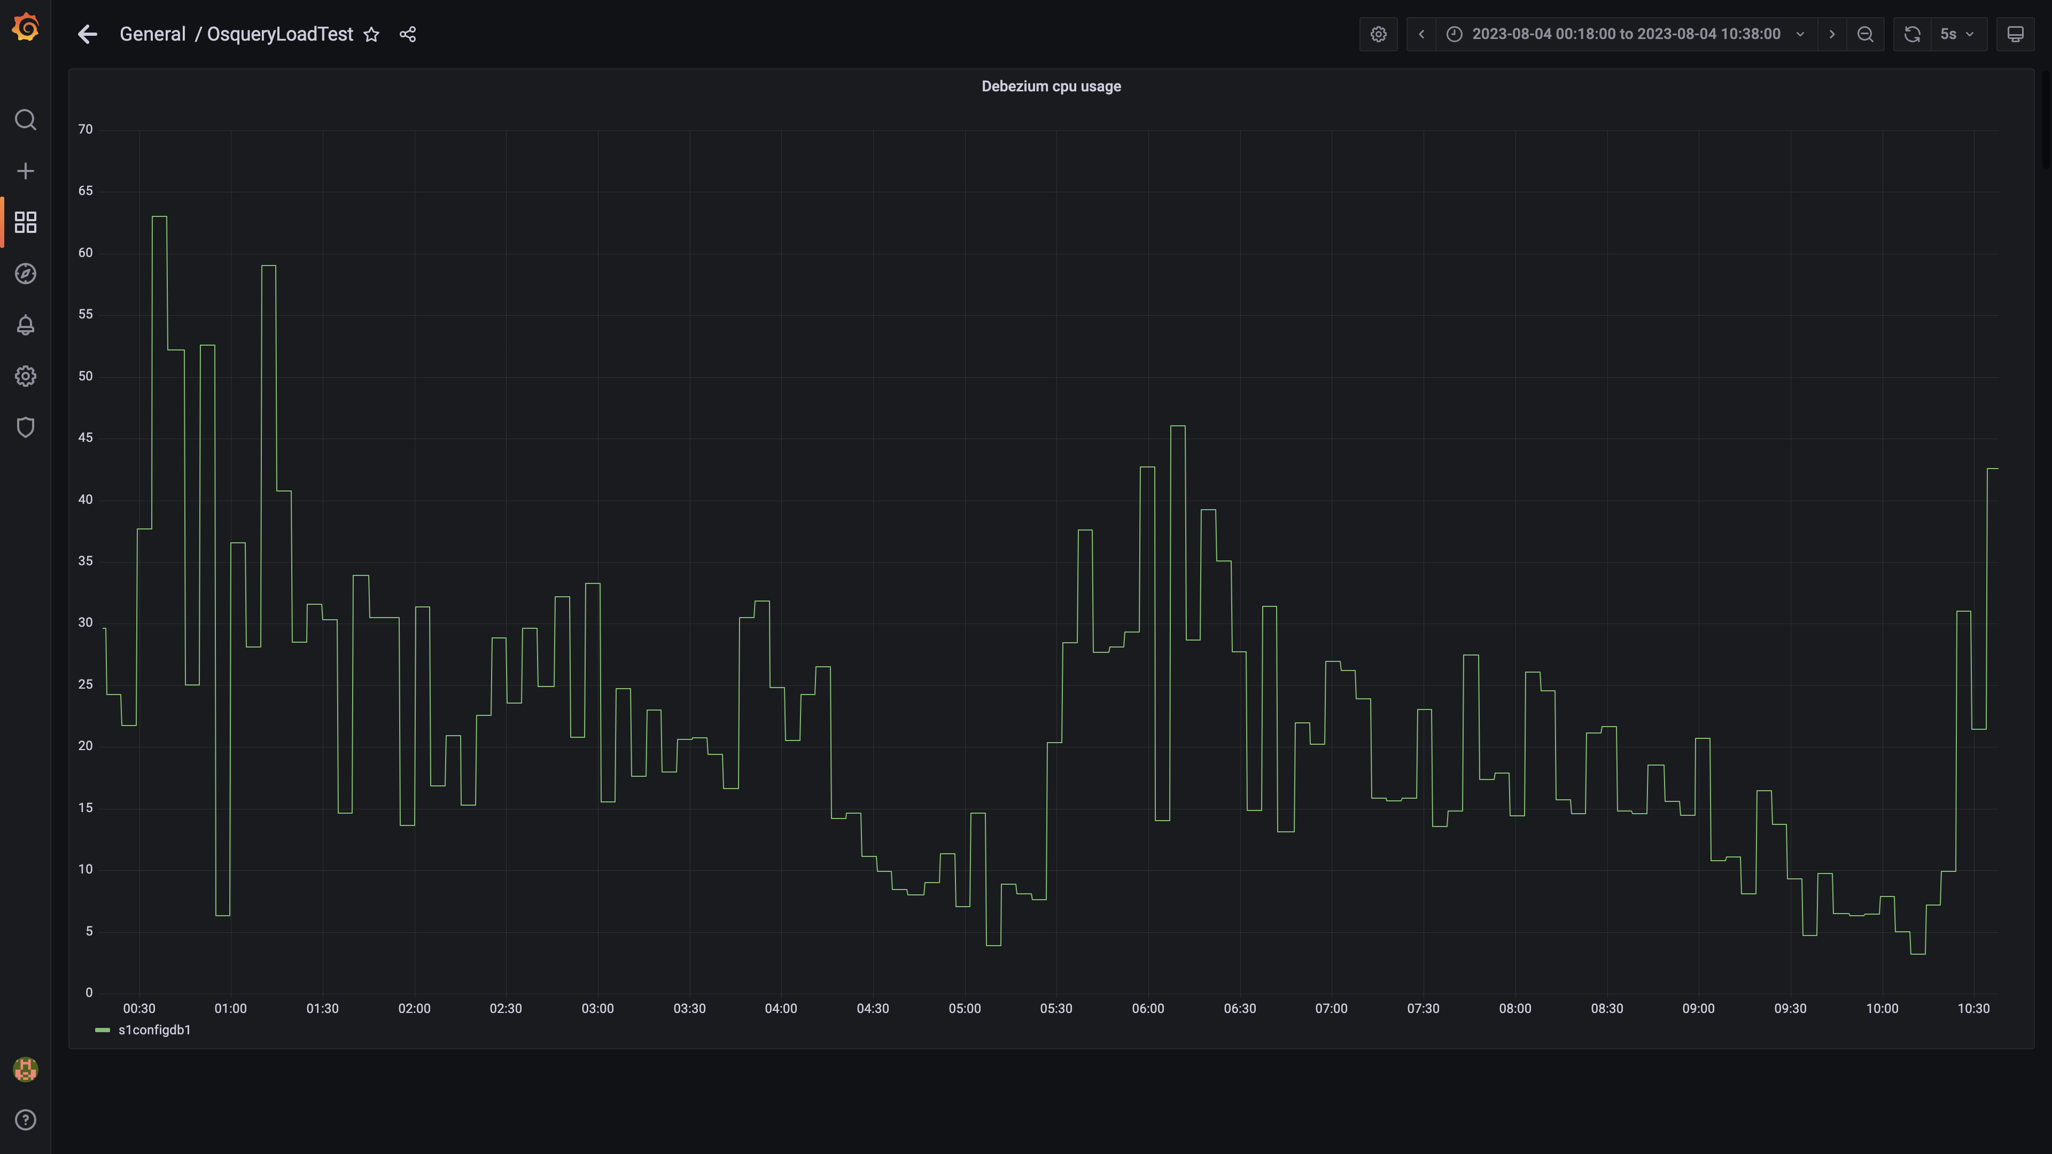

### Cpu consumed by spark-master

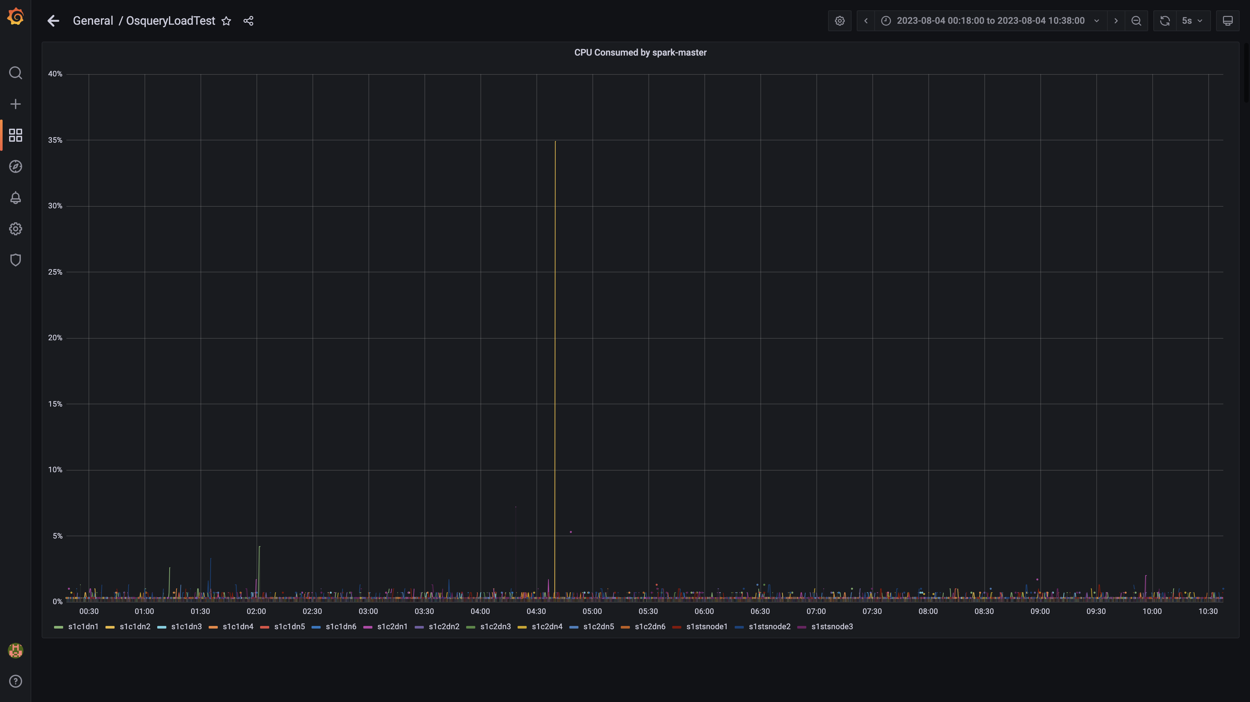

### Cpu consumed by tls

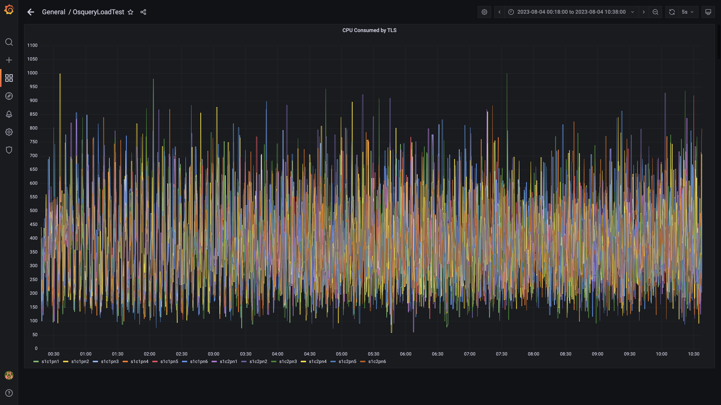

### Airflow cpu usage

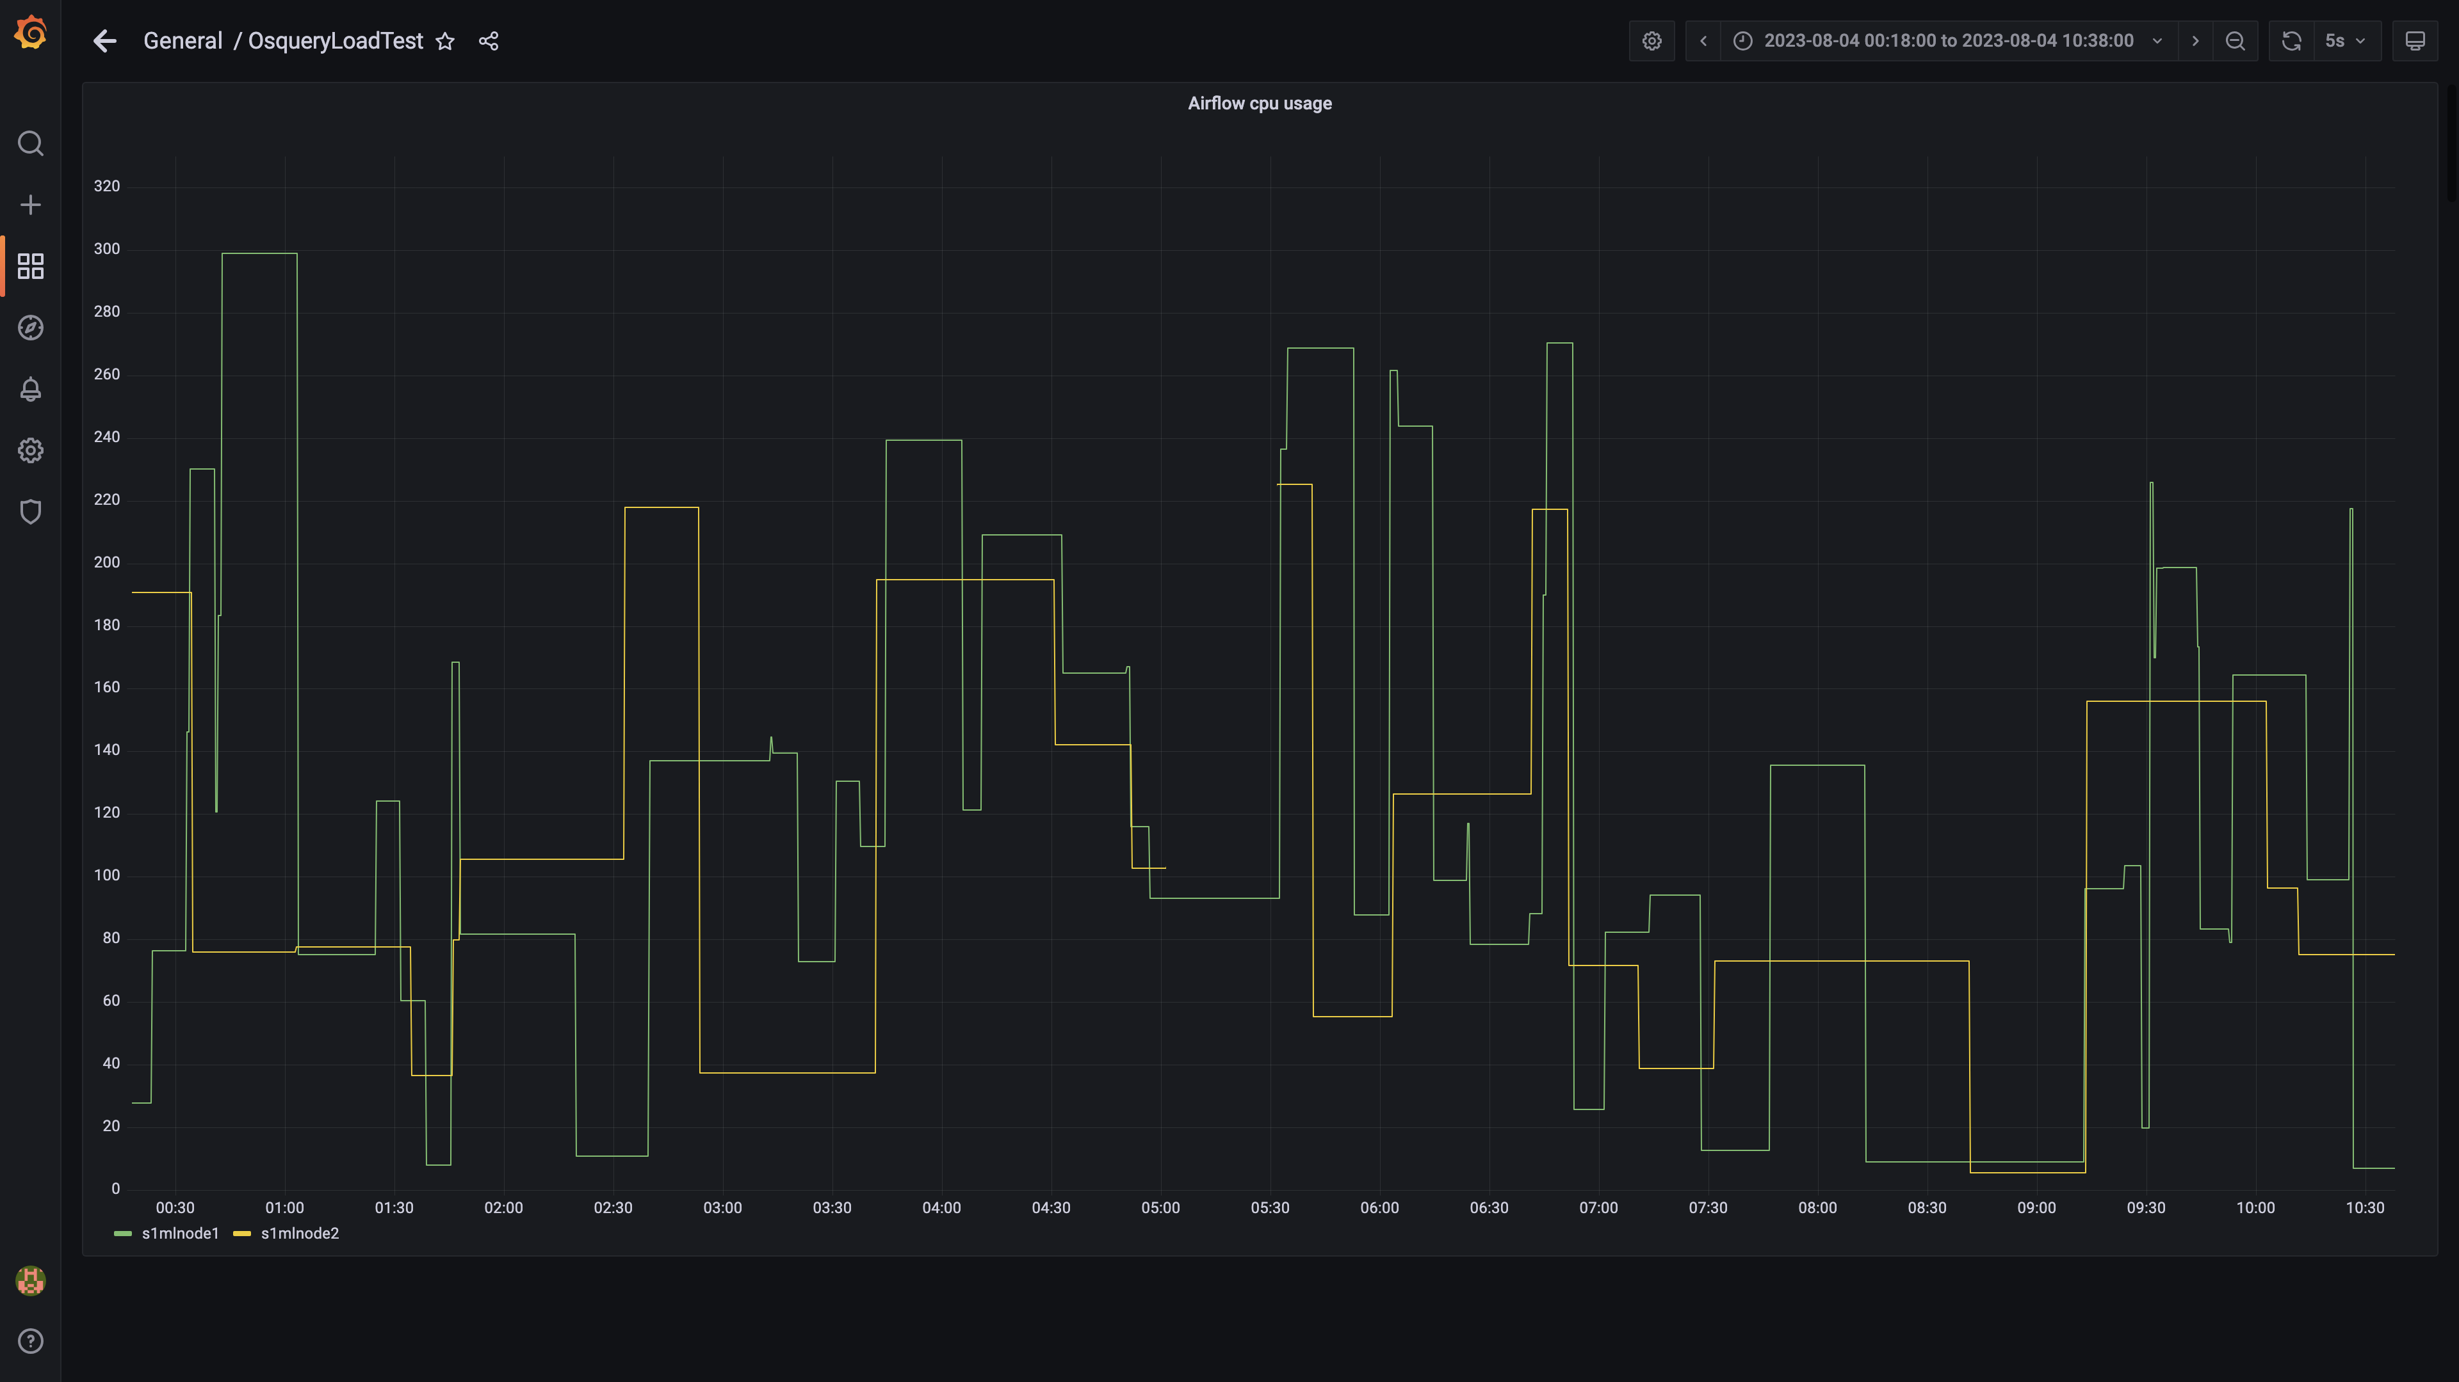

### Spark inject and drain rate agent osquery

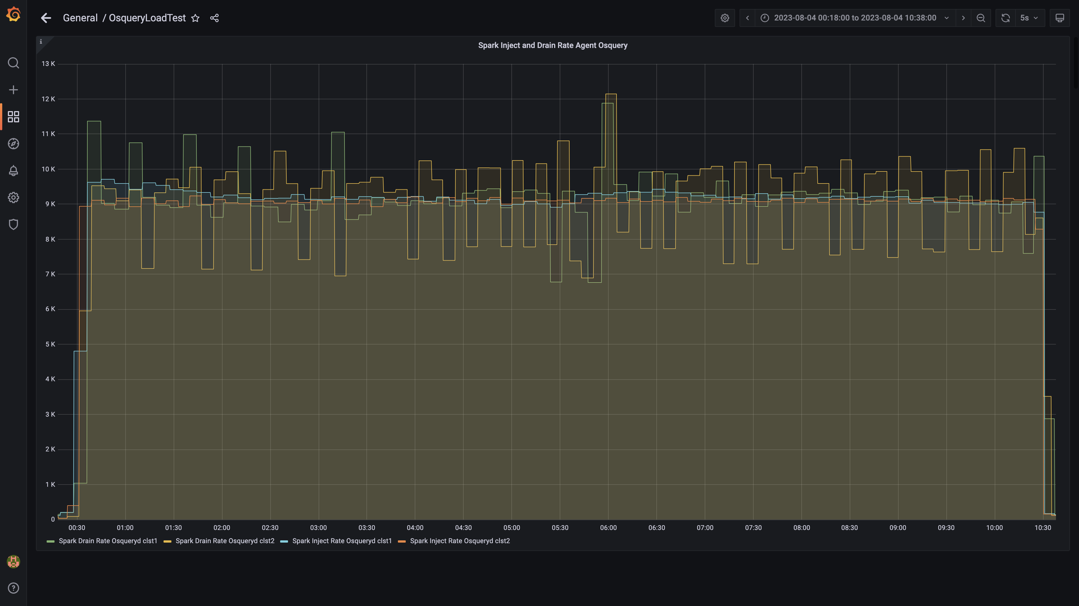

### Spark lag for agent osquery

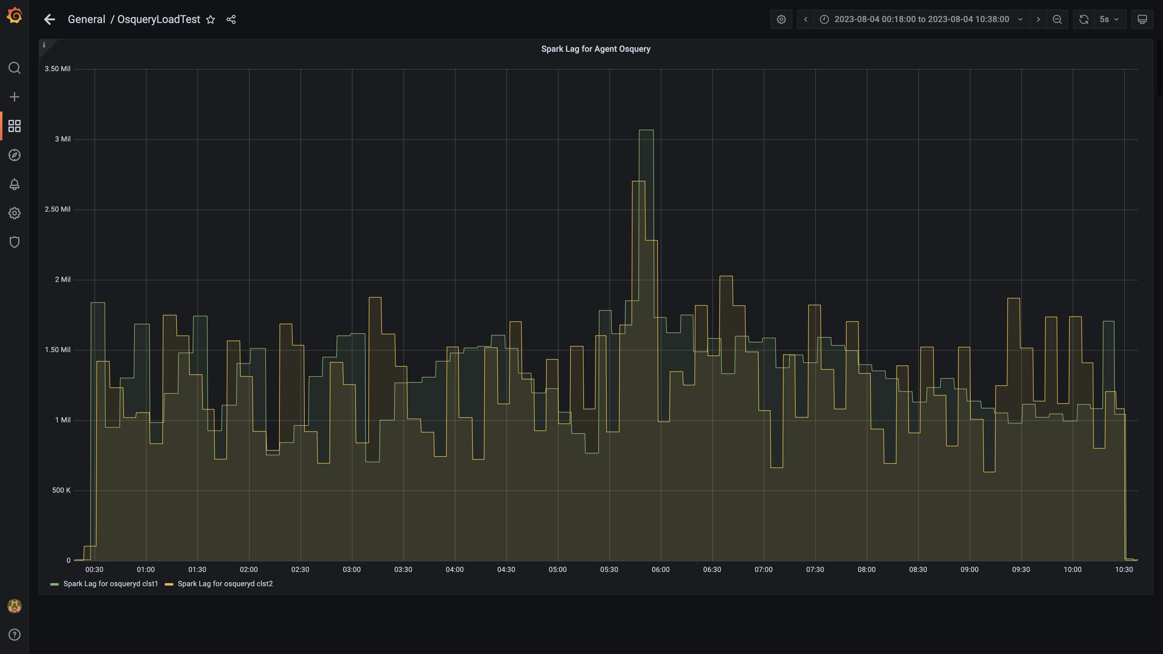

### Spark inject and drain rate events

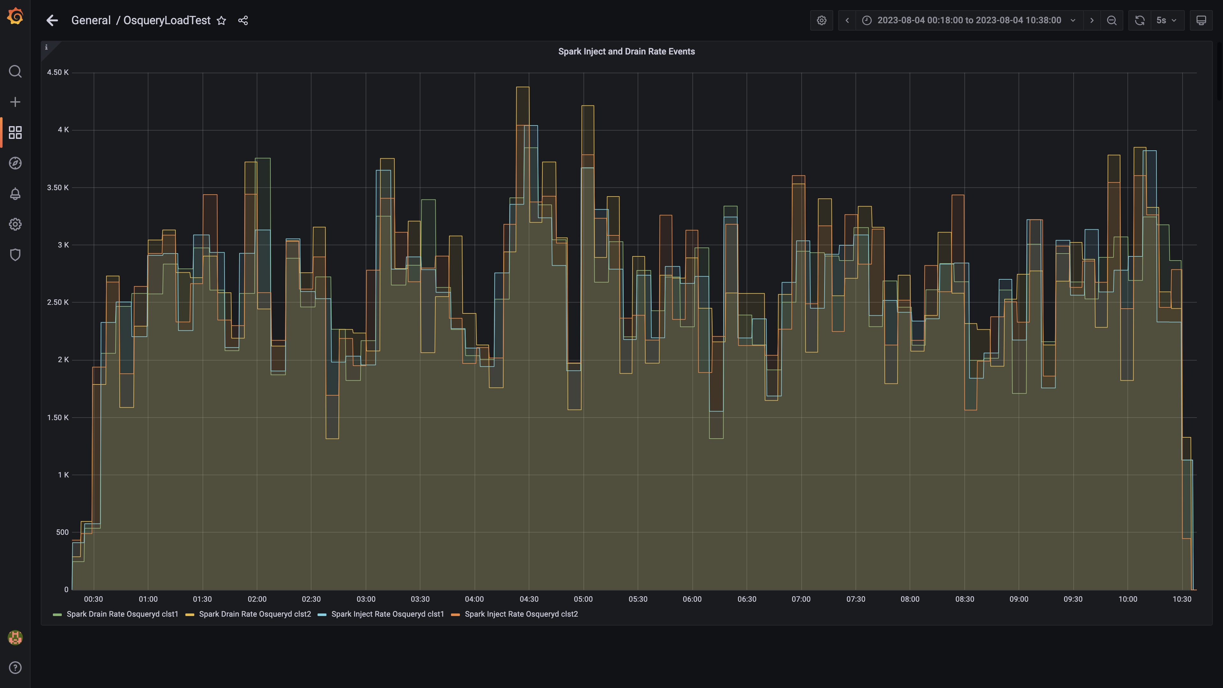

### Spark lag for events

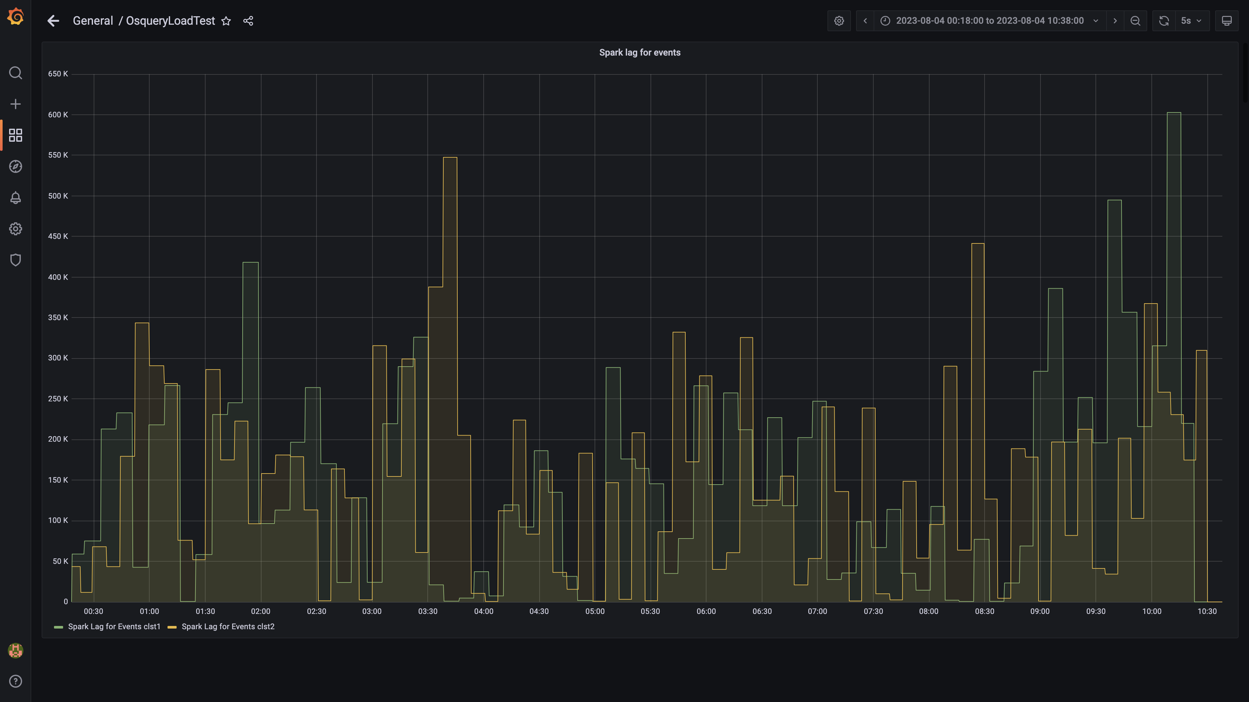

### Inject and drain rate db-alerts group

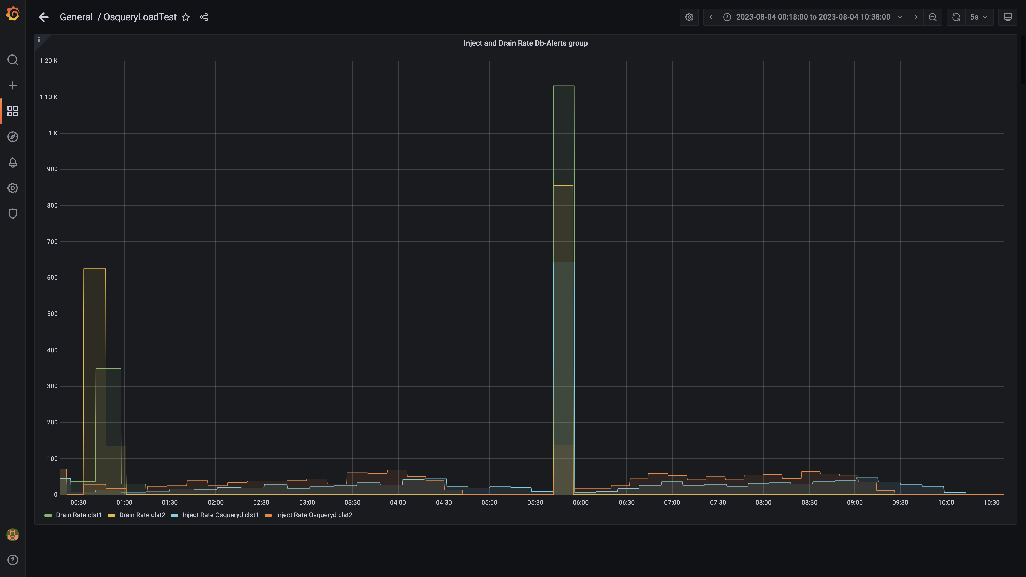

### Kafka lag for db-alerts group

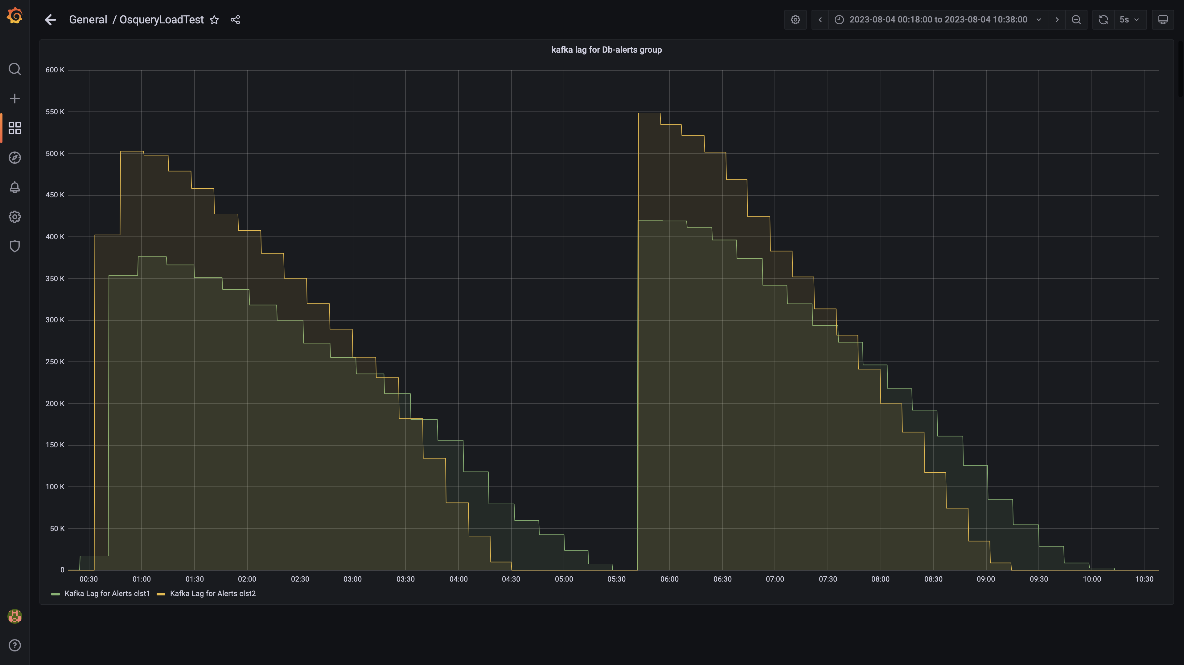

### Inject drain rates for ruleengine group

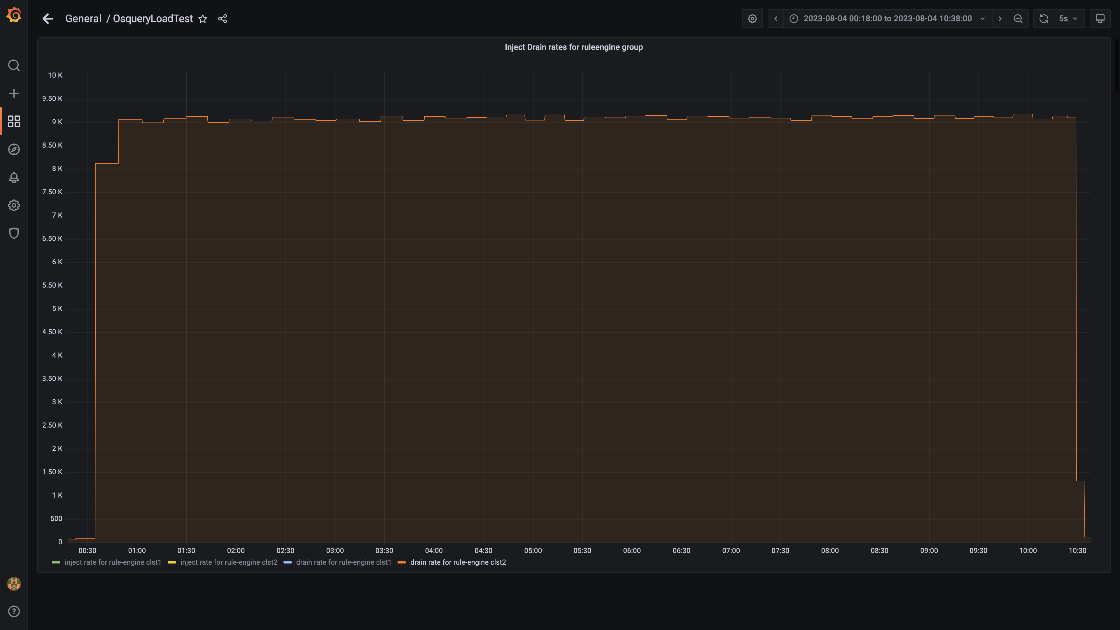

### Kafka lag for ruleengine group

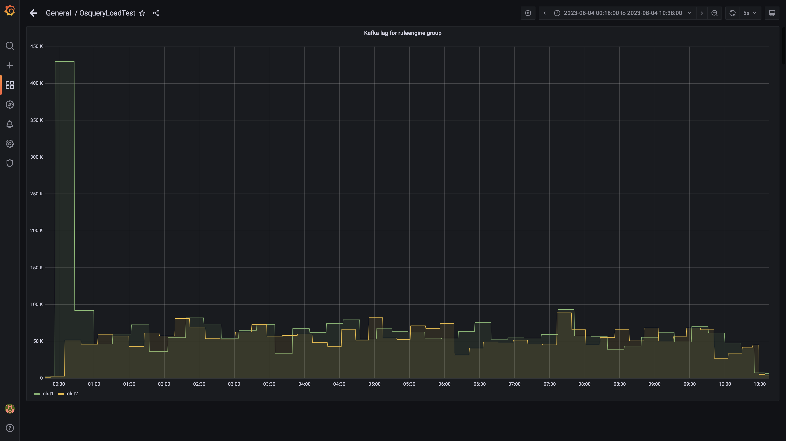

### Kafka inject and drain rates for debezium group

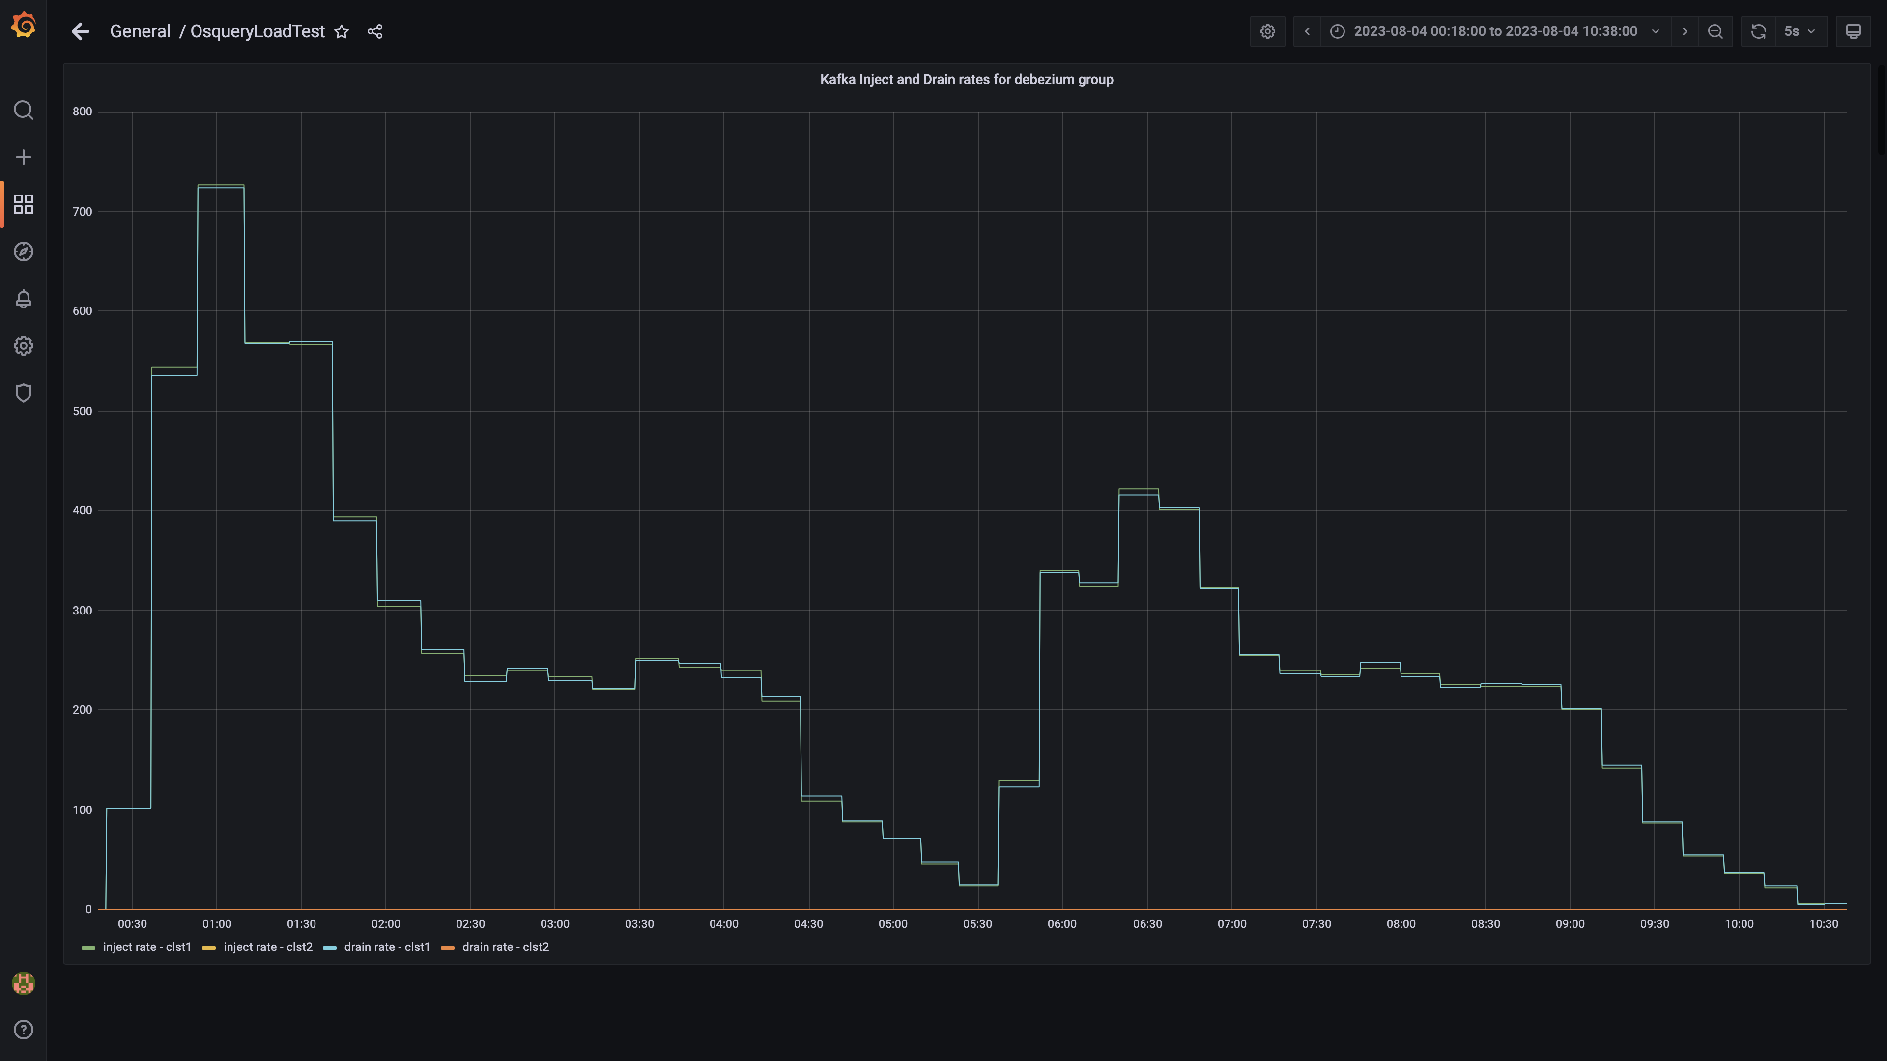

### Aggregate lag

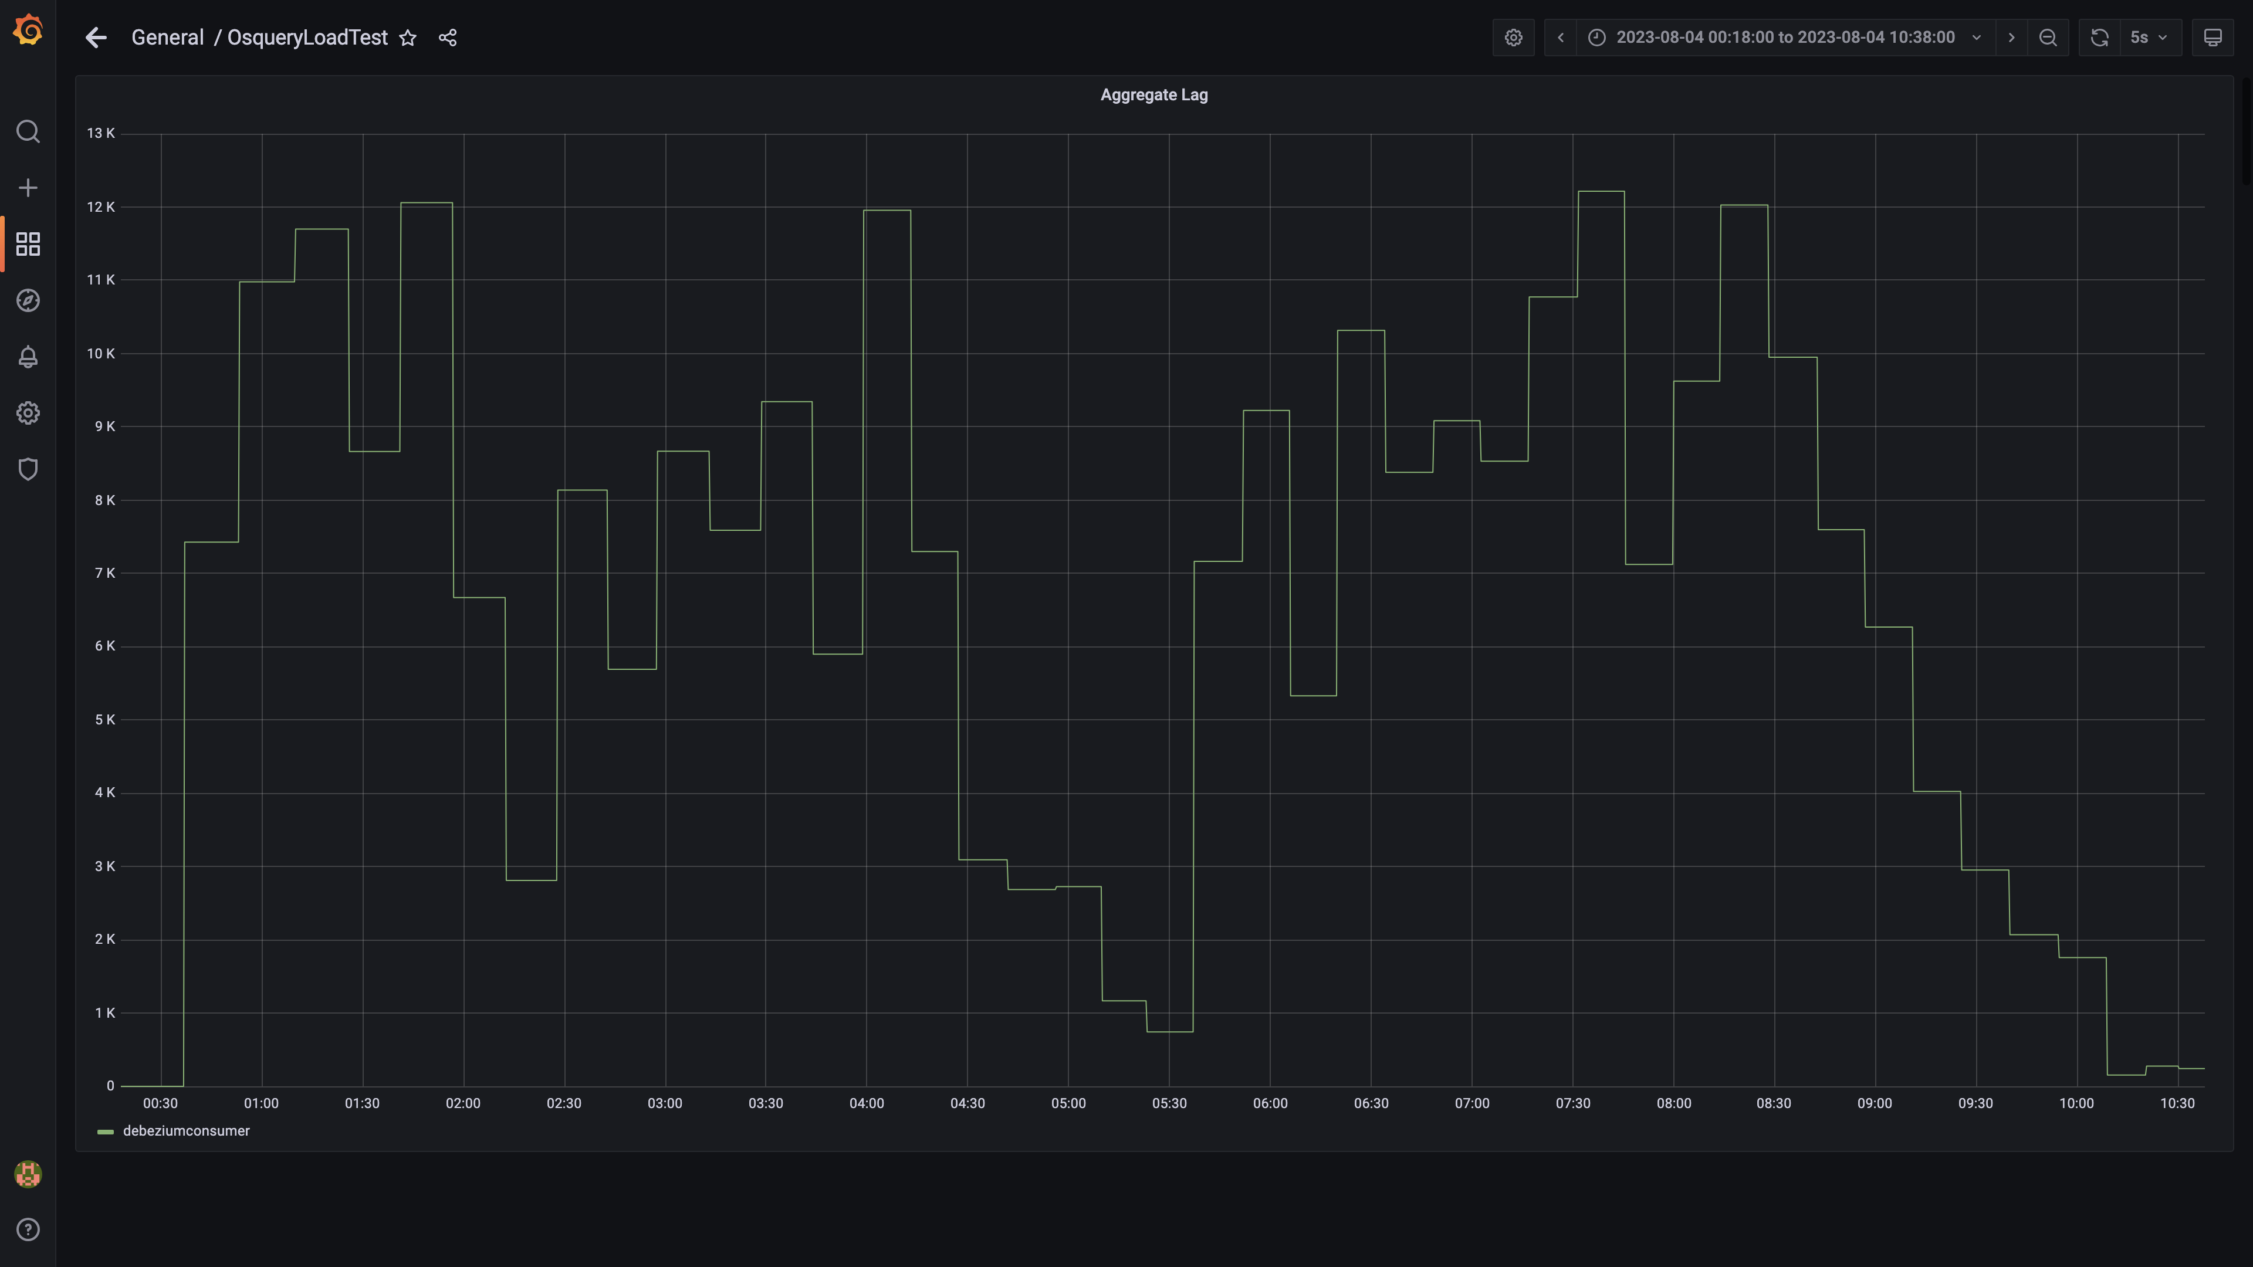

### Debezium replication lag

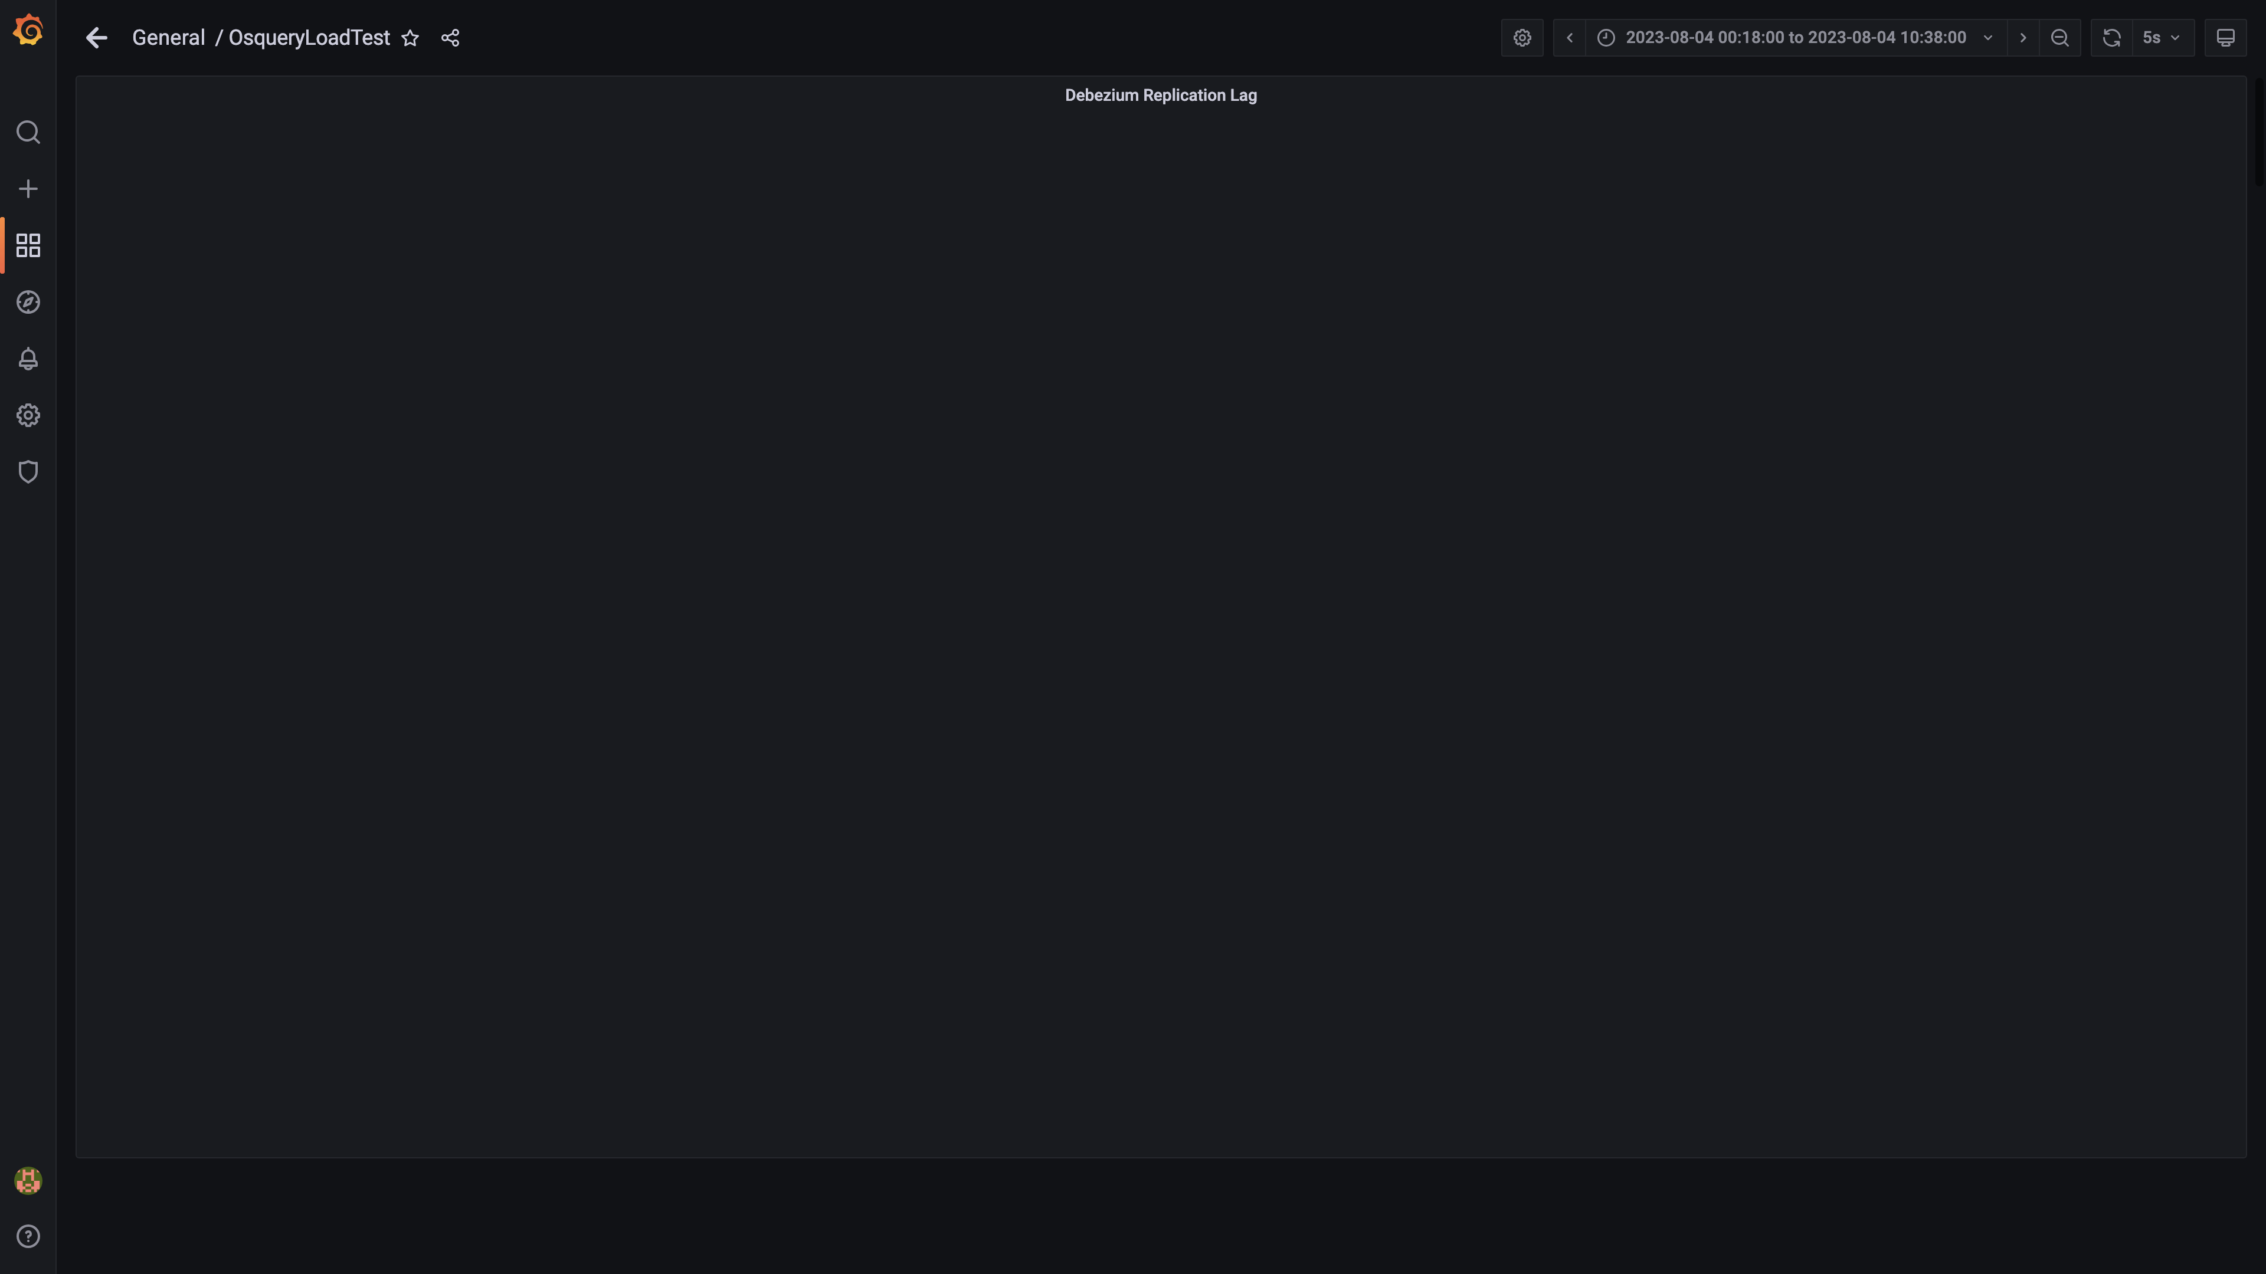

### Active client connections

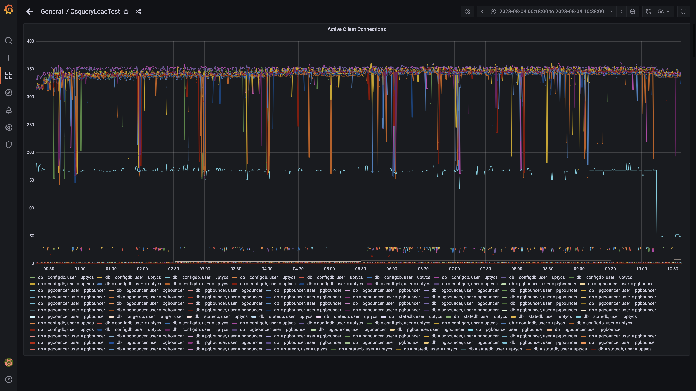

### Panel 130 not loaded in given time

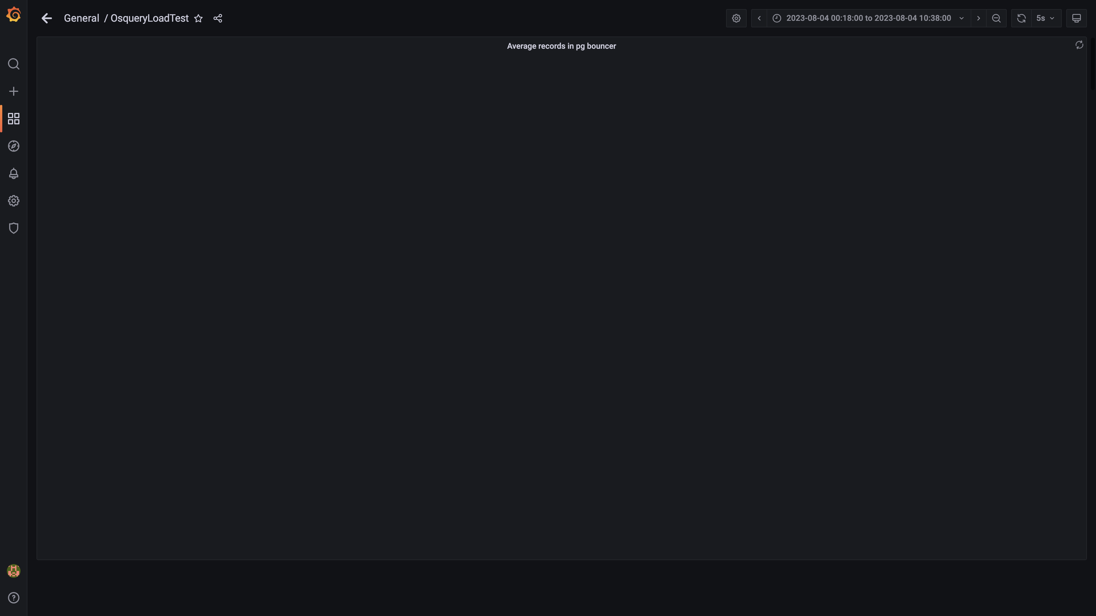

### Panel 128 not loaded in given time

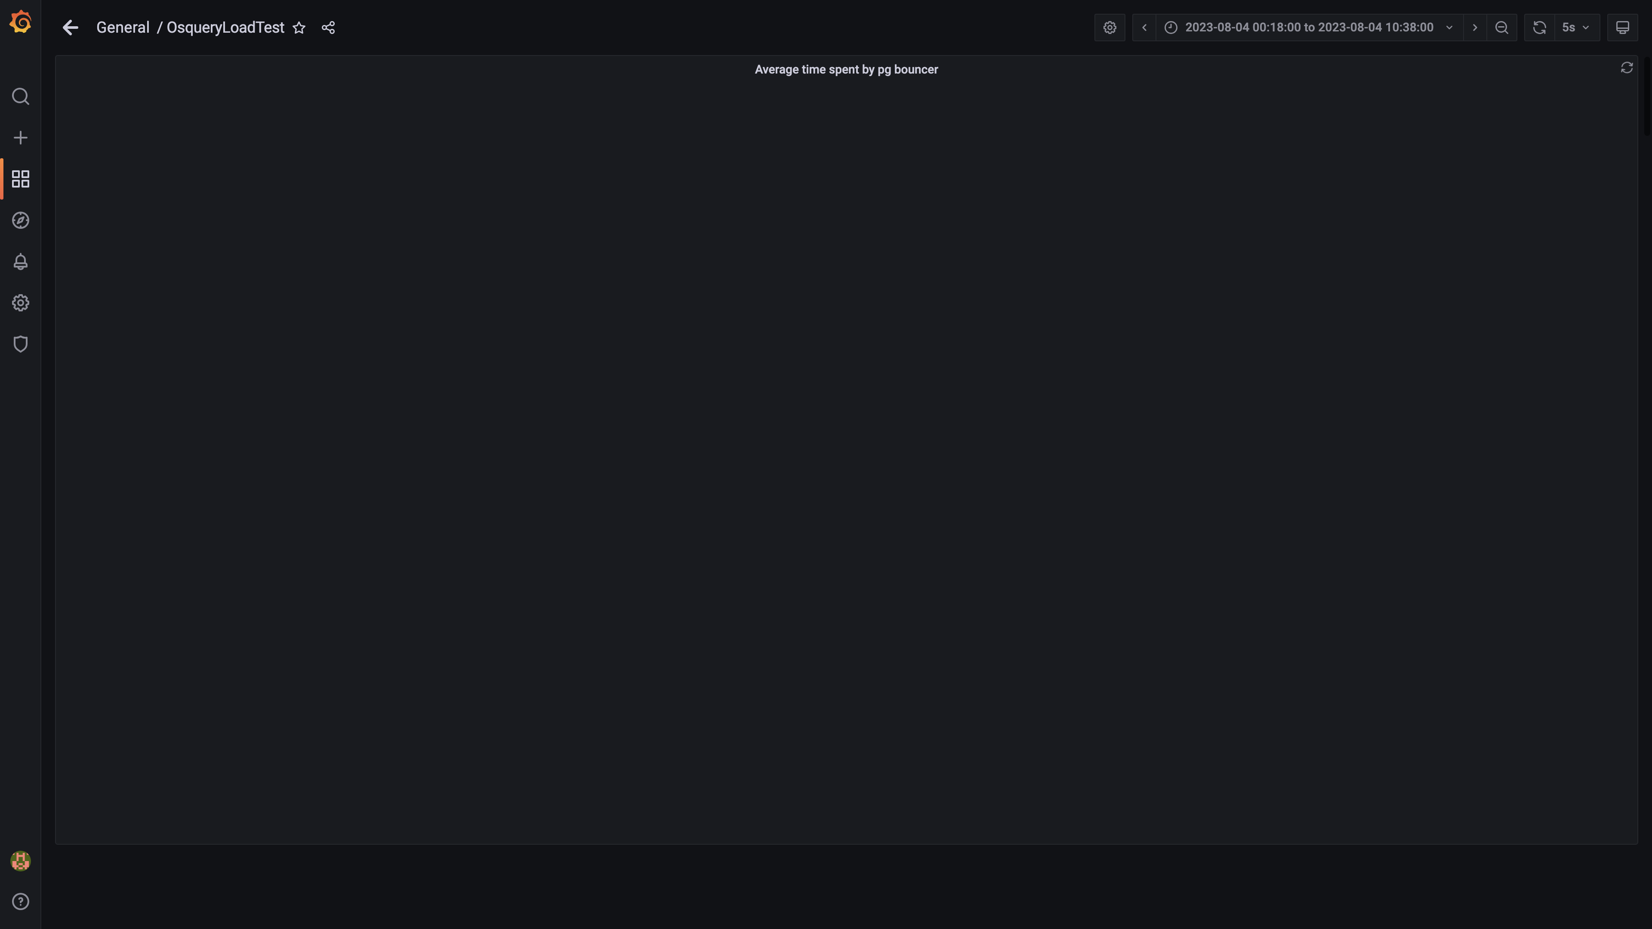

### Redis client connections for tls

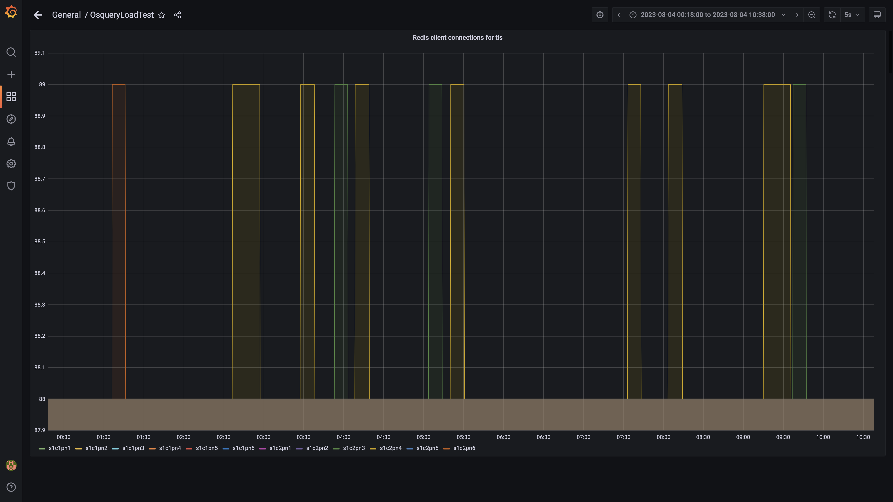

### Configdb pg wal folder size

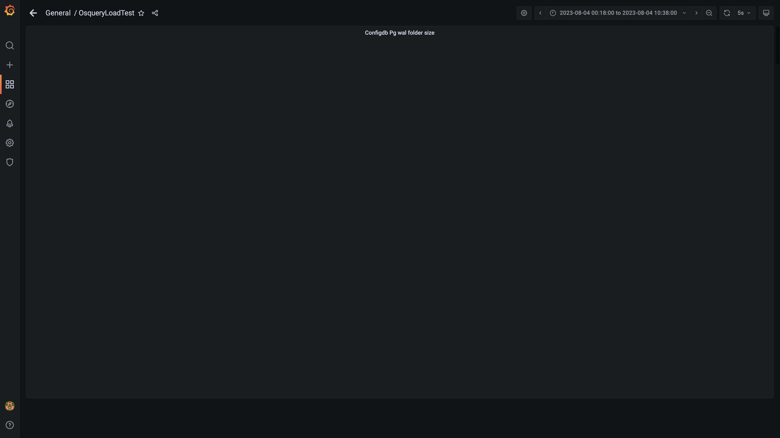

### Configdb number of wal files

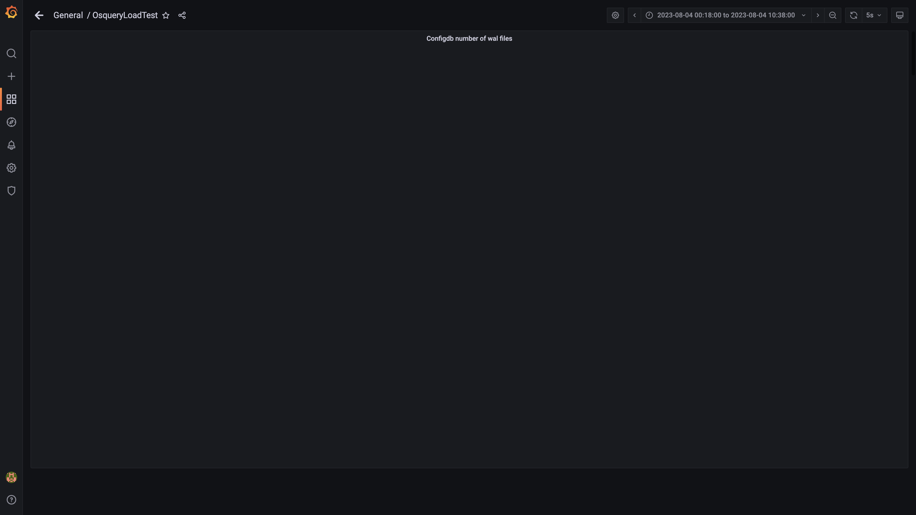

### Top 10 redis client connections by app

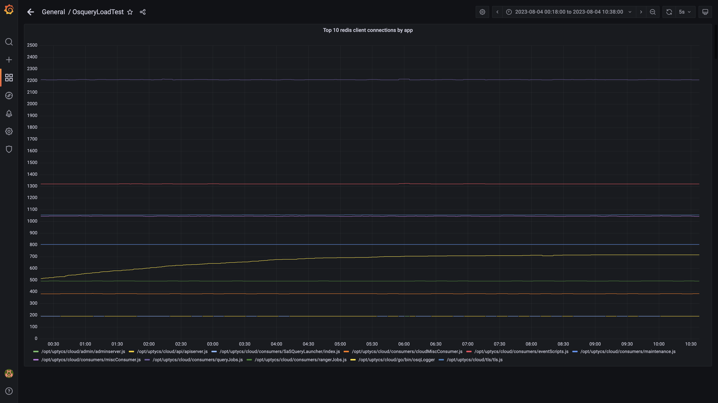

### Configdb folder size

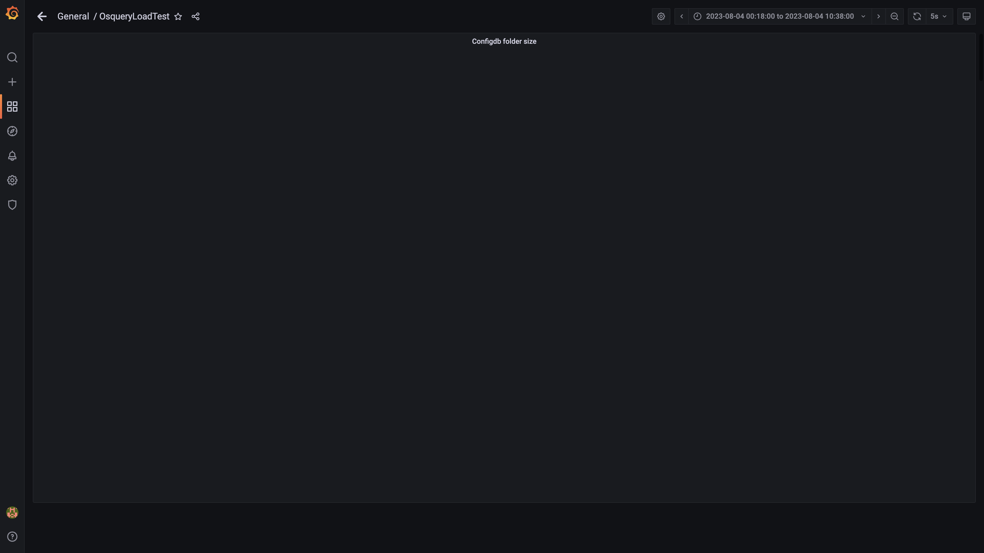

### Cpu and memory usages

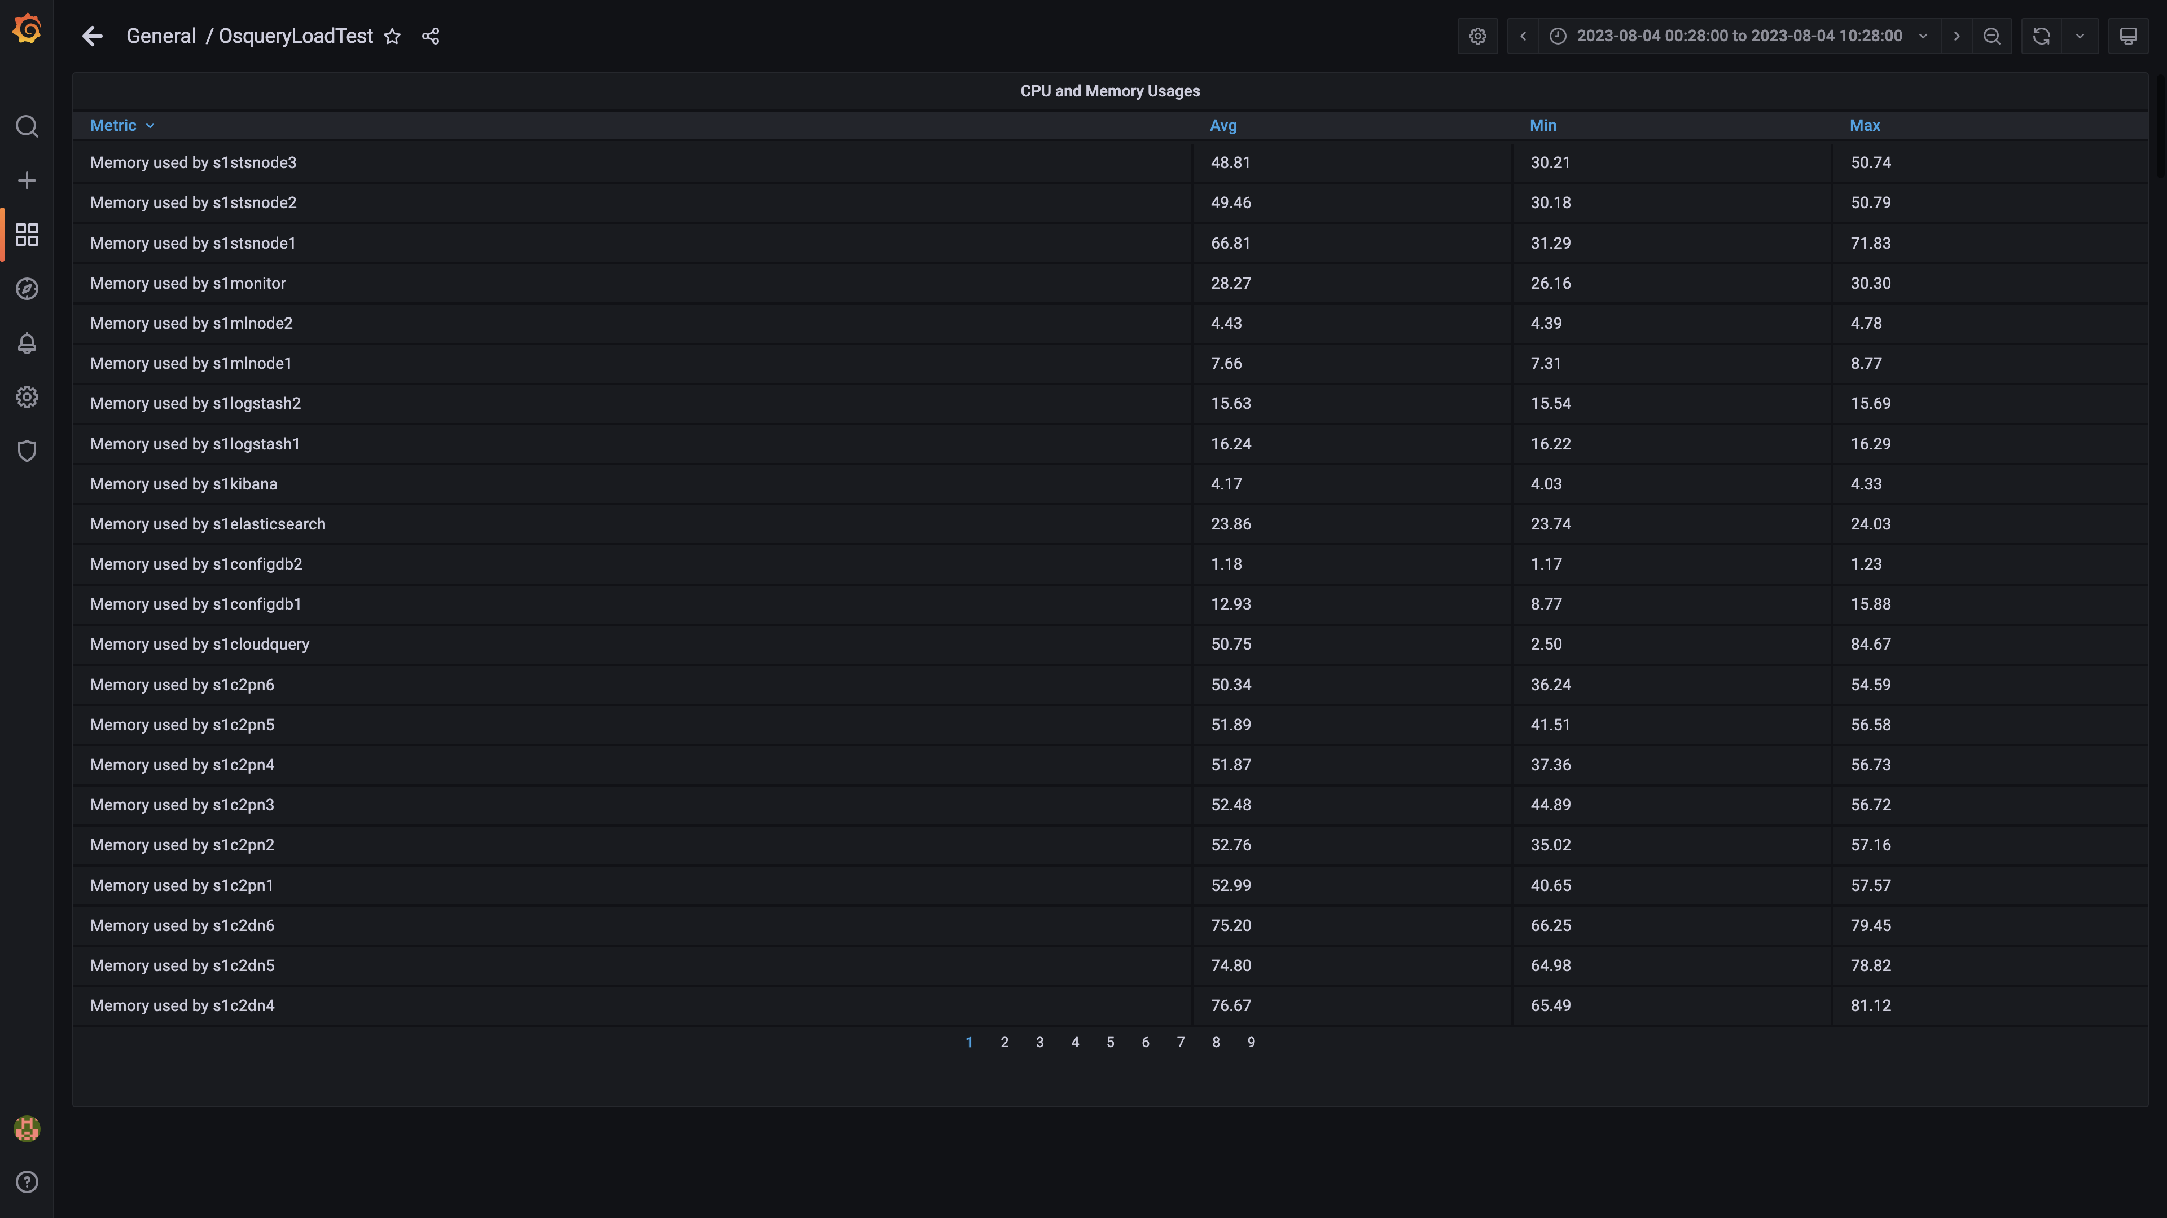

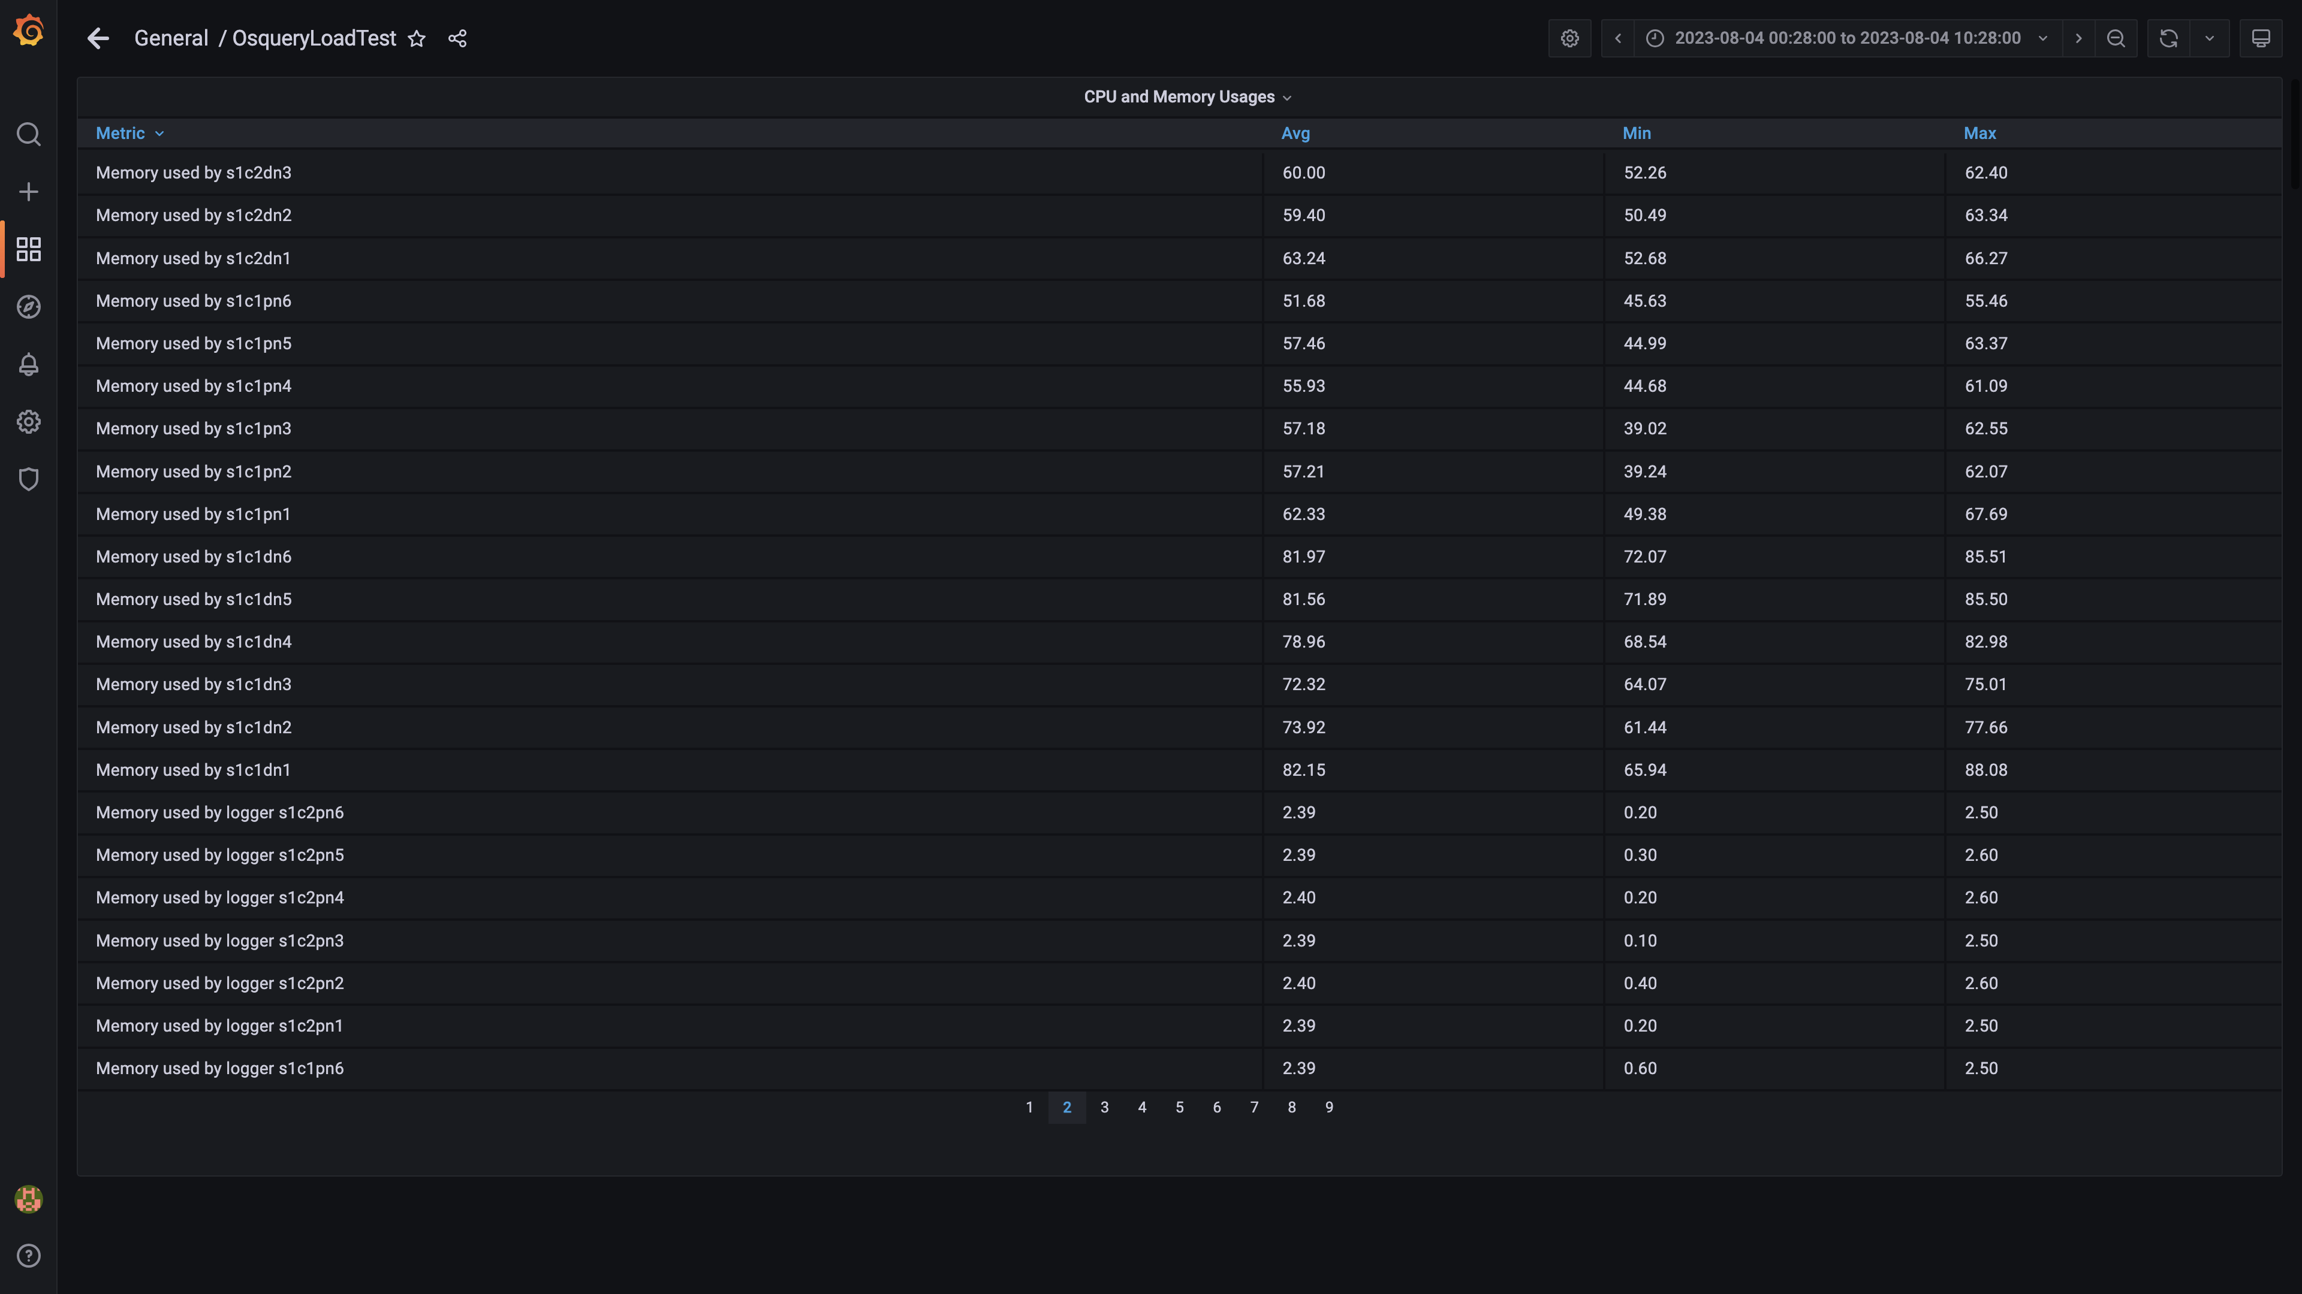

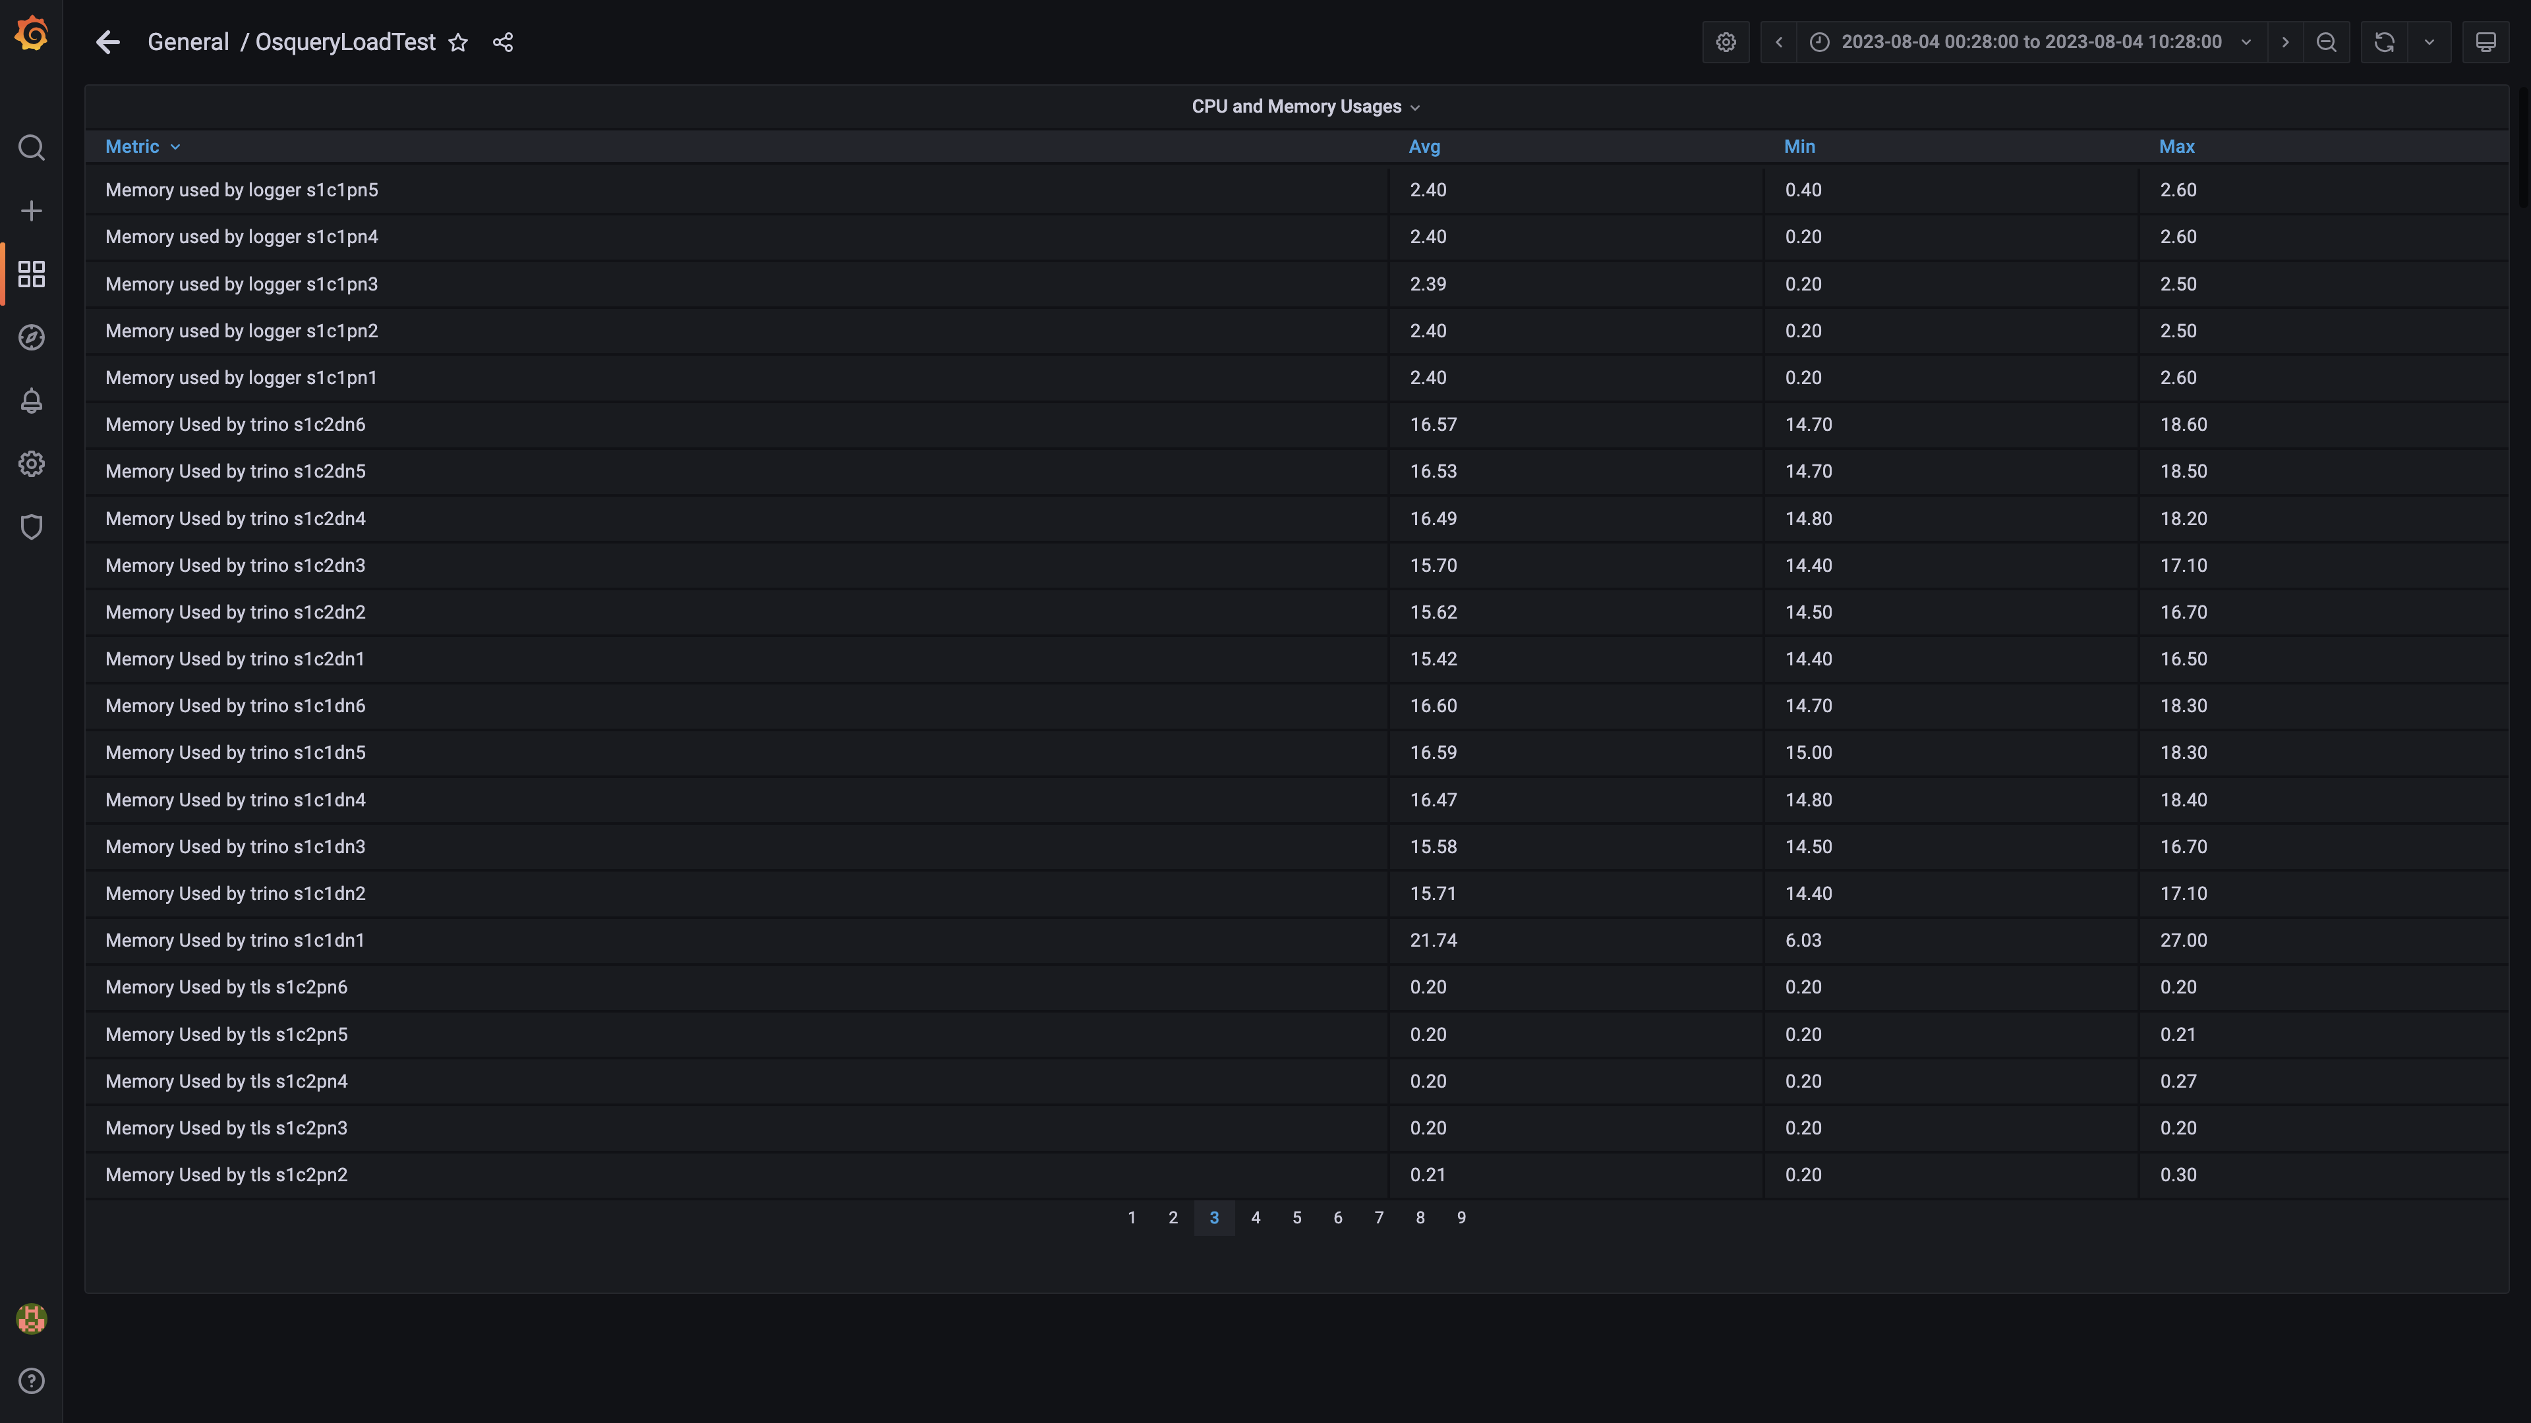

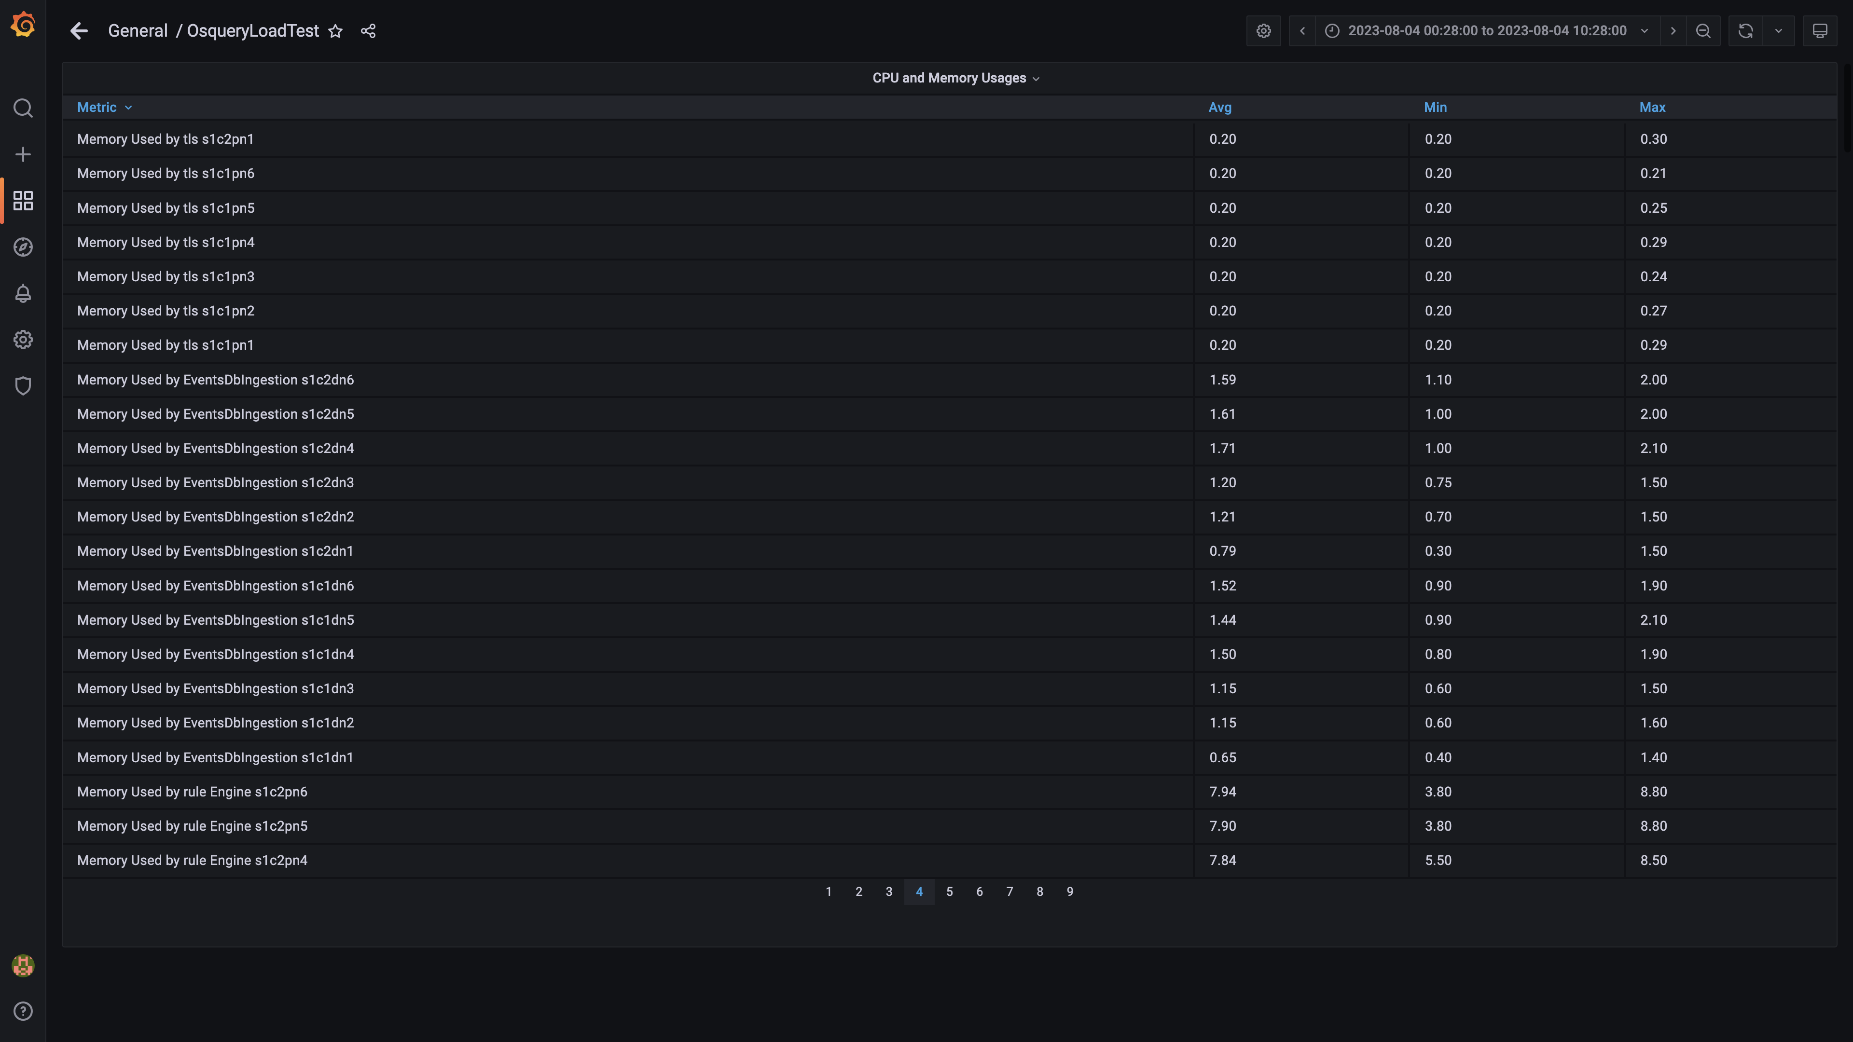

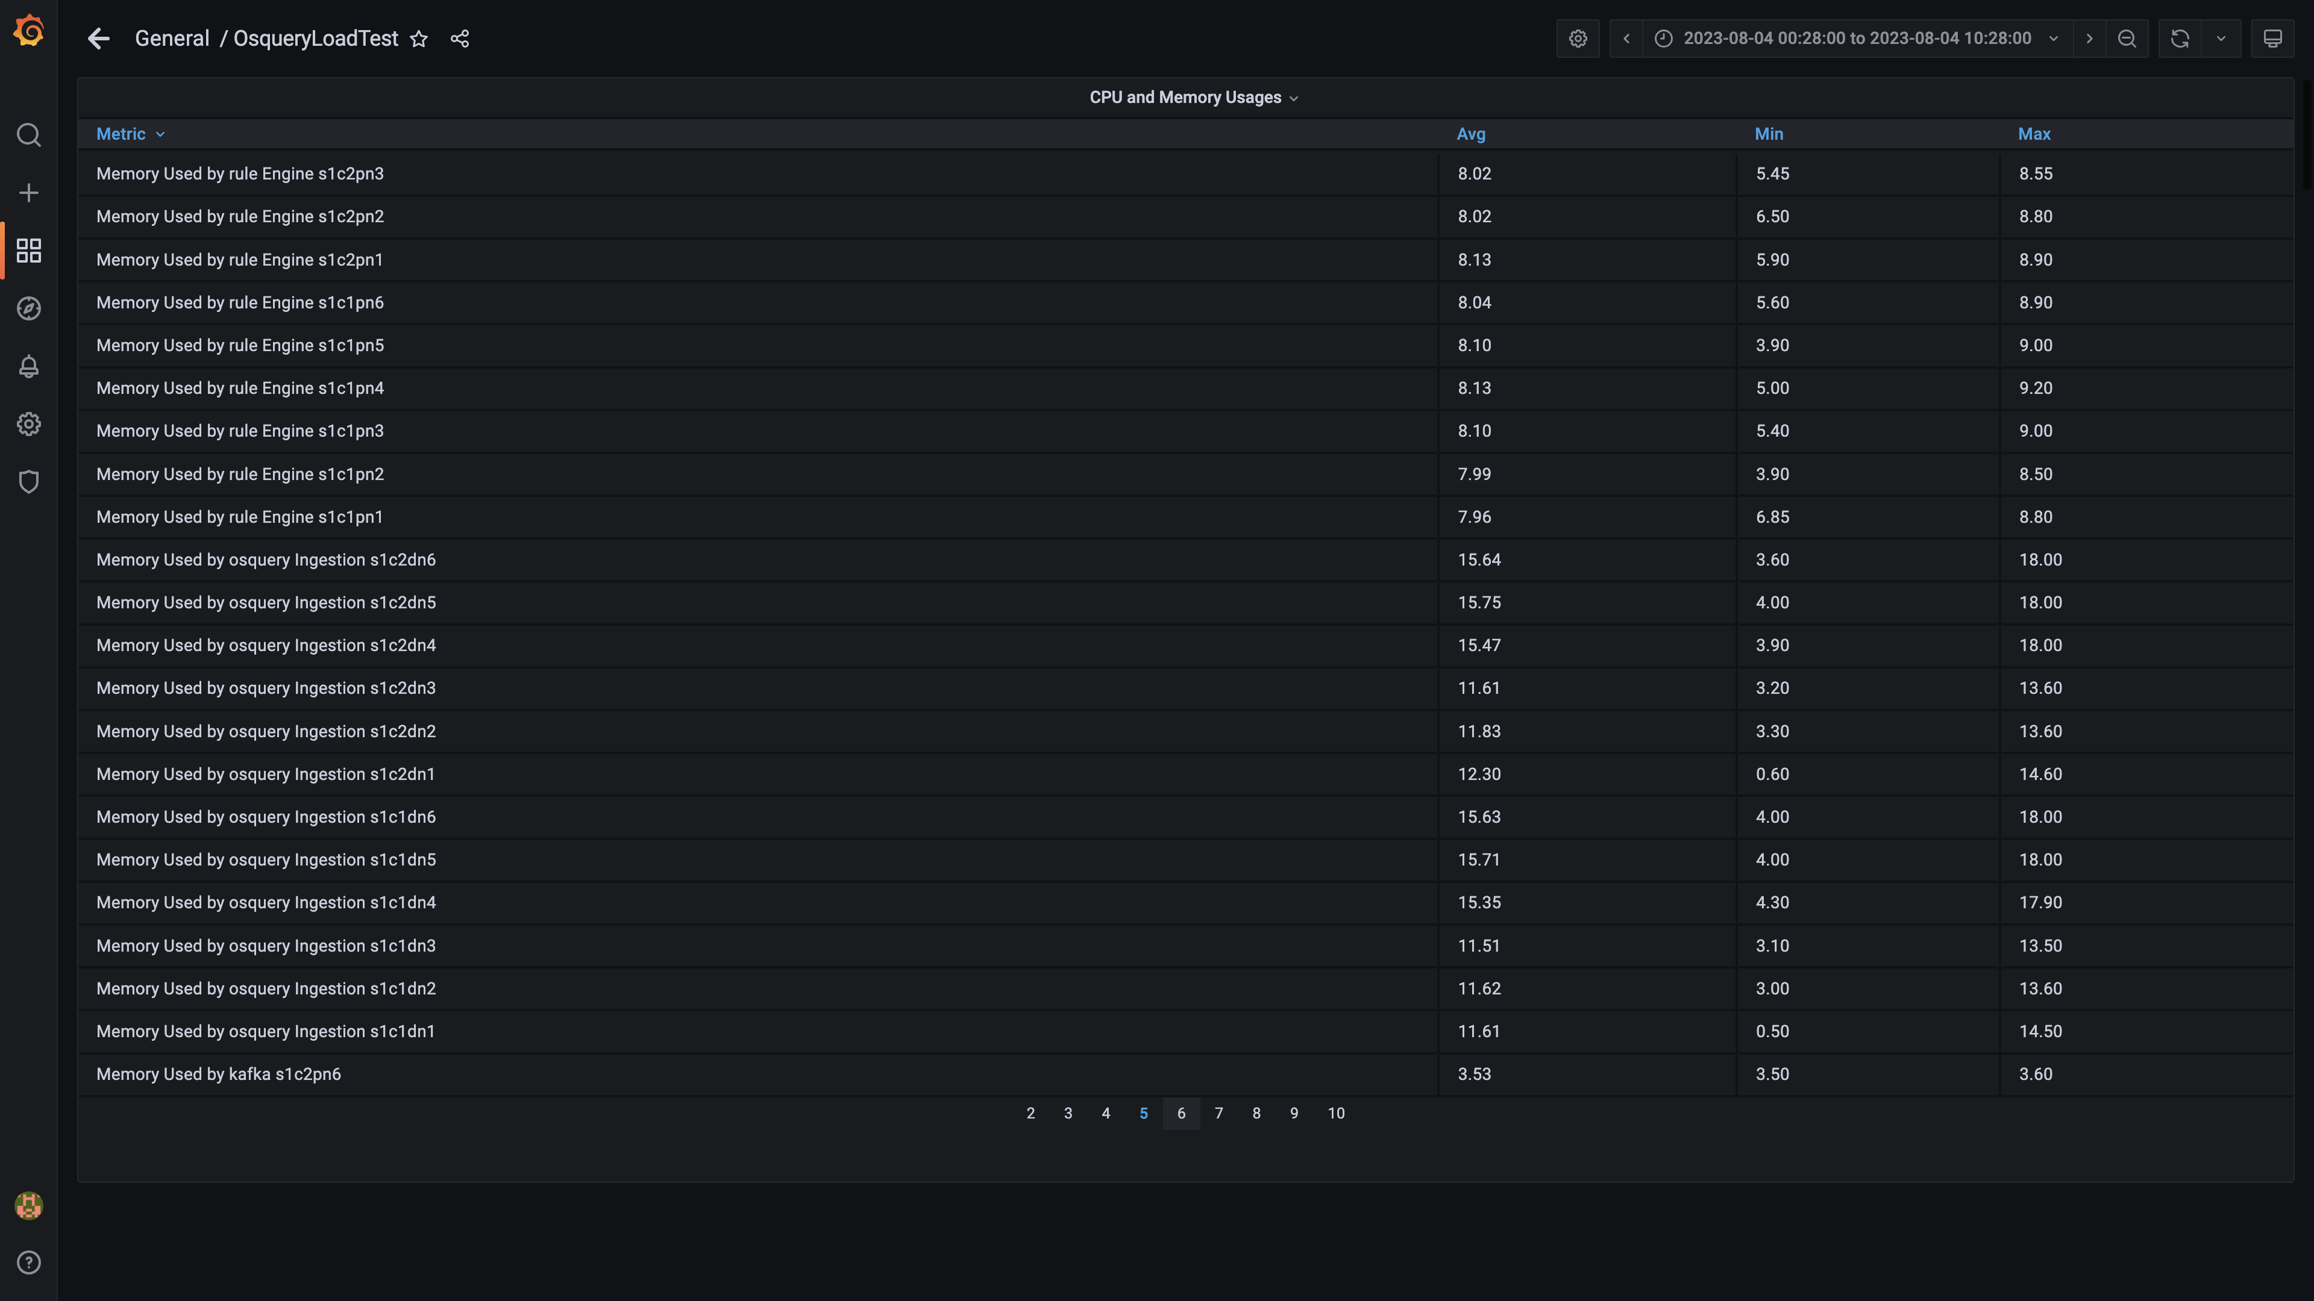

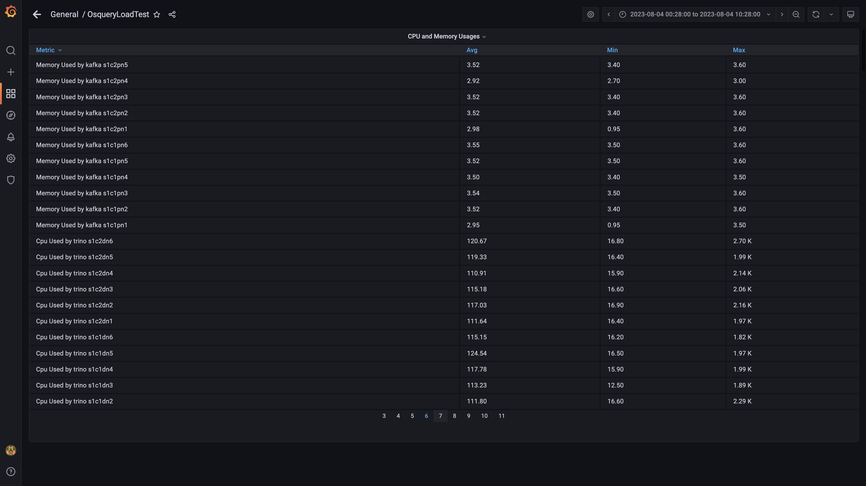

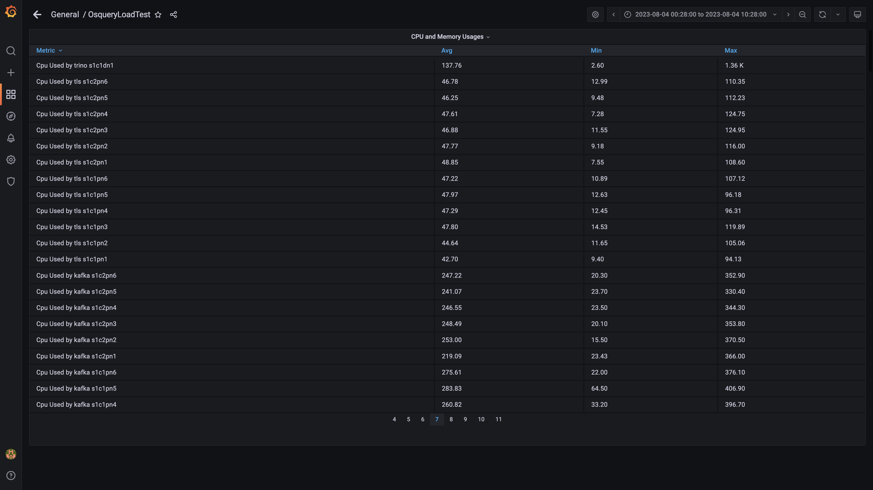

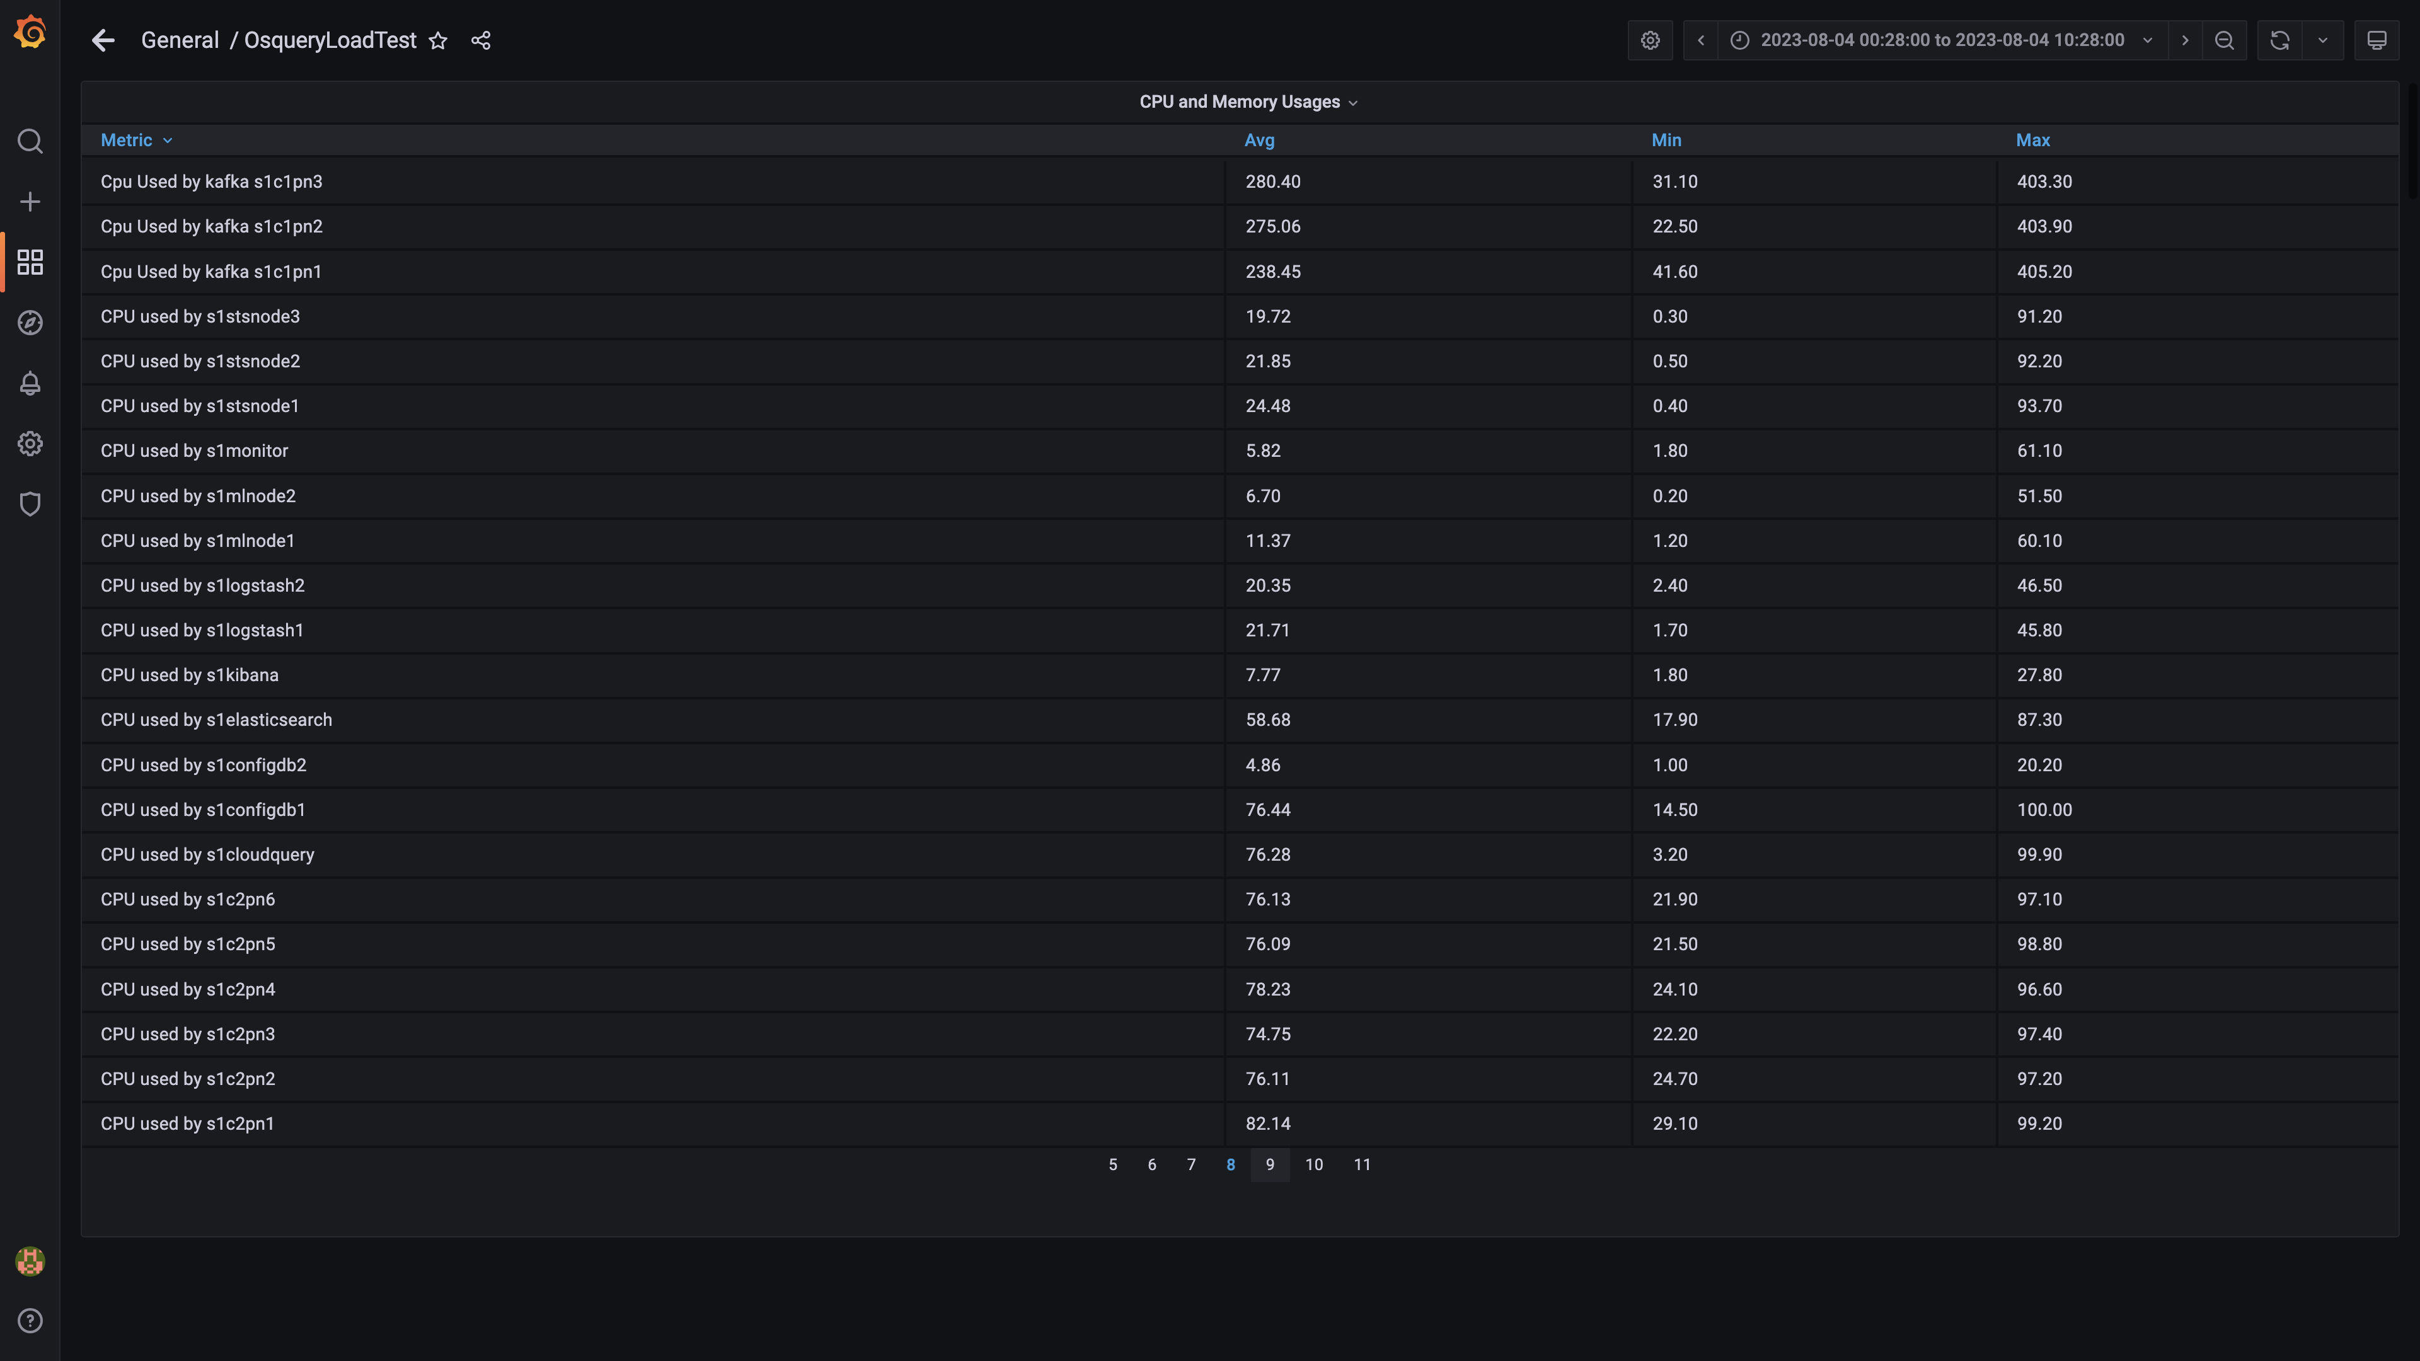

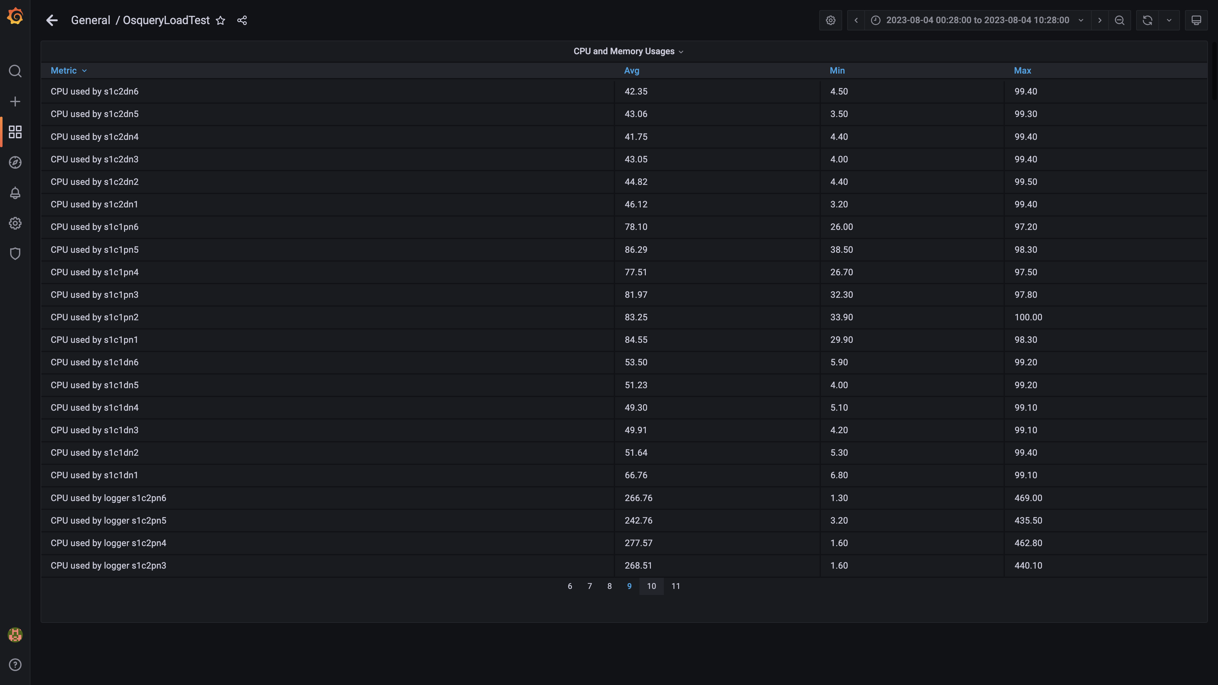

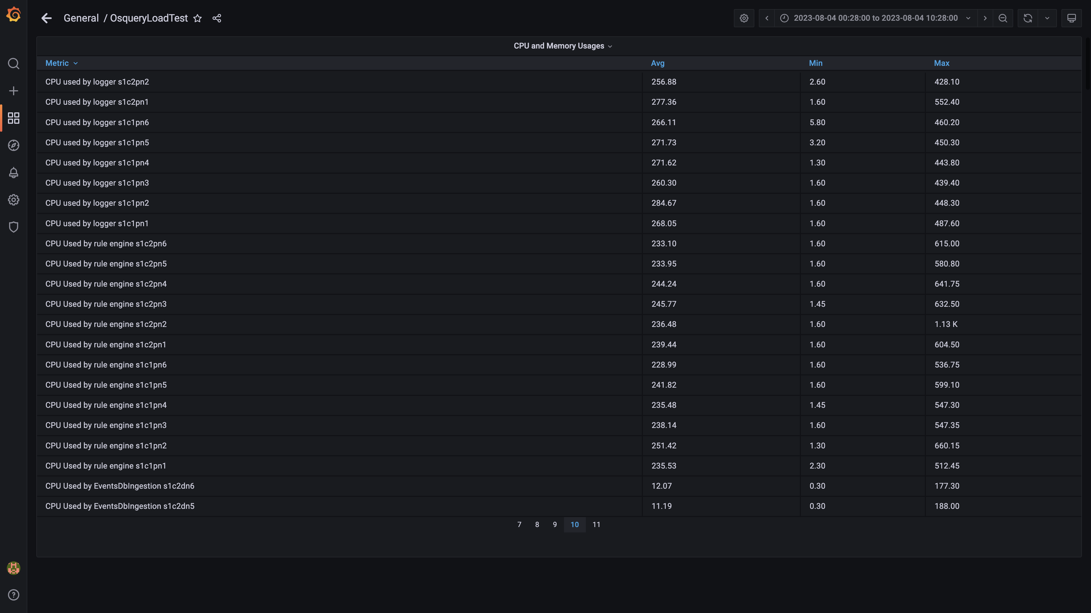

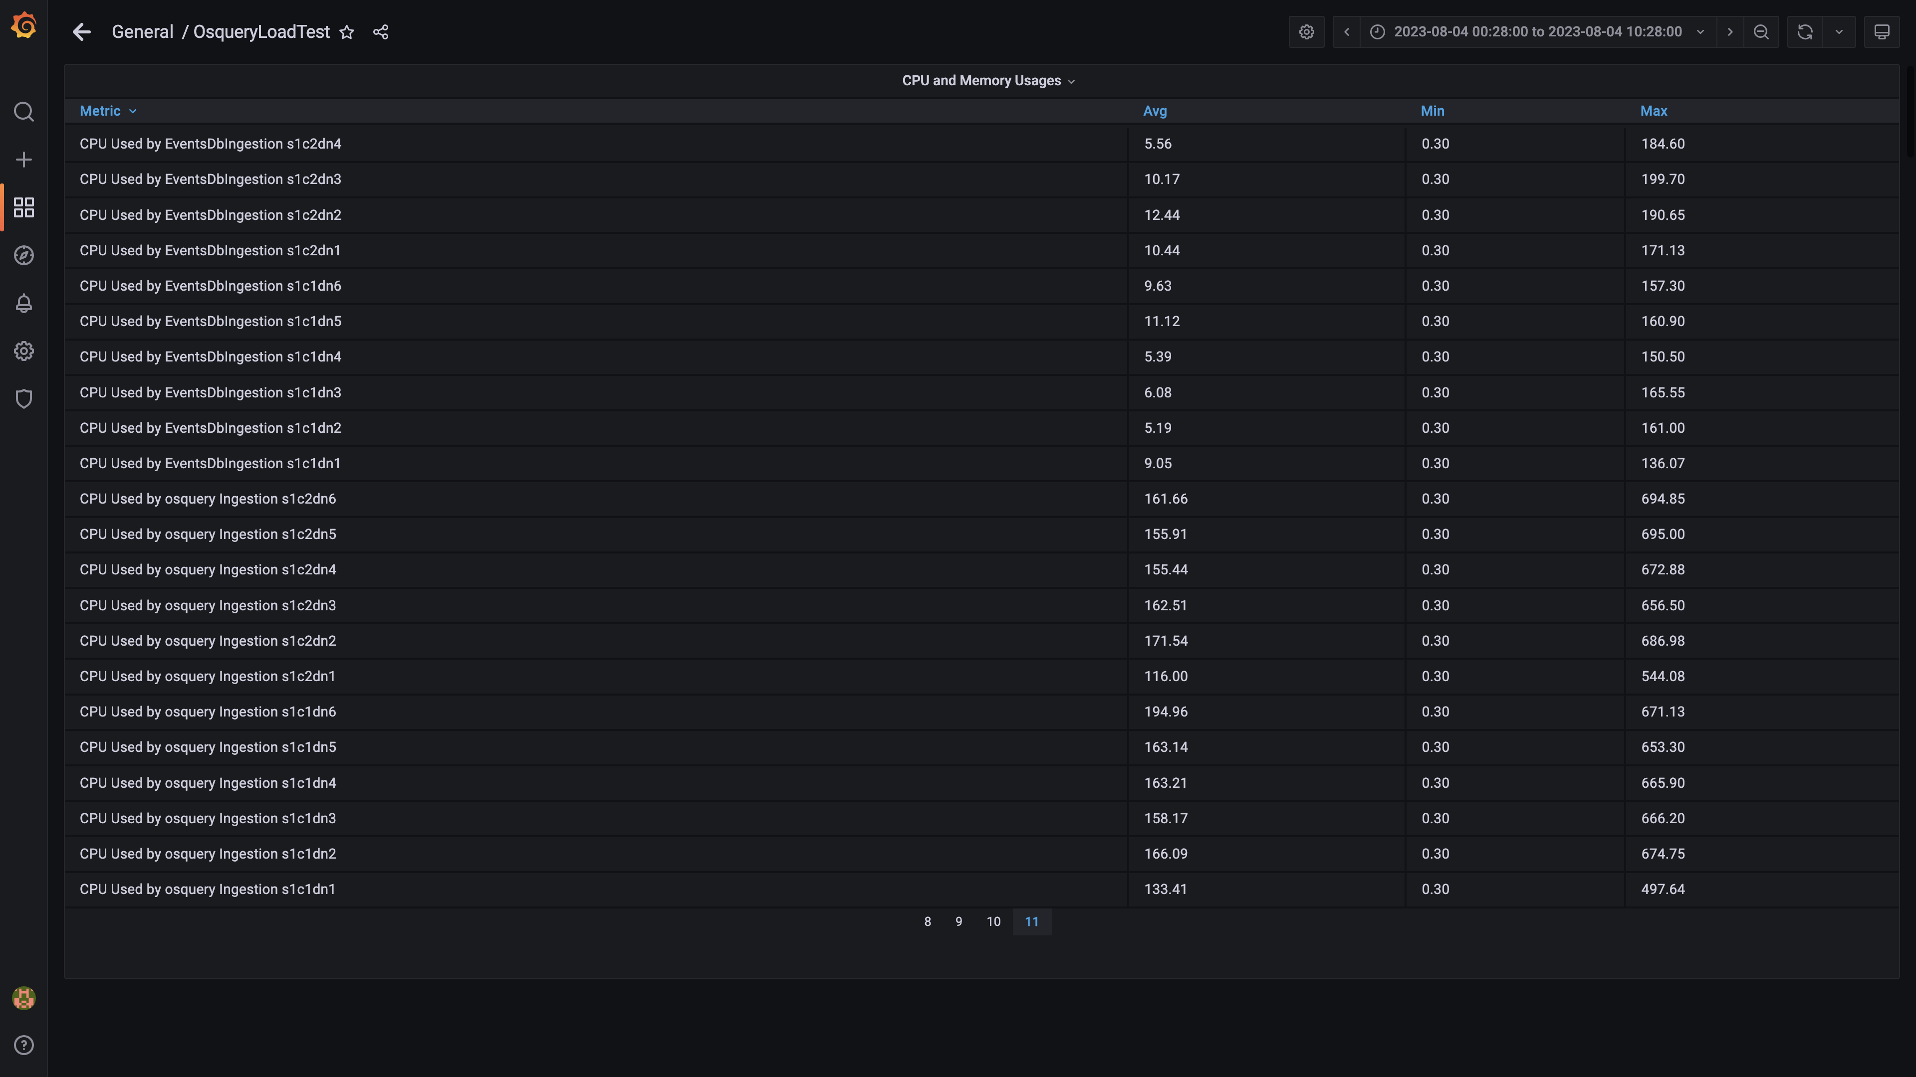

### Overall container memory and cpu usage

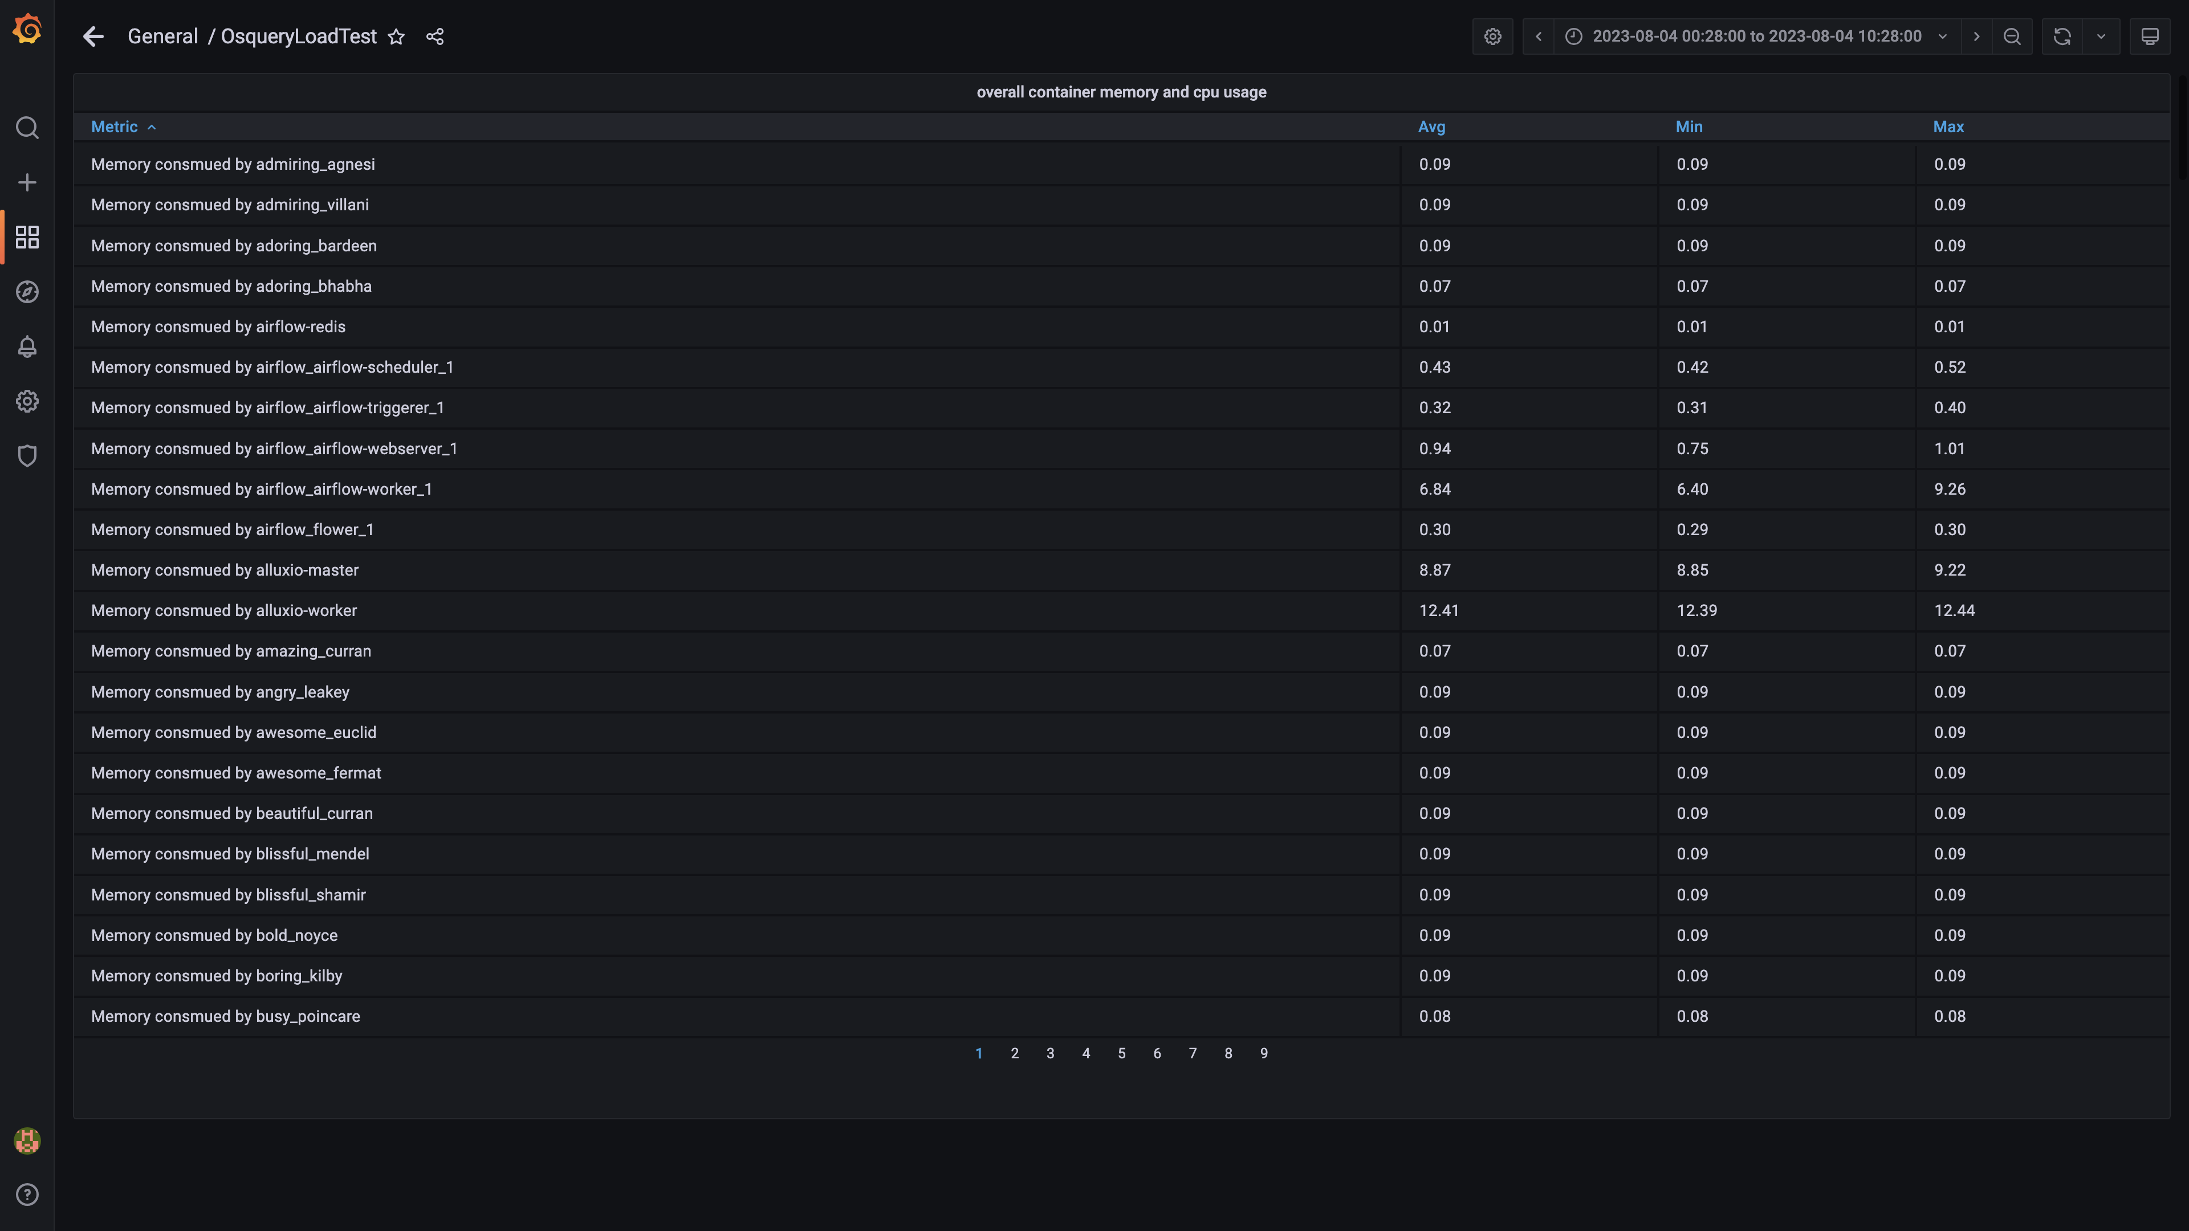

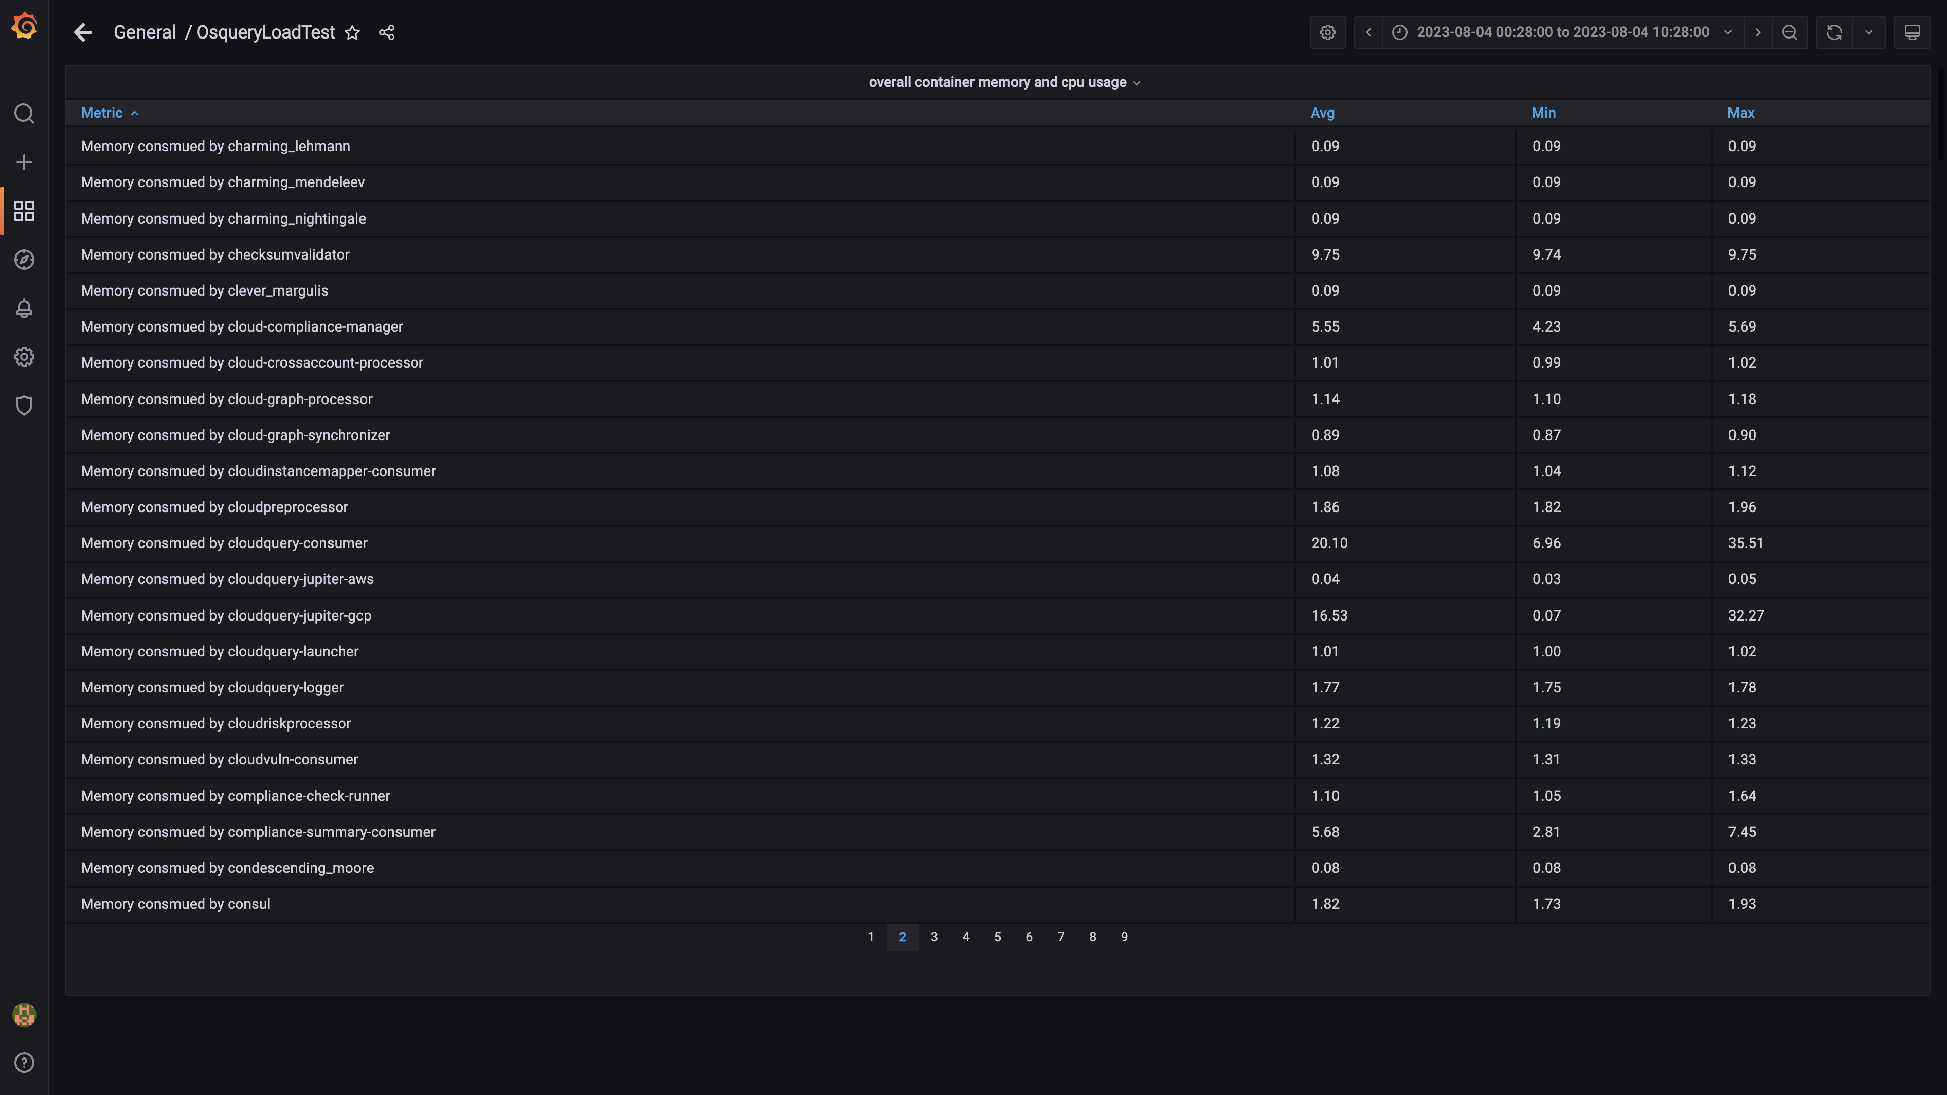

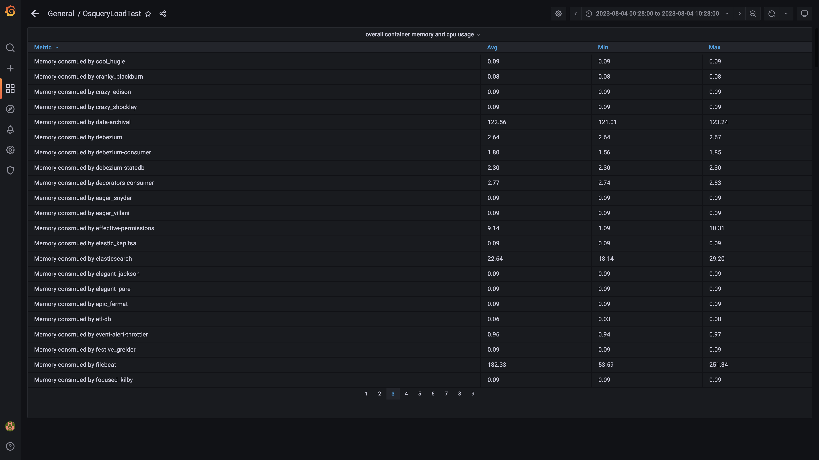

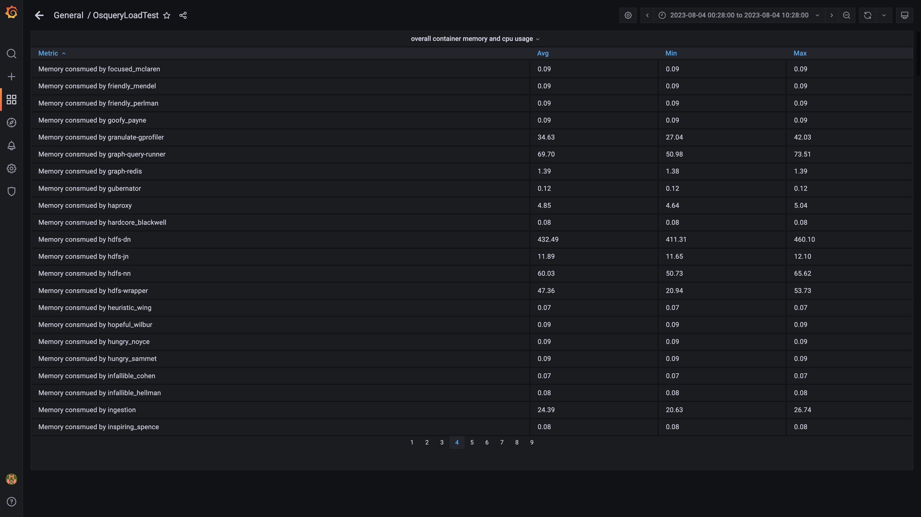

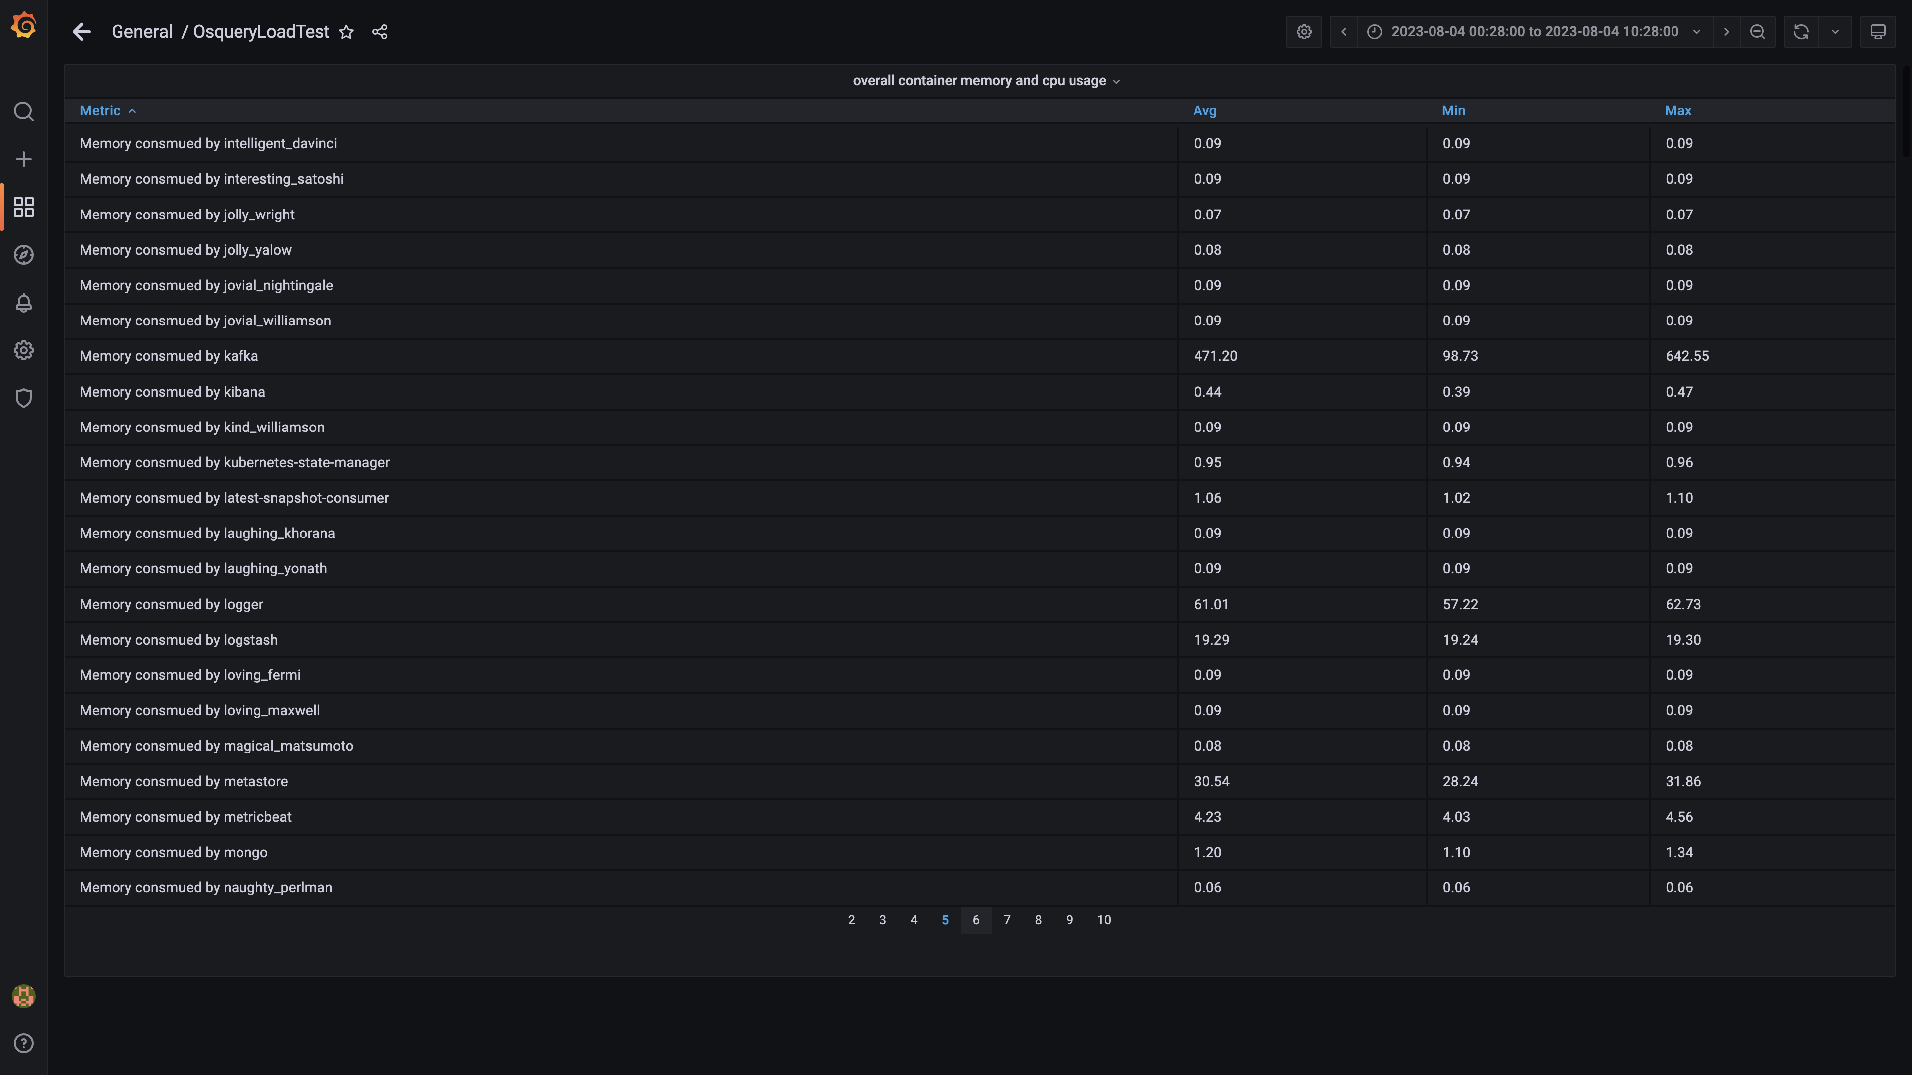

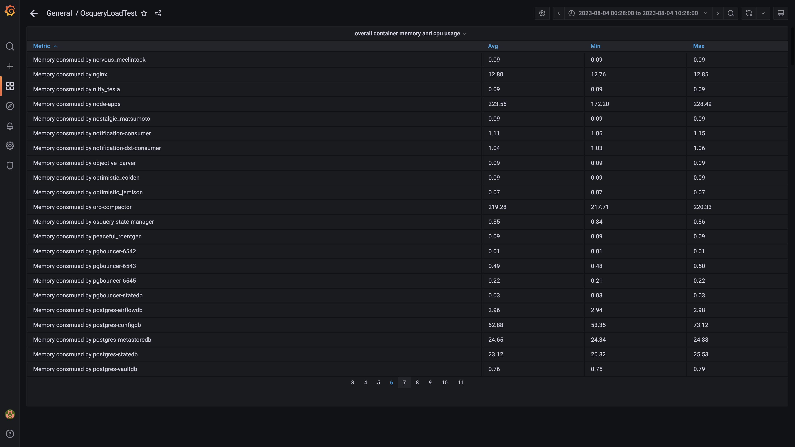

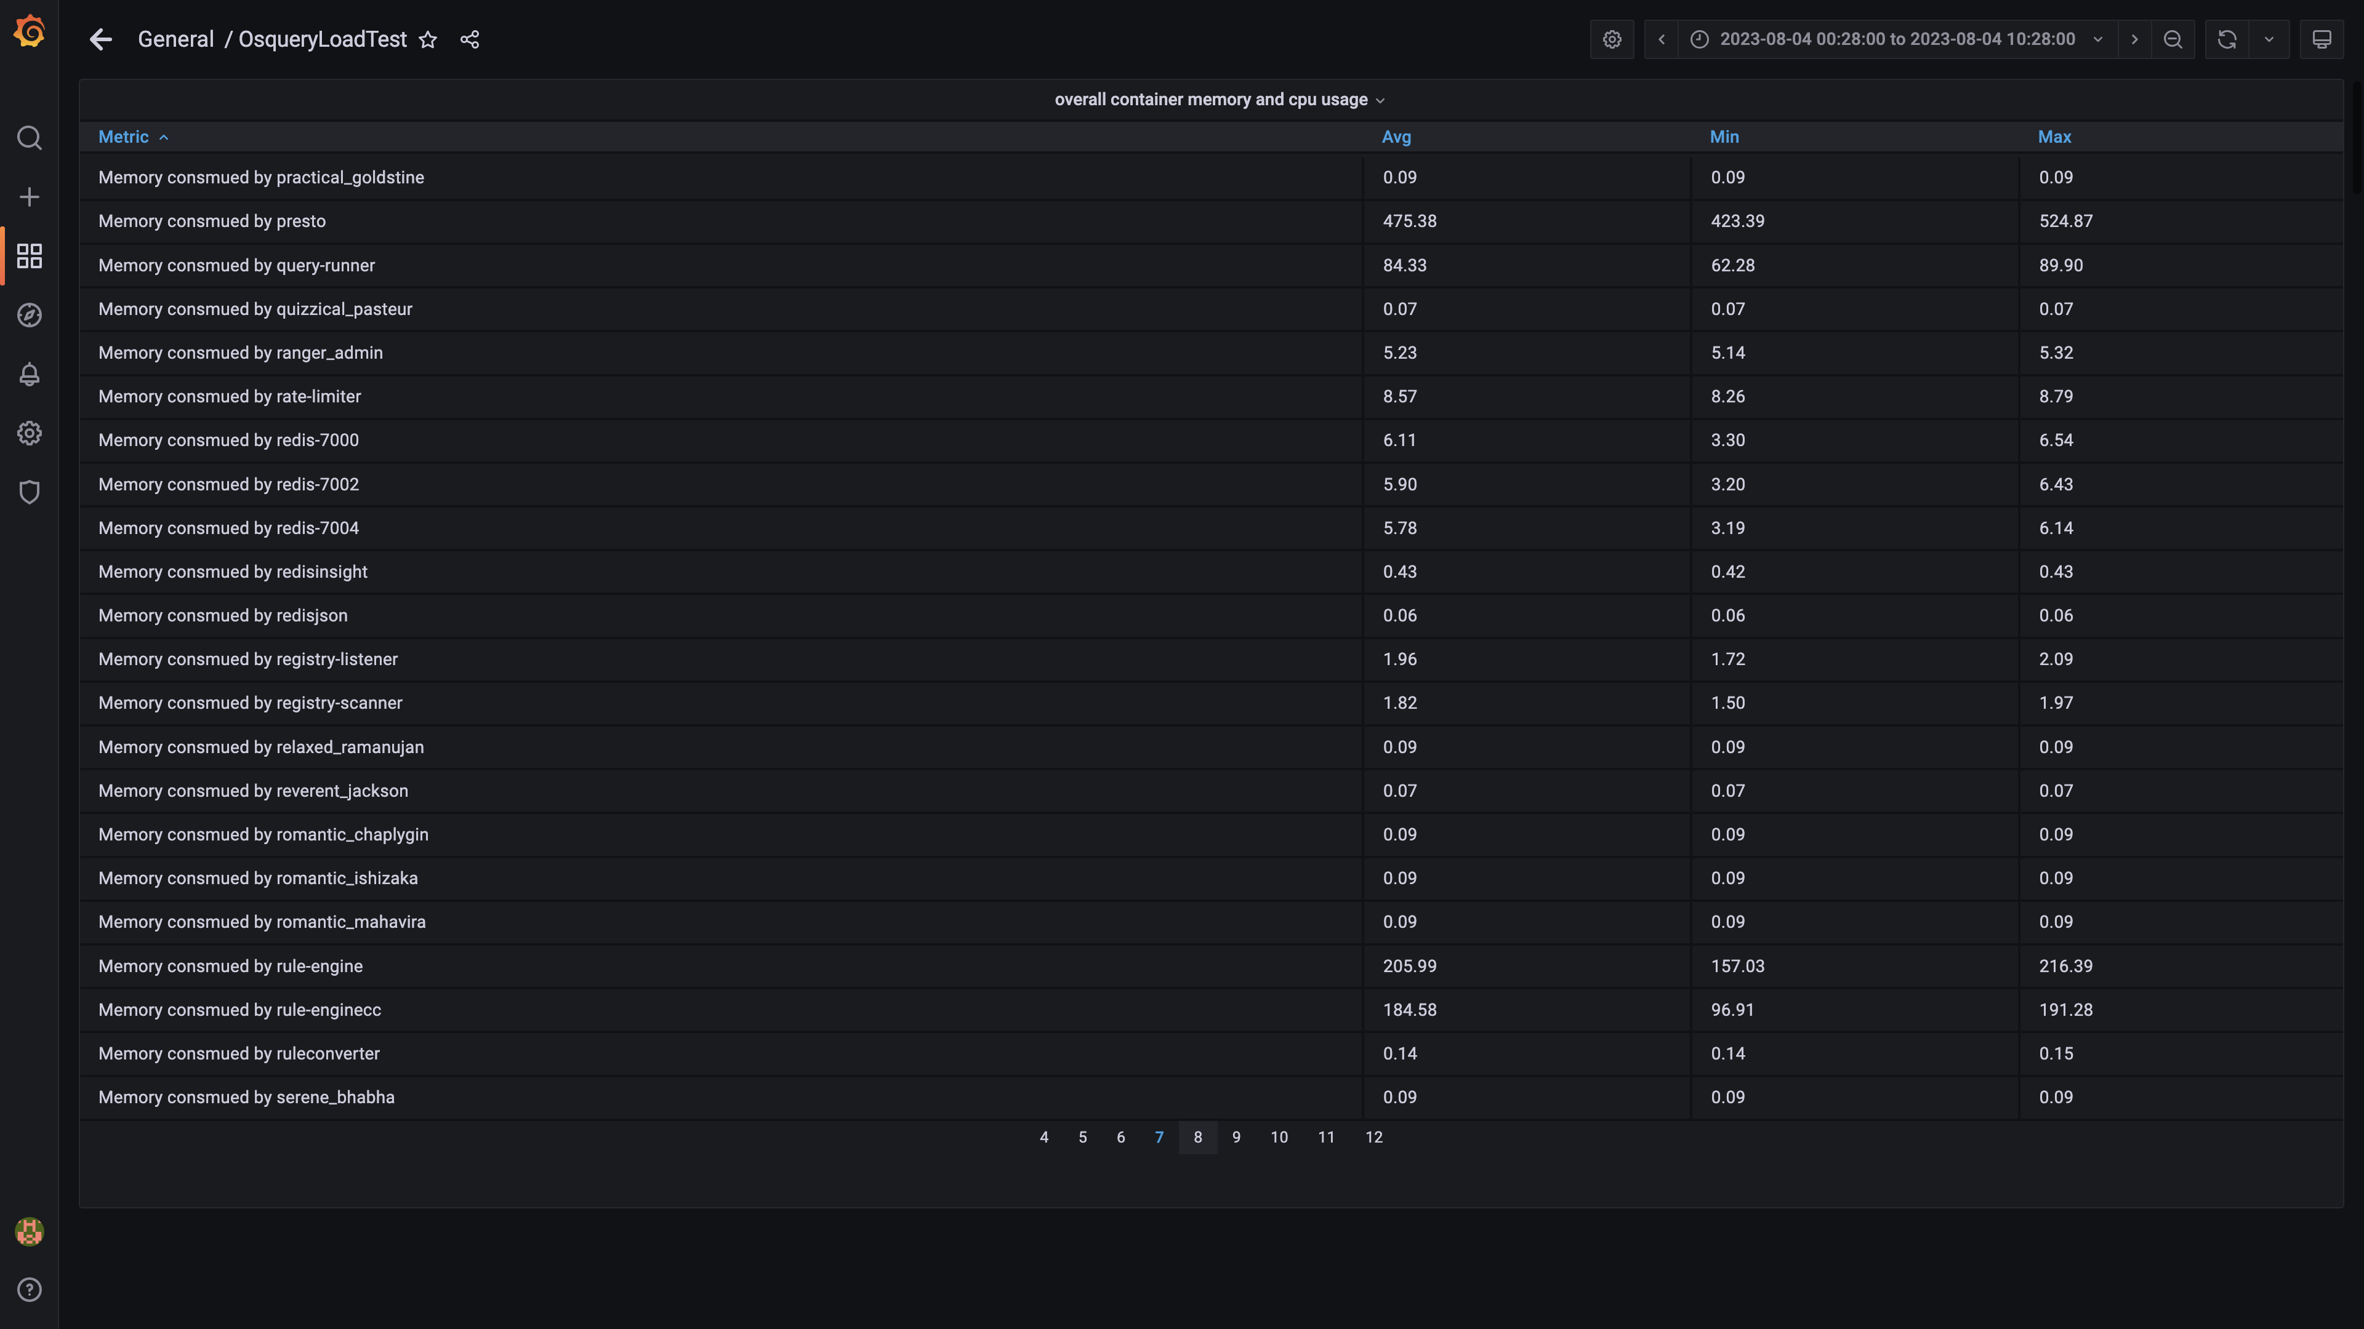

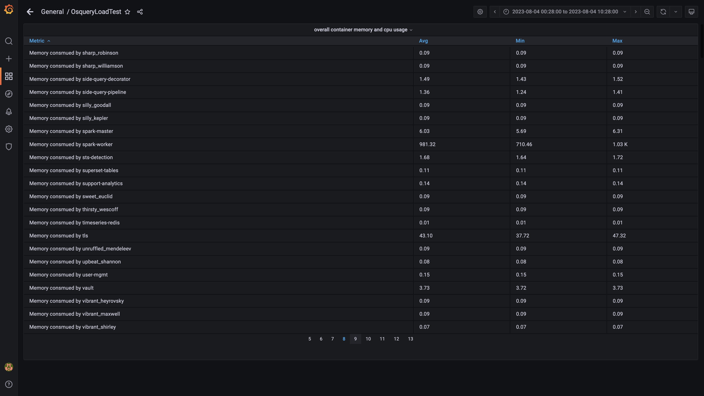

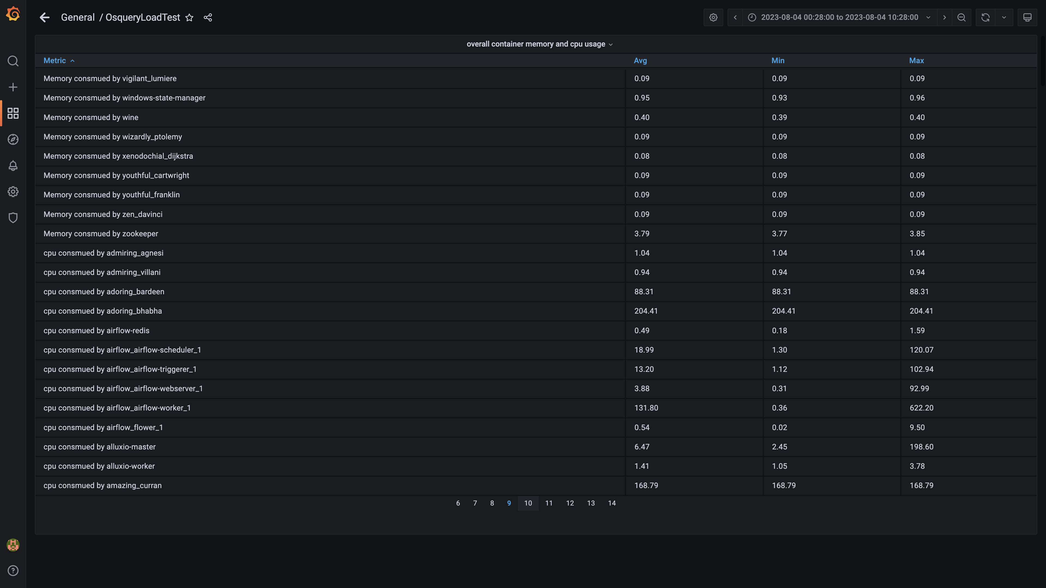

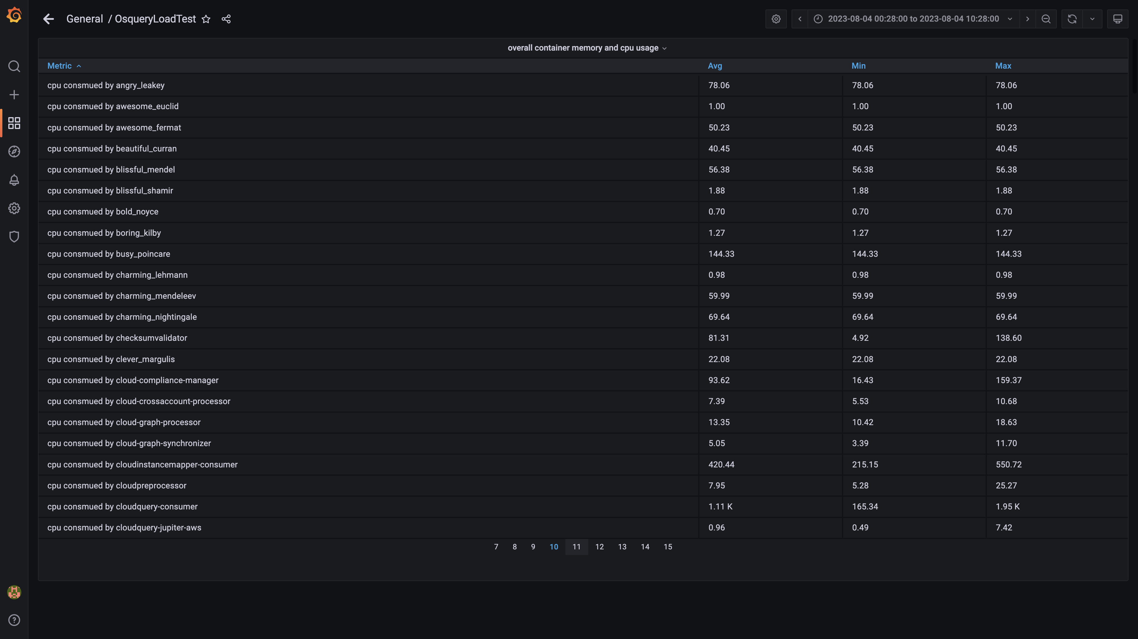

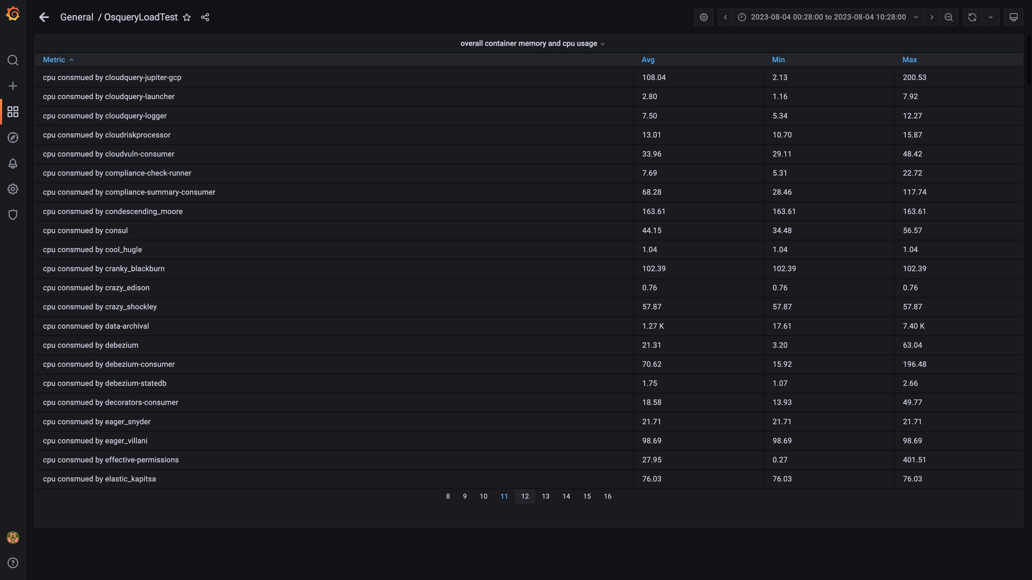

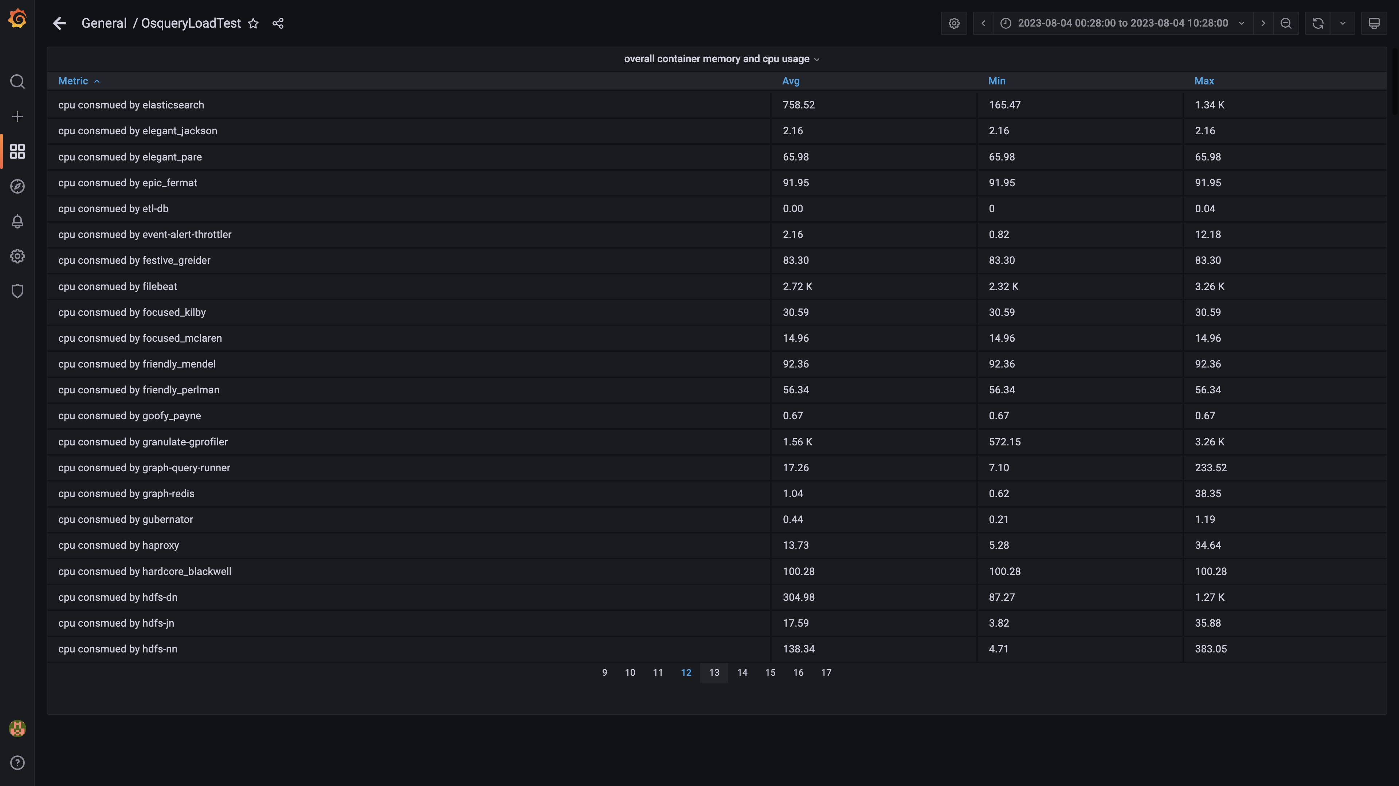

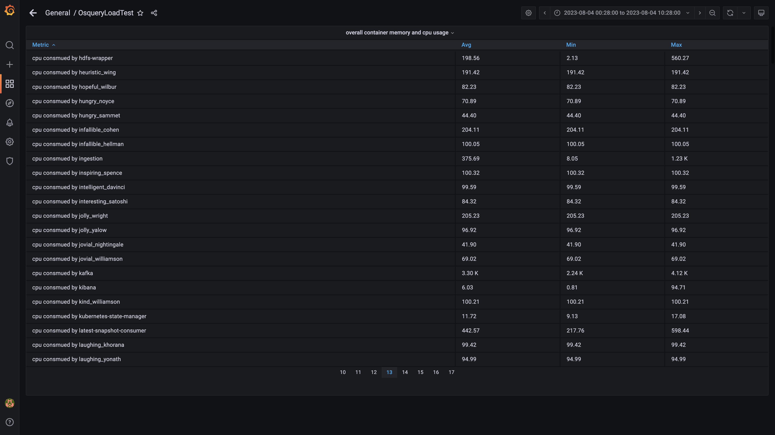

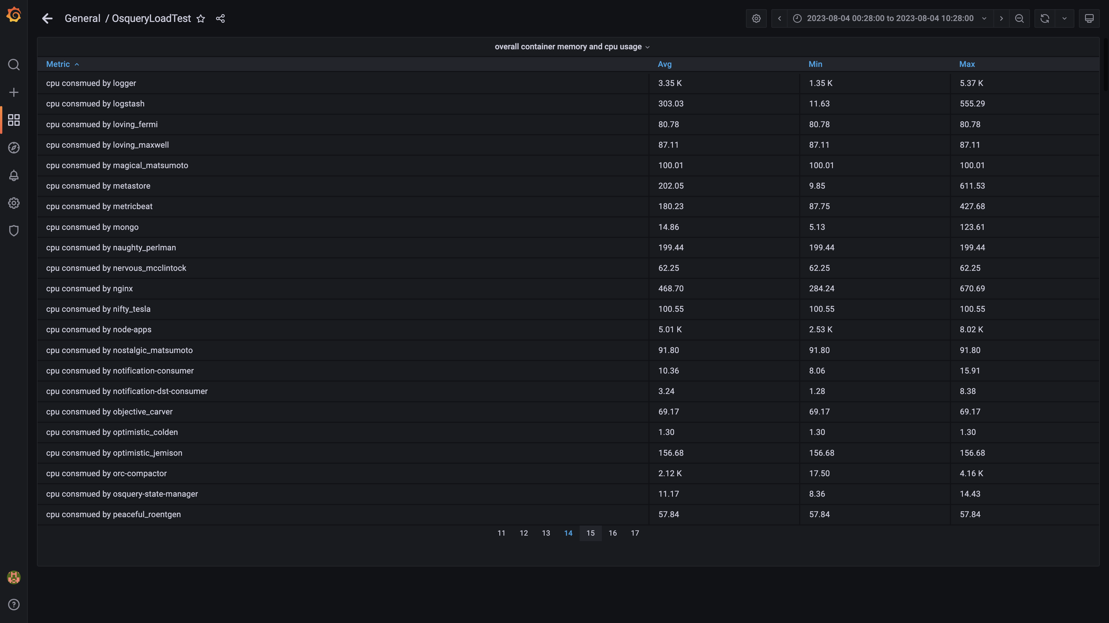

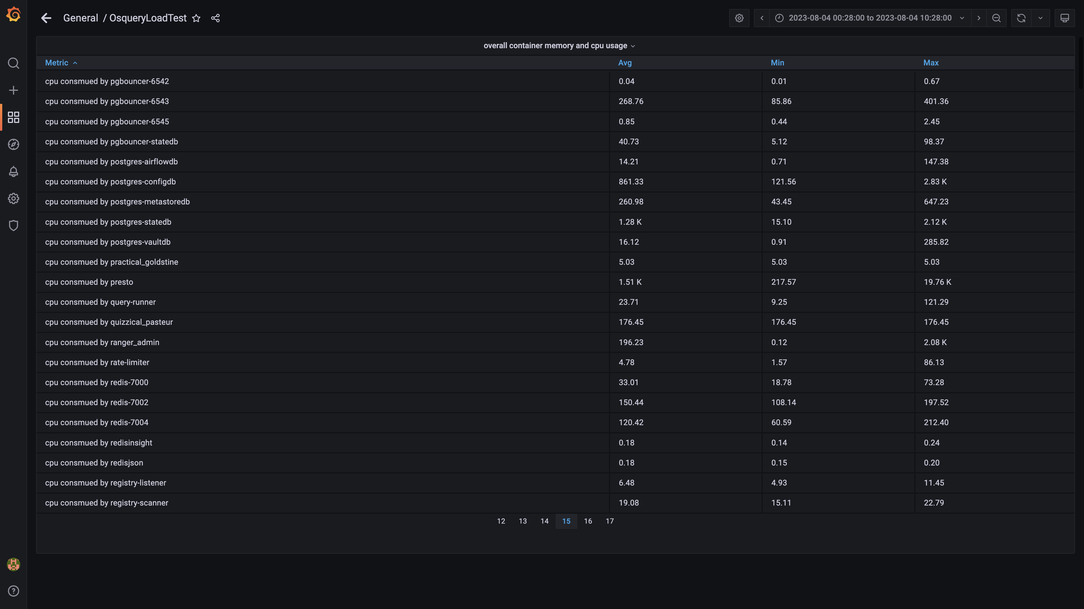

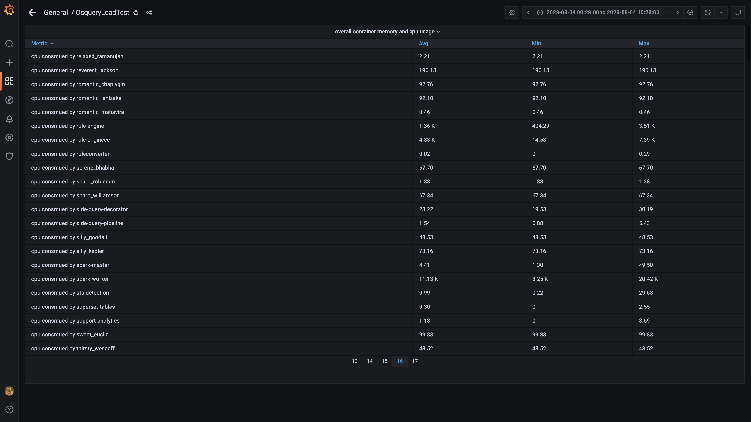

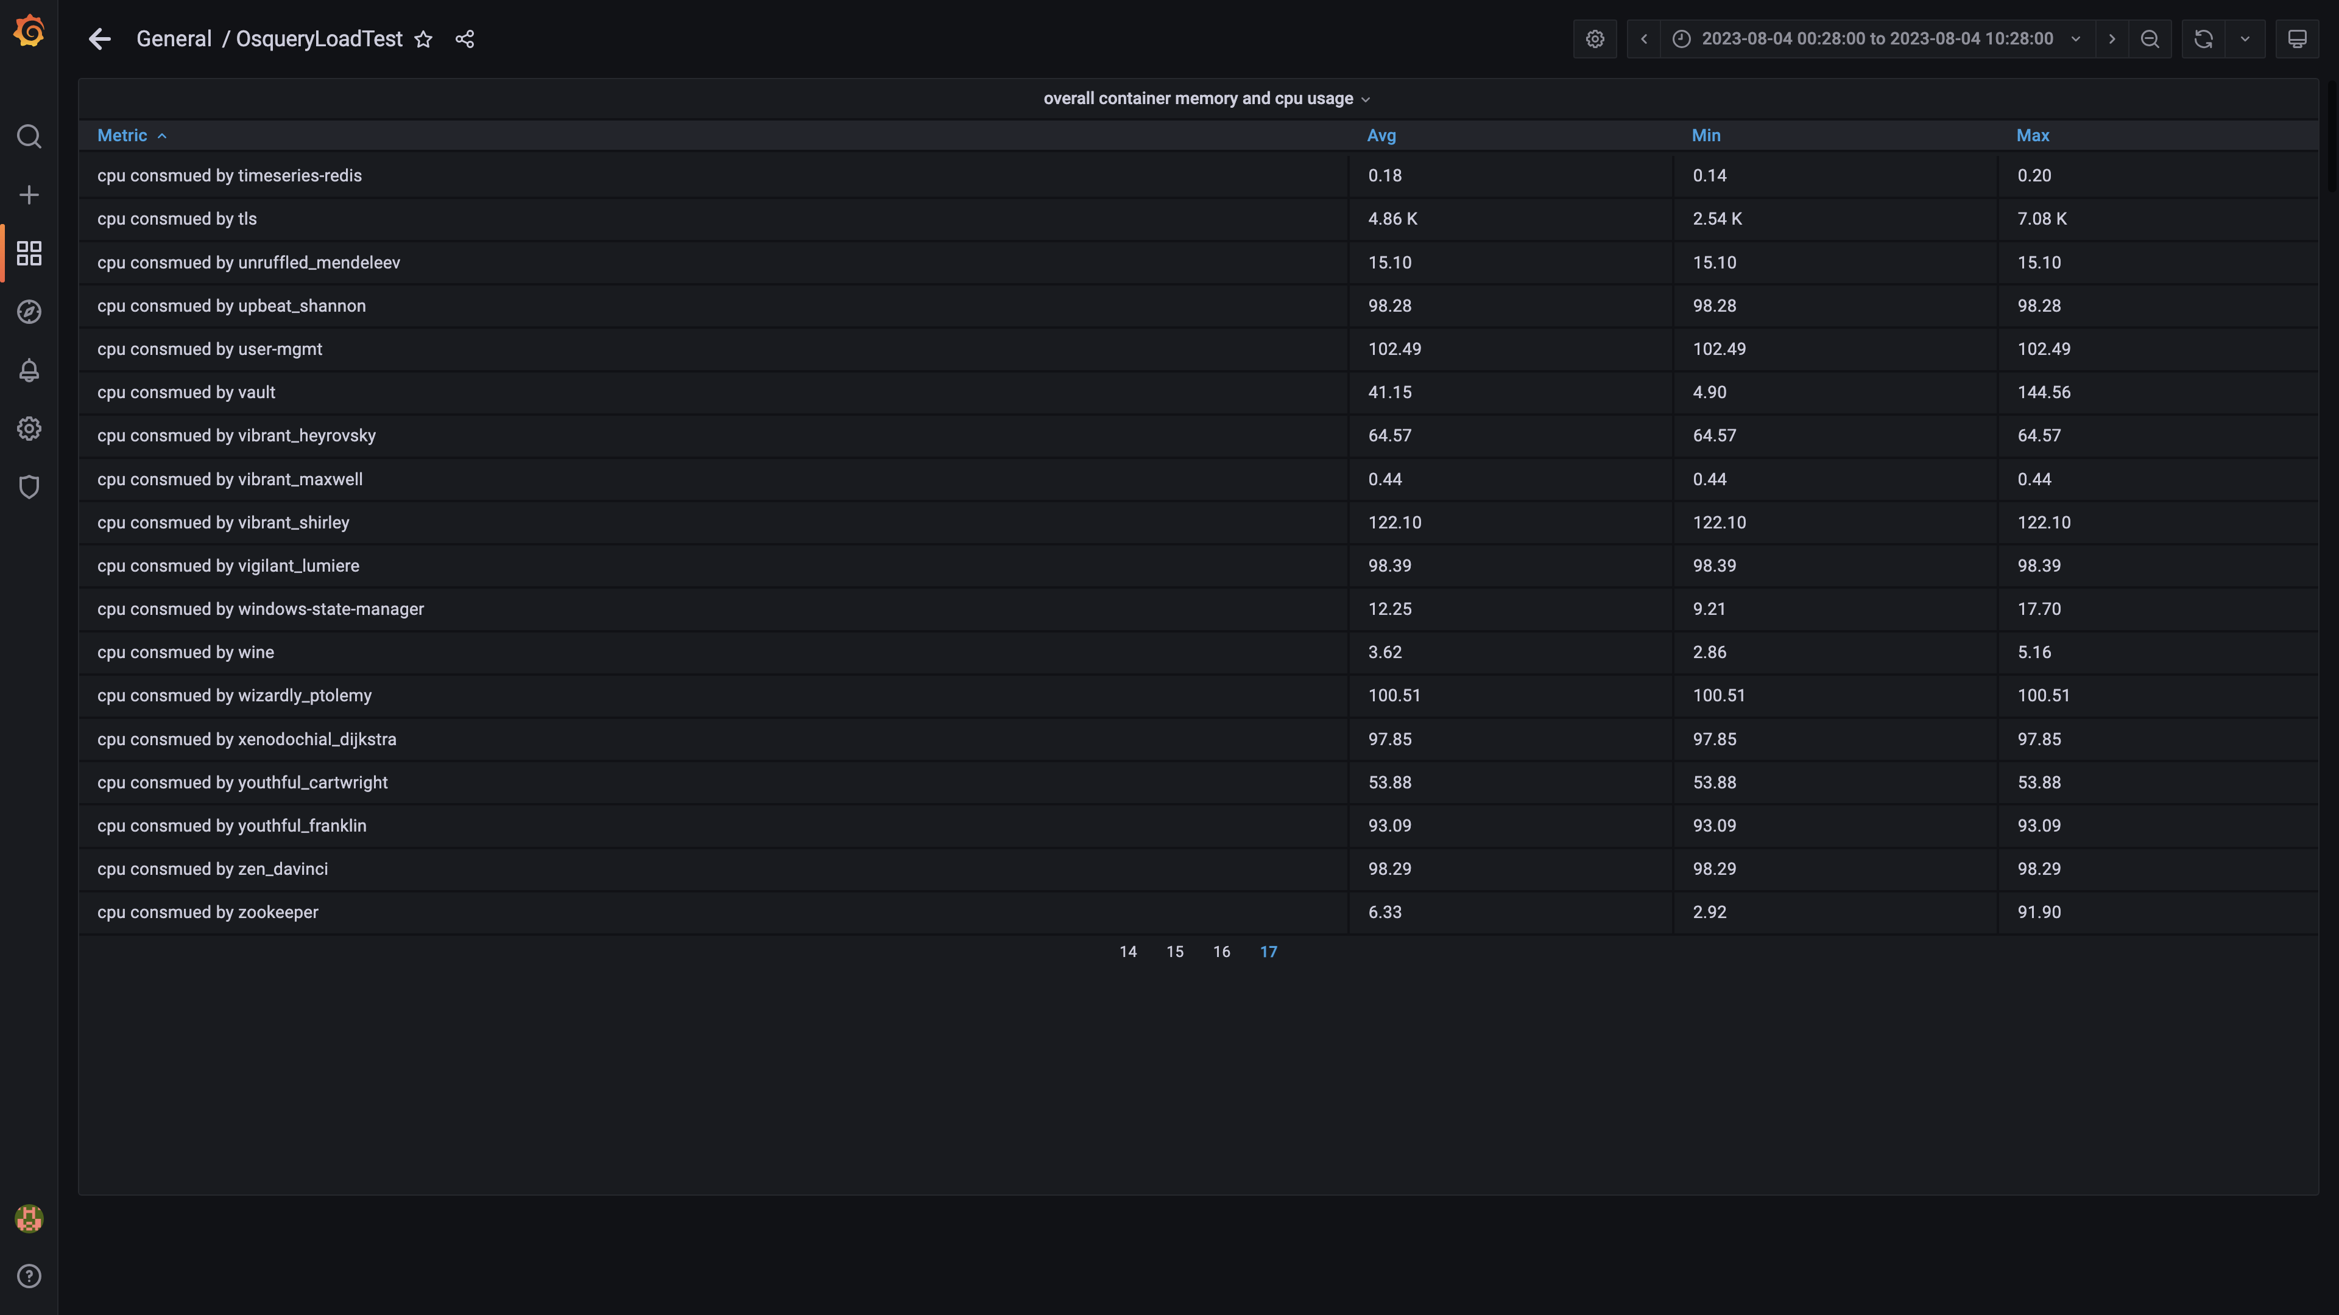

### Overall memory and cpu usages

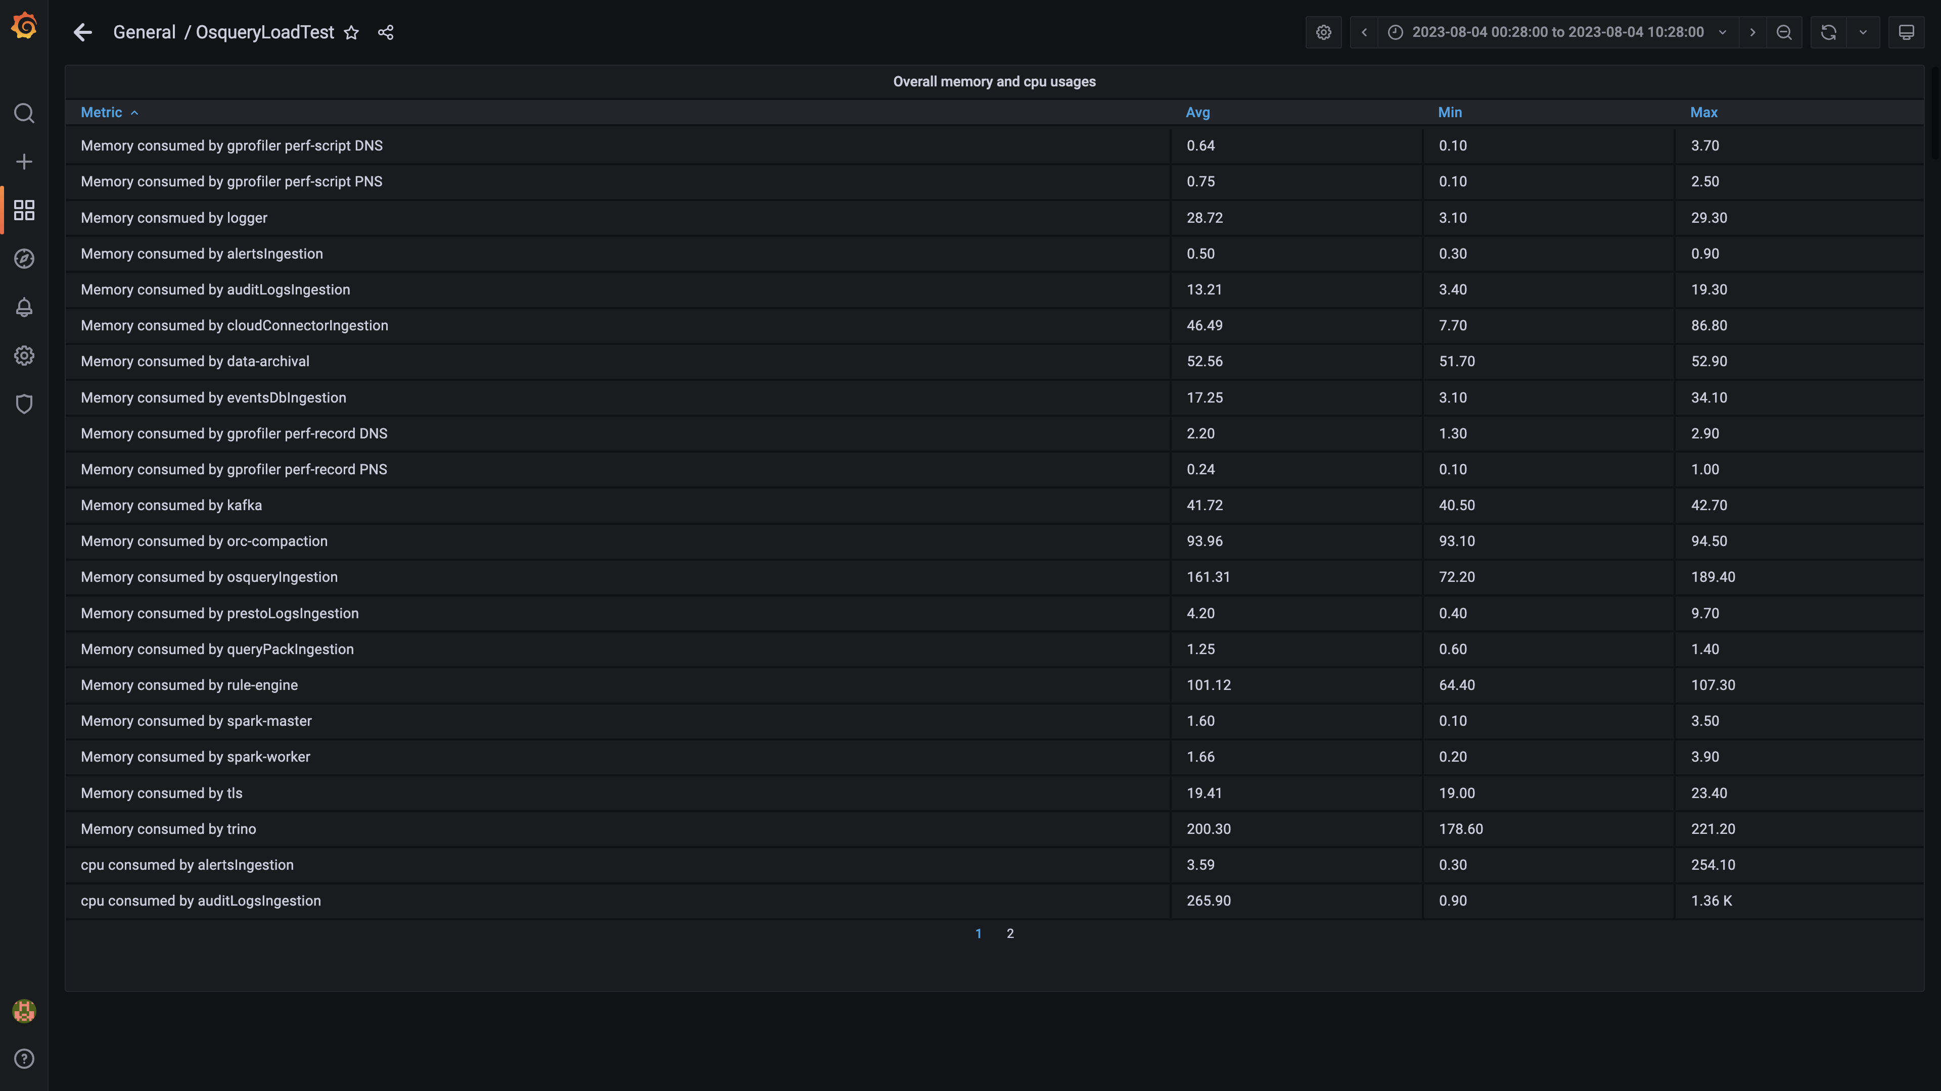

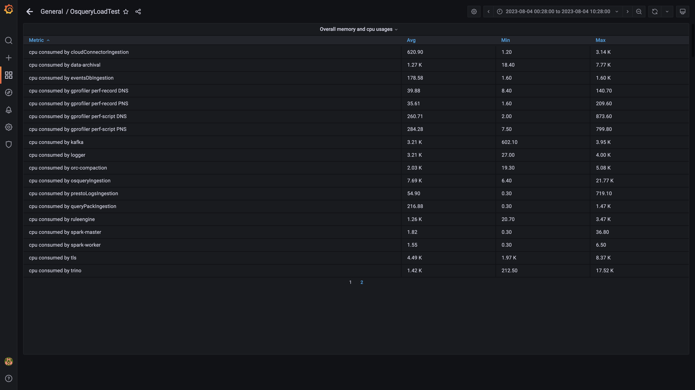

## Resource Utilization

### Comparison of average Memory utilization

|  |  |  |  |  |
| --- | --- | --- | --- | --- |
| Metric | - | 136020 | Absolute diff(%) | Relative diff(%) |
| Memory consumed by Host s1c1dn1 | - | 82.15% | - | - |
| Memory consumed by Host s1c1dn2 | - | 73.93% | - | - |
| Memory consumed by Host s1c1dn3 | - | 72.32% | - | - |
| Memory consumed by Host s1c1dn4 | - | 78.95% | - | - |
| Memory consumed by Host s1c1dn5 | - | 81.56% | - | - |
| Memory consumed by Host s1c1dn6 | - | 81.97% | - | - |
| Memory consumed by Host s1c1pn1 | - | 62.33% | - | - |
| Memory consumed by Host s1c1pn2 | - | 57.21% | - | - |
| Memory consumed by Host s1c1pn3 | - | 57.18% | - | - |
| Memory consumed by Host s1c1pn4 | - | 55.94% | - | - |
| Memory consumed by Host s1c1pn5 | - | 57.46% | - | - |
| Memory consumed by Host s1c1pn6 | - | 51.68% | - | - |
| Memory consumed by Host s1c2dn1 | - | 63.24% | - | - |
| Memory consumed by Host s1c2dn2 | - | 59.40% | - | - |
| Memory consumed by Host s1c2dn3 | - | 60.00% | - | - |
| Memory consumed by Host s1c2dn4 | - | 76.67% | - | - |
| Memory consumed by Host s1c2dn5 | - | 74.80% | - | - |
| Memory consumed by Host s1c2dn6 | - | 75.20% | - | - |
| Memory consumed by Host s1c2pn1 | - | 52.99% | - | - |
| Memory consumed by Host s1c2pn2 | - | 52.76% | - | - |
| Memory consumed by Host s1c2pn3 | - | 52.48% | - | - |
| Memory consumed by Host s1c2pn4 | - | 51.86% | - | - |
| Memory consumed by Host s1c2pn5 | - | 51.89% | - | - |
| Memory consumed by Host s1c2pn6 | - | 50.34% | - | - |
| Memory consumed by Host s1cloudquery | - | 50.74% | - | - |
| Memory consumed by Host s1configdb1 | - | 12.93% | - | - |
| Memory consumed by Host s1configdb2 | - | 1.18% | - | - |
| Memory consumed by Host s1elasticsearch | - | 23.86% | - | - |
| Memory consumed by Host s1kibana | - | 4.17% | - | - |
| Memory consumed by Host s1logstash1 | - | 16.24% | - | - |
| Memory consumed by Host s1logstash2 | - | 15.63% | - | - |
| Memory consumed by Host s1mlnode1 | - | 7.66% | - | - |
| Memory consumed by Host s1mlnode2 | - | 4.43% | - | - |
| Memory consumed by Host s1monitor | - | 28.27% | - | - |
| Memory consumed by Host s1stsnode1 | - | 66.80% | - | - |
| Memory consumed by Host s1stsnode2 | - | 49.47% | - | - |
| Memory consumed by Host s1stsnode3 | - | 48.81% | - | - |
| Memory consumed by Rule Engine s1c1pn1 | - | 7.96% | - | - |
| Memory consumed by Rule Engine s1c1pn2 | - | 7.99% | - | - |
| Memory consumed by Rule Engine s1c1pn3 | - | 8.10% | - | - |
| Memory consumed by Rule Engine s1c1pn4 | - | 8.13% | - | - |
| Memory consumed by Rule Engine s1c1pn5 | - | 8.10% | - | - |
| Memory consumed by Rule Engine s1c1pn6 | - | 8.04% | - | - |
| Memory consumed by Rule Engine s1c2pn1 | - | 8.13% | - | - |
| Memory consumed by Rule Engine s1c2pn2 | - | 8.02% | - | - |
| Memory consumed by Rule Engine s1c2pn3 | - | 8.02% | - | - |
| Memory consumed by Rule Engine s1c2pn4 | - | 7.85% | - | - |
| Memory consumed by Rule Engine s1c2pn5 | - | 7.90% | - | - |
| Memory consumed by Rule Engine s1c2pn6 | - | 7.94% | - | - |
| Memory consumed by Osquery Ingestion s1c1dn1 | - | 11.80% | - | - |
| Memory consumed by Osquery Ingestion s1c1dn2 | - | 11.65% | - | - |
| Memory consumed by Osquery Ingestion s1c1dn3 | - | 11.64% | - | - |
| Memory consumed by Osquery Ingestion s1c1dn4 | - | 15.54% | - | - |
| Memory consumed by Osquery Ingestion s1c1dn5 | - | 15.41% | - | - |
| Memory consumed by Osquery Ingestion s1c1dn6 | - | 15.81% | - | - |
| Memory consumed by Osquery Ingestion s1c2dn1 | - | 11.98% | - | - |
| Memory consumed by Osquery Ingestion s1c2dn2 | - | 11.94% | - | - |
| Memory consumed by Osquery Ingestion s1c2dn3 | - | 11.51% | - | - |
| Memory consumed by Osquery Ingestion s1c2dn4 | - | 15.62% | - | - |
| Memory consumed by Osquery Ingestion s1c2dn5 | - | 15.42% | - | - |
| Memory consumed by Osquery Ingestion s1c2dn6 | - | 15.45% | - | - |
| Memory consumed by Kafka s1c1pn1 | - | 2.94% | - | - |
| Memory consumed by Kafka s1c1pn2 | - | 3.52% | - | - |
| Memory consumed by Kafka s1c1pn3 | - | 3.54% | - | - |
| Memory consumed by Kafka s1c1pn4 | - | 3.50% | - | - |
| Memory consumed by Kafka s1c1pn5 | - | 3.52% | - | - |
| Memory consumed by Kafka s1c1pn6 | - | 3.55% | - | - |
| Memory consumed by Kafka s1c2pn1 | - | 2.98% | - | - |
| Memory consumed by Kafka s1c2pn2 | - | 3.52% | - | - |
| Memory consumed by Kafka s1c2pn3 | - | 3.52% | - | - |
| Memory consumed by Kafka s1c2pn4 | - | 2.92% | - | - |
| Memory consumed by Kafka s1c2pn5 | - | 3.52% | - | - |
| Memory consumed by Kafka s1c2pn6 | - | 3.53% | - | - |
| Memory consumed by Trino s1c1dn1 | - | 21.75% | - | - |
| Memory consumed by Trino s1c1dn2 | - | 15.71% | - | - |
| Memory consumed by Trino s1c1dn3 | - | 15.58% | - | - |
| Memory consumed by Trino s1c1dn4 | - | 16.47% | - | - |
| Memory consumed by Trino s1c1dn5 | - | 16.59% | - | - |
| Memory consumed by Trino s1c1dn6 | - | 16.60% | - | - |
| Memory consumed by Trino s1c2dn1 | - | 15.42% | - | - |
| Memory consumed by Trino s1c2dn2 | - | 15.62% | - | - |
| Memory consumed by Trino s1c2dn3 | - | 15.70% | - | - |
| Memory consumed by Trino s1c2dn4 | - | 16.49% | - | - |
| Memory consumed by Trino s1c2dn5 | - | 16.53% | - | - |
| Memory consumed by Trino s1c2dn6 | - | 16.57% | - | - |
| Memory consumed by Tls s1c1pn1 | - | 0.20% | - | - |
| Memory consumed by Tls s1c1pn2 | - | 0.20% | - | - |
| Memory consumed by Tls s1c1pn3 | - | 0.20% | - | - |
| Memory consumed by Tls s1c1pn4 | - | 0.20% | - | - |
| Memory consumed by Tls s1c1pn5 | - | 0.20% | - | - |
| Memory consumed by Tls s1c1pn6 | - | 0.20% | - | - |
| Memory consumed by Tls s1c2pn1 | - | 0.20% | - | - |
| Memory consumed by Tls s1c2pn2 | - | 0.21% | - | - |
| Memory consumed by Tls s1c2pn3 | - | 0.20% | - | - |
| Memory consumed by Tls s1c2pn4 | - | 0.20% | - | - |
| Memory consumed by Tls s1c2pn5 | - | 0.20% | - | - |
| Memory consumed by Tls s1c2pn6 | - | 0.20% | - | - |
| Memory consumed by EventsDbIngestion s1c1dn1 | - | 0.65% | - | - |
| Memory consumed by EventsDbIngestion s1c1dn2 | - | 1.15% | - | - |
| Memory consumed by EventsDbIngestion s1c1dn3 | - | 1.15% | - | - |
| Memory consumed by EventsDbIngestion s1c1dn4 | - | 1.50% | - | - |
| Memory consumed by EventsDbIngestion s1c1dn5 | - | 1.44% | - | - |
| Memory consumed by EventsDbIngestion s1c1dn6 | - | 1.52% | - | - |
| Memory consumed by EventsDbIngestion s1c2dn1 | - | 0.79% | - | - |
| Memory consumed by EventsDbIngestion s1c2dn2 | - | 1.21% | - | - |
| Memory consumed by EventsDbIngestion s1c2dn3 | - | 1.20% | - | - |
| Memory consumed by EventsDbIngestion s1c2dn4 | - | 1.71% | - | - |
| Memory consumed by EventsDbIngestion s1c2dn5 | - | 1.61% | - | - |
| Memory consumed by EventsDbIngestion s1c2dn6 | - | 1.59% | - | - |
| Memory consumed by Logger s1c1pn1 | - | 2.40% | - | - |
| Memory consumed by Logger s1c1pn2 | - | 2.40% | - | - |
| Memory consumed by Logger s1c1pn3 | - | 2.39% | - | - |
| Memory consumed by Logger s1c1pn4 | - | 2.40% | - | - |
| Memory consumed by Logger s1c1pn5 | - | 2.40% | - | - |
| Memory consumed by Logger s1c1pn6 | - | 2.39% | - | - |
| Memory consumed by Logger s1c2pn1 | - | 2.39% | - | - |
| Memory consumed by Logger s1c2pn2 | - | 2.40% | - | - |
| Memory consumed by Logger s1c2pn3 | - | 2.39% | - | - |
| Memory consumed by Logger s1c2pn4 | - | 2.40% | - | - |
| Memory consumed by Logger s1c2pn5 | - | 2.39% | - | - |
| Memory consumed by Logger s1c2pn6 | - | 2.39% | - | - |

### Comparison of average CPU utilization

|  |  |  |  |  |
| --- | --- | --- | --- | --- |
| Metric | - | 136020 | Absolute diff(%) | Relative diff(%) |
| CPU consumed by Host s1c1dn1 | - | 66.34% | - | - |
| CPU consumed by Host s1c1dn2 | - | 52.35% | - | - |
| CPU consumed by Host s1c1dn3 | - | 50.74% | - | - |
| CPU consumed by Host s1c1dn4 | - | 50.19% | - | - |
| CPU consumed by Host s1c1dn5 | - | 50.77% | - | - |
| CPU consumed by Host s1c1dn6 | - | 52.68% | - | - |
| CPU consumed by Host s1c1pn1 | - | 84.58% | - | - |
| CPU consumed by Host s1c1pn2 | - | 83.35% | - | - |
| CPU consumed by Host s1c1pn3 | - | 81.92% | - | - |
| CPU consumed by Host s1c1pn4 | - | 77.43% | - | - |
| CPU consumed by Host s1c1pn5 | - | 86.25% | - | - |
| CPU consumed by Host s1c1pn6 | - | 78.08% | - | - |
| CPU consumed by Host s1c2dn1 | - | 45.05% | - | - |
| CPU consumed by Host s1c2dn2 | - | 44.73% | - | - |
| CPU consumed by Host s1c2dn3 | - | 42.57% | - | - |
| CPU consumed by Host s1c2dn4 | - | 42.40% | - | - |
| CPU consumed by Host s1c2dn5 | - | 42.51% | - | - |
| CPU consumed by Host s1c2dn6 | - | 42.55% | - | - |
| CPU consumed by Host s1c2pn1 | - | 82.02% | - | - |
| CPU consumed by Host s1c2pn2 | - | 76.16% | - | - |
| CPU consumed by Host s1c2pn3 | - | 74.83% | - | - |
| CPU consumed by Host s1c2pn4 | - | 78.15% | - | - |
| CPU consumed by Host s1c2pn5 | - | 75.94% | - | - |
| CPU consumed by Host s1c2pn6 | - | 76.34% | - | - |
| CPU consumed by Host s1cloudquery | - | 76.16% | - | - |
| CPU consumed by Host s1configdb1 | - | 76.29% | - | - |
| CPU consumed by Host s1configdb2 | - | 4.86% | - | - |
| CPU consumed by Host s1elasticsearch | - | 58.61% | - | - |
| CPU consumed by Host s1kibana | - | 7.82% | - | - |
| CPU consumed by Host s1logstash1 | - | 21.63% | - | - |
| CPU consumed by Host s1logstash2 | - | 20.32% | - | - |
| CPU consumed by Host s1mlnode1 | - | 11.45% | - | - |
| CPU consumed by Host s1mlnode2 | - | 6.78% | - | - |
| CPU consumed by Host s1monitor | - | 5.82% | - | - |
| CPU consumed by Host s1stsnode1 | - | 24.49% | - | - |
| CPU consumed by Host s1stsnode2 | - | 21.95% | - | - |
| CPU consumed by Host s1stsnode3 | - | 19.82% | - | - |
| CPU consumed by Rule Engine s1c1pn1 | - | 234.58% | - | - |
| CPU consumed by Rule Engine s1c1pn2 | - | 251.90% | - | - |
| CPU consumed by Rule Engine s1c1pn3 | - | 237.91% | - | - |
| CPU consumed by Rule Engine s1c1pn4 | - | 234.67% | - | - |
| CPU consumed by Rule Engine s1c1pn5 | - | 241.03% | - | - |
| CPU consumed by Rule Engine s1c1pn6 | - | 228.25% | - | - |
| CPU consumed by Rule Engine s1c2pn1 | - | 240.20% | - | - |
| CPU consumed by Rule Engine s1c2pn2 | - | 236.06% | - | - |
| CPU consumed by Rule Engine s1c2pn3 | - | 246.05% | - | - |
| CPU consumed by Rule Engine s1c2pn4 | - | 244.22% | - | - |
| CPU consumed by Rule Engine s1c2pn5 | - | 232.32% | - | - |
| CPU consumed by Rule Engine s1c2pn6 | - | 234.21% | - | - |
| CPU consumed by Osquery Ingestion s1c1dn1 | - | 126.69% | - | - |
| CPU consumed by Osquery Ingestion s1c1dn2 | - | 167.52% | - | - |
| CPU consumed by Osquery Ingestion s1c1dn3 | - | 166.12% | - | - |
| CPU consumed by Osquery Ingestion s1c1dn4 | - | 169.53% | - | - |
| CPU consumed by Osquery Ingestion s1c1dn5 | - | 165.43% | - | - |
| CPU consumed by Osquery Ingestion s1c1dn6 | - | 185.42% | - | - |
| CPU consumed by Osquery Ingestion s1c2dn1 | - | 119.23% | - | - |
| CPU consumed by Osquery Ingestion s1c2dn2 | - | 164.97% | - | - |
| CPU consumed by Osquery Ingestion s1c2dn3 | - | 159.43% | - | - |
| CPU consumed by Osquery Ingestion s1c2dn4 | - | 157.13% | - | - |
| CPU consumed by Osquery Ingestion s1c2dn5 | - | 159.67% | - | - |
| CPU consumed by Osquery Ingestion s1c2dn6 | - | 170.23% | - | - |
| CPU consumed by Kafka s1c1pn1 | - | 237.85% | - | - |
| CPU consumed by Kafka s1c1pn2 | - | 275.30% | - | - |
| CPU consumed by Kafka s1c1pn3 | - | 280.46% | - | - |
| CPU consumed by Kafka s1c1pn4 | - | 261.39% | - | - |
| CPU consumed by Kafka s1c1pn5 | - | 283.66% | - | - |
| CPU consumed by Kafka s1c1pn6 | - | 275.68% | - | - |
| CPU consumed by Kafka s1c2pn1 | - | 218.50% | - | - |
| CPU consumed by Kafka s1c2pn2 | - | 253.11% | - | - |
| CPU consumed by Kafka s1c2pn3 | - | 248.60% | - | - |
| CPU consumed by Kafka s1c2pn4 | - | 246.40% | - | - |
| CPU consumed by Kafka s1c2pn5 | - | 240.97% | - | - |
| CPU consumed by Kafka s1c2pn6 | - | 247.06% | - | - |
| CPU consumed by Trino s1c1dn1 | - | 138.97% | - | - |
| CPU consumed by Trino s1c1dn2 | - | 115.06% | - | - |
| CPU consumed by Trino s1c1dn3 | - | 117.25% | - | - |
| CPU consumed by Trino s1c1dn4 | - | 120.80% | - | - |
| CPU consumed by Trino s1c1dn5 | - | 121.31% | - | - |
| CPU consumed by Trino s1c1dn6 | - | 115.87% | - | - |
| CPU consumed by Trino s1c2dn1 | - | 109.58% | - | - |
| CPU consumed by Trino s1c2dn2 | - | 117.79% | - | - |
| CPU consumed by Trino s1c2dn3 | - | 112.83% | - | - |
| CPU consumed by Trino s1c2dn4 | - | 112.40% | - | - |
| CPU consumed by Trino s1c2dn5 | - | 116.28% | - | - |
| CPU consumed by Trino s1c2dn6 | - | 119.64% | - | - |
| CPU consumed by Tls s1c1pn1 | - | 42.76% | - | - |
| CPU consumed by Tls s1c1pn2 | - | 44.55% | - | - |
| CPU consumed by Tls s1c1pn3 | - | 47.77% | - | - |
| CPU consumed by Tls s1c1pn4 | - | 47.39% | - | - |
| CPU consumed by Tls s1c1pn5 | - | 48.17% | - | - |
| CPU consumed by Tls s1c1pn6 | - | 47.32% | - | - |
| CPU consumed by Tls s1c2pn1 | - | 48.73% | - | - |
| CPU consumed by Tls s1c2pn2 | - | 47.65% | - | - |
| CPU consumed by Tls s1c2pn3 | - | 46.88% | - | - |
| CPU consumed by Tls s1c2pn4 | - | 47.57% | - | - |
| CPU consumed by Tls s1c2pn5 | - | 46.27% | - | - |
| CPU consumed by Tls s1c2pn6 | - | 46.74% | - | - |
| CPU consumed by EventsDbIngestion s1c1dn1 | - | 9.38% | - | - |
| CPU consumed by EventsDbIngestion s1c1dn2 | - | 7.19% | - | - |
| CPU consumed by EventsDbIngestion s1c1dn3 | - | 8.71% | - | - |
| CPU consumed by EventsDbIngestion s1c1dn4 | - | 7.73% | - | - |
| CPU consumed by EventsDbIngestion s1c1dn5 | - | 8.73% | - | - |
| CPU consumed by EventsDbIngestion s1c1dn6 | - | 9.62% | - | - |
| CPU consumed by EventsDbIngestion s1c2dn1 | - | 8.27% | - | - |
| CPU consumed by EventsDbIngestion s1c2dn2 | - | 11.37% | - | - |
| CPU consumed by EventsDbIngestion s1c2dn3 | - | 7.92% | - | - |
| CPU consumed by EventsDbIngestion s1c2dn4 | - | 8.05% | - | - |
| CPU consumed by EventsDbIngestion s1c2dn5 | - | 9.05% | - | - |
| CPU consumed by EventsDbIngestion s1c2dn6 | - | 12.49% | - | - |
| CPU consumed by Logger s1c1pn1 | - | 267.86% | - | - |
| CPU consumed by Logger s1c1pn2 | - | 284.97% | - | - |
| CPU consumed by Logger s1c1pn3 | - | 260.29% | - | - |
| CPU consumed by Logger s1c1pn4 | - | 271.28% | - | - |
| CPU consumed by Logger s1c1pn5 | - | 272.25% | - | - |
| CPU consumed by Logger s1c1pn6 | - | 265.74% | - | - |
| CPU consumed by Logger s1c2pn1 | - | 277.17% | - | - |
| CPU consumed by Logger s1c2pn2 | - | 256.73% | - | - |
| CPU consumed by Logger s1c2pn3 | - | 268.28% | - | - |
| CPU consumed by Logger s1c2pn4 | - | 277.40% | - | - |
| CPU consumed by Logger s1c2pn5 | - | 243.40% | - | - |
| CPU consumed by Logger s1c2pn6 | - | 266.27% | - | - |

## Overall Usages

### Comparision of Overall Memory Usage

|  |  |  |  |
| --- | --- | --- | --- |
| Metric | - | 136020 | Delta |
| Average Memory used by pnodes (GB) | 0.00 GB | 1229.73 GB | - |
| Average Memory used by dnodes (GB) | 0.00 GB | 1913.70 GB | - |
| Average Memory used by pgnodes (GB) | 0.00 GB | 26.53 GB | - |

### Comparision of Overall CPU Usage

|  |  |  |  |
| --- | --- | --- | --- |
| Metric | - | 136020 | Delta |
| Average CPU used by pnodes (cores) | 0.00 cores | 305.62 cores | - |
| Average CPU used by dnodes (cores) | 0.00 cores | 186.52 cores | - |
| Average CPU used by pgnodes (cores) | 0.00 cores | 25.97 cores | - |